Improving Self-consumption of Photovoltaic systems by E-mobility – Limits of Autarky

Albert Hiesl, Vienna University of Technology, +43 1 58801 370371 , hiesl@eeg.tuwien.ac.at
Michael Hartner, Vienna University of Technology, +43 1 58801 370379 , hartner@eeg.tuwien.ac.at

Overview

In recent years PV-electricity has become an increasingly competitive energy source for decentralized use. With increasing retail electricity prices and decreasing feed-in tariffs, the rate of self consumption of PV-electricity is an essential parameter for the profitability of PV-systems. Increasing the PV electricity self-consumption means the improvement of the synchronization between demand and PV-production. The use of batteries in combination with photovoltaic systems is still very limited. Besides stationary battery systems, electric vehicles appear to be a good solution to store the excess of solar power production temporarily. Electric vehicles have the advantage that no additional space is needed, but also the disadvantage that it is not always ready to charge when the sun is shining. This paper focuses on the economics of decentralized PV-systems in combination with e-mobility. The core objective is to identify the limits of autarky for buildings with photovoltaic systems in combination with electric vehicles and to determine the economic effects. We look at two different scenarios: PV-Systems on residential buildings and PV-Systems on office buildings which often have an higher share of available space.

Methods

Based on measured data of horizontal irradiation and ambient temperature, the PV-output is calculated following the approach suggested by Huld (Huld et al, 2010). The electricity consumption of residential buildings as well as office buildings are implemented as standardized load profiles and are scalable with the yearly electricity consumption. It is assumed, that the electric vehicle is operated as commuter vehicle between residential buildings and office buildings with typical road length, grid to wheel consumption, traveling times and starting times. The battery of the electric vehicle is modeled as lithium battery with a typical loading gauge. The PV-output, the load profile as well as the parameters of the commuter traffic are input parameters for the optimization model implemented in MATLAB. The optimization model, which is based on the YALMIP toolbox and the GUROBI solver, decides when to charge the electric vehicle, when to purchase electricity and when to feed in the PV-surplus. The objective function of the model is to minimize the costs of electricity purchase and the calculation is done for 25 years with different sizes of the load profiles. The specific costs for Building integrated PV-system in Austria depends on the size. In 2013 a 1 kWp system accounts for about 4000€/kWp and a 15 kWp system accounts for about 1700 €/kWp. With assumptions on the future developement of household electricity prices and feed-in tariffs, the internal rate of return (IRR) is calculated.
The economic calculation is done by

$$NPV= -\left(I_{PV}\right)+ \sum_{t=1}^{25}{\frac{C_{t}}{{\left(1+IRR\right)}^{t}}}=0$$

where the cash-flow (C_{t}) strongly depends on self-consumption, electricity prices and feed-in tariffs.

Results

The following figures show results based on a PV-system located on a rooftop of a residential building in Vienna with an installation angle of 30° and southward orientation, but can also be calculated for other locations, orientations and installation angles. In these figures, the calculation is done with a standardized household load profile, in the final paper we will also compare residential buildings and office buildings with photovoltaic systems installed.
Due to the bad correlation of PV-production and the times where the electric vehicle is available to charge at home, it is expected that the rate of self sufficiency of the electric vehicle will be not that high.

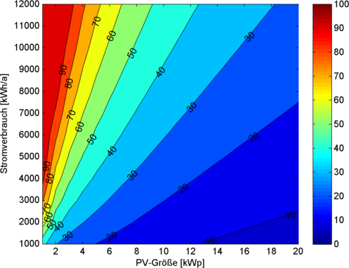  Electricty consumption [kwh/a]  PV-Capacity [kWp]  Figure 1: Rate of self consumption of a household and electric vehicle [%] | 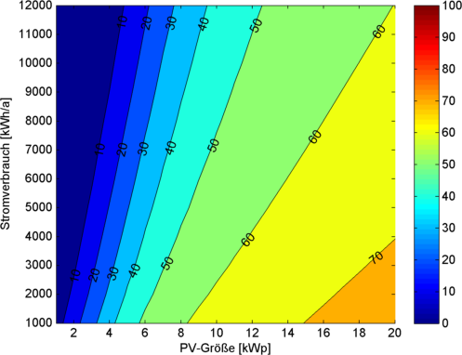Figure 2: Rate of self-sufficiency of the electric-vehicle [%]  Electricty consumption [kwh/a]  PV-Capacity [kWp]
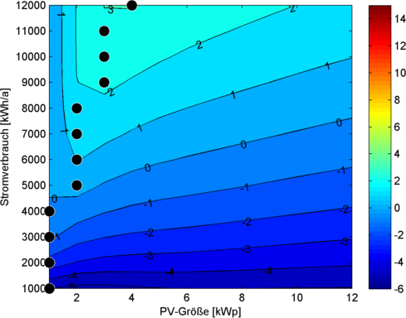
Figure 1 shows the rate of self consumption of a household in combination with an electric vehicle. The rate of self consumption slightly increases because of the electric vehicle compared to PV-Systems without an electric vehicle. In this case, the electric vehicle will only be charged from the PV-System and the electricity grid, but not vice versa. Due to the optimisation strategie, the electricity demand of the electric vehicle can be covered up to 70% with PV-capacities above 15 kWp and electricity consumption between 1000 and 4000 kWh/a, as one can see in Figure 2. When we compare this figure with a non optimal charging of the electric vehicle (i.e. the electric vehicle is charged after every stop) then we figure out, that the demand of the vehicle can be covered at a maxium of 40%.
Figure 3: Internal Rate of Return [%]
Electricty consumption [kwh/a]
PV-Capacity [kWp]
We also investigated the same combination on office buildings and due to the better correlation of “standing times” and PV-Production the rate of self sufficiency of the electric vehicle increases compared to residential buildings. With bigger PV-Systems it is also possible to charge more electric vehicles at the same time and to increase the rate of self consumption significantly.
Figure 3 shows the Internal rate of return of PV-Systems in combination with electric vehicles. The internal rate of return lies between -4% and about 3% and strongly depends on the electricity consumption of the household and the rate of self consumption. Due to the slightly increasing rate of self consumption, also the internal rate of return increases compared to PV-Systes without an electric vehicle. The economically optimal size of the PV-System lies between 1 kWp for an electricity consumption of 1000 kWh/a and 4 kWp for a yearly electricity consumption of 12000 kWh/a.
The final version of this paper will also consider analyses of the economics of PV-Systmes on office buildings in combination with electric vehicles. We will also look at the effects, when electric vehicles also can cover some electricity demand of the building.

Conclusions
From a household’s point of view, the benefit in terms of self consumption of an electric vehicle (as commuter vehicle) is non-essential, because charging is just possible in the morning or in the evening. This correlation is much better at office buildings, where the electric vehicle is available during the day and therefore the benefit will be much better. In addition a higher IRR can be achieved due to decreasing costs for bigger PV-Systems and the corresponding higher electricity consumption of these buildings.

References
Huld, T., Gottschalg, R., Beyer, H.G., and Topič, M. (2010). Mapping the performance of PV modules, effects of module type and data averaging. Sol. Energy 84, 324–338.

