energy communities as an enabler for PV

Johannes Radl, Technische Universität Wien, Energy Economics Group, +430158801370372, radl@eeg.tuwien.ac.at
Andreas Fleischhacker, Technische Universität Wien, Energy Economics Group, +430158801370361, fleischhacker@eeg.tuwien.ac.at
Georg Lettner Technische Universität Wien, Energy Economics Group, +430158801370376, lettner@eeg.tuwien.ac.at

Overview
In energy communities (EC) we consider the collaborative use of PV-generation and their benefits due to aggregation effects. When considering one consumer who produces PV-energy (prosumer) individually, the prosumer feeds a lot of excess PV energy into the grid, whereas in some times the PV-generation cannot satisfy the prosumers load. Therefore the PV-use of each individual prosumer is lower than if all prosumers share their PV-generation and optimize their load together. Since the community approach makes PV-systems more profitable, they are less dependent on subsidies.
Within the project PV-Prosumers4Grid, we distinguish between a baseline and a future scenario. In the baseline scenario, heating, hot water and individual transportation are based on fossil fuels, which we replace by heat pumps and electric vehicles (EV) in the future scenario. Further, we examine different approaches: (1) The individual approach treats all prosumers separately. (2) The community consists of tenants in an apartment building who share a PV-system. (3) A whole village shares the excess energy of all PV-systems.

Methods
The setting of the simulation is a “European village” where we picture the average housing situation of Europeans in terms of people per household (Eurostat, 2018) together with the average car distribution in Europe (Eurostat, 2018).
Consumer | People per housing | EVs per housing |  | Consumer | People per housing | EV’s per housing
Commercial 1 | - | - |  | Commercial 2 | - | -
Flat 1 | 1 | 1 |  | House 1 | 2 | 1
Flat 2 | 1 |  |  | House 2 | 3 | 2
Flat 3 | 1 |  |  | House 3 | 4 | 2
Flat 4 | 2 | 1 |  | House 4 | 4 | 3
Flat 5 | 2 |  |  | Apartment b. | 10 | 3
Flat 6 | 3 | 1
With the Load Profile Generator (Pflugradt, 2019) we generate a synthetic high-resolution electricity and hot-water load profile based on the number of people per household. The heat demand is based on the household size and the outside-temperature. For simulating the EV energy consumption we used measured charging profiles, weighted with the average driven range (Eurostat, 2018) and average EV consumption.
With an optimization model, we evaluate the optimal portfolio for each use-case. The sizes of the PV-systems and storage technologies are an output of the model, depending on household sizes, consumption profiles and economic feasibility.
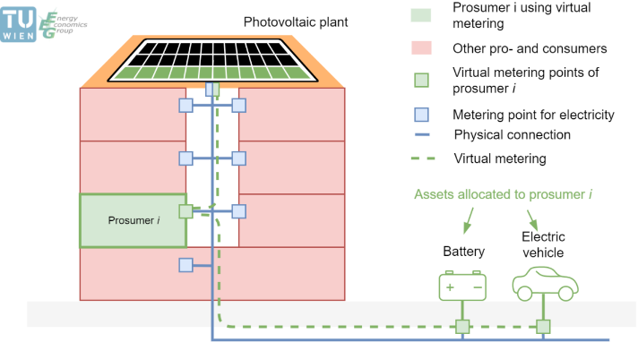
The individual approach (1) is currently the most common use-case, where all prosumers optimize their individual portfolio separately. The prosumers consume their own PV-energy and feed the surplus energy into the grid. Nevertheless, grid tariffs and taxes might apply for the energy consumed from the grid.
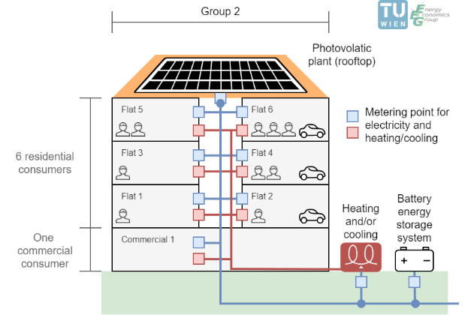
With the community approach for apartment buildings (2) the energy exchange within the tenants is not charged. The tenants share a PV-system. Due to the collaborative use of the PV-system, almost no electricity is fed into the public grid. Grid fees and taxes apply for the electricity consumed from the public grid only.
The community approach for a whole village (3) incentives the energy exchange between all inhabitants. Since no grid fees apply for transporting energy within the “village grid” it does not matter where a PV system is located within the village. If the rooftop size of the apartment building is the limitation for the PV-system in the previous approaches, then with this approach the excess energy from the neighbor can be used.
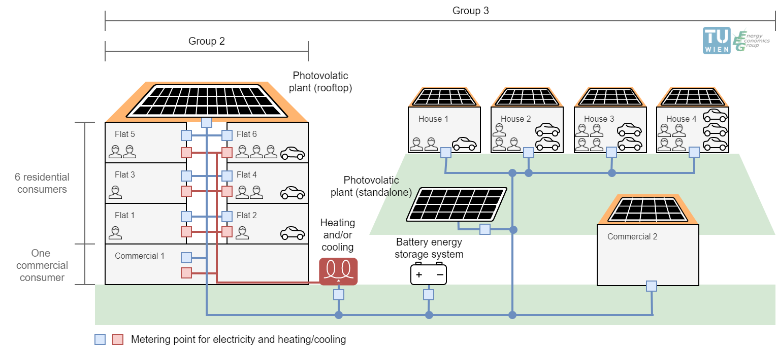

Results
We expect to have the highest costs and lowest rate of PV installations for the individual approach (1). Since the loads of the apartment building succeed the possible PV-generation, we expect the rooftop size to be the limiting factor for the PV-system. The community approach for the whole village (3) might lead to the highest PV penetration and to the lowest costs. Since we have a higher electricity demand in the improved scenario due to heat pumps and EV’s we expect a much higher penetration of PV systems than in the baseline scenario.

Conclusions
The community approach increases PV-consumption, which reduces the costs for grid fees and taxes. Therefore, the profitability of a PV system is increased which leads to a lower dependence on subsidies. When we focus on the apartment building, where the grid between the tenants is property of the building owners, it is obvious that they should not be charged for using their own grid for sharing or exchanging energy. The evaluation of optimizing a whole village shows the benefit of exchanging energy with neighbors. Since this strategy uses the lowest grid level of the public grid for exchanging energy between houses only, a lower grid tariff should apply.

References
Eurostat, 2018. Housing statistics and passenger cars in the European Union [WWW Documents], URL https://ec.europa.eu/eurostat/statistics-explained/index.php/Housing_statistics and https://ec.europa.eu/eurostat/statistics-explained/index.php/Passenger_cars_in_the_EU (accessed 11.12.18).
Fleischhacker, A., Corinaldesi, C., Lettner, G., Auer, H., 2018. Energy Sharing Approaches in Energy Communities. (Working Paper).
Fleischhacker, A., Lettner, G., Schwabeneder, D., Moisl, F., Auer, H., Pause, F., Wizinger, S., Verhaegen, R., 2017. BestRES - Improved Business Models of selected aggregators in target countries (Technical Report No. D3.2).
Lettner, G., Auer, H., Fleischhacker, A., Schwabeneder, D., Dallinger, B., Moisl, F., Roman, E., Velte, D., 2018. D2.1 - Existing and Future PV Prosumer Concepts (Technical Report). Vienna.
Pflugradt, N. Load Profile Generator, URL https://www.loadprofilegenerator.de (accessed 06.03.19).

The project PV-Prosumers4Grid has received funding from the European Union’s Horizon 2020 research and innovation programme under grant agreement No 764786.

