Quality of life modelling in terms of energy consumption

Reza Nadimi

Department of Transdisciplinary Science and Engineering, School of Environment and Society, Tokyo Institute of Technology, 4259 Nagatsuta-cho, Midori-ku, Yokohama, 226-8503, Japan.

* Corresponding Author: Nadimi.r.aa@m.titech.ac.jp

Overview
Energy consumption and its management are key points in energy contexts. Sector-based energy analysis and modeling usually regard economic and environmental aspects to manage energy consumption. Sector-based analysis attempts to take into account energy consumption in industrial, commercial, agricultural, transportation, and residential as well as considering their impacts on economic and environment. Reflecting human aspects in energy consumption does not highlight much more in sector-based analysis whilst consumer-oriented insight into energy consumption and energy modeling reveals significant contribution of human in the center of energy consumption. Consumer-based energy management can occur by investigation on different aspects of human life such as behavior, culture, well-being, priority, and religion. Investigation by [1] indicated that around 80 percent of the energy consumption of year 1997 in the USA belonged to consumer demand. Quality of Life (QoL) is one of the wealthy society indicators which is extracted and modelled in terms of some social variables. Present study believes that there is latent variable among quality of life indices and tries to model its variation in linear form and finally make another model with energy and electricity consumption separately.

Method
Quality of life indicators may utilize several variables to explain the level of quality in the society from positive and negative aspects. Current study conducts research on variables which are reasonable, measureable and available for the most of countries as well as being in the spotlight of other researches which are: infant mortality rate, life expectancy, Mean years of schooling, gross domestic product, gross national income, improving water access.
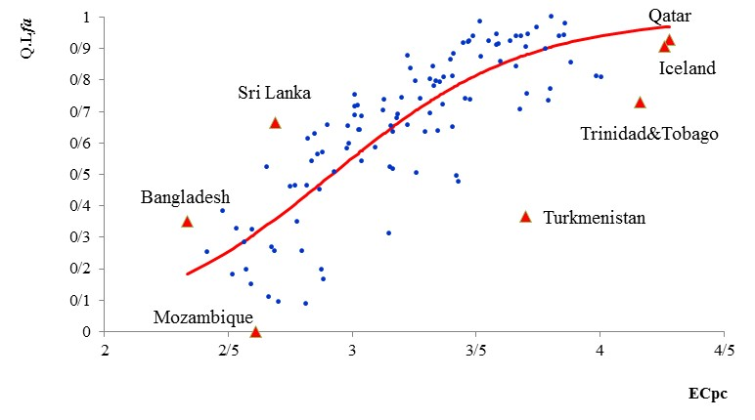
Figure 1: Quality of Life Indicator against (a) Energy consumption per capita, and (b) Q.L_{si} model against energy consumption per capita

Quality of life is modeled in terms of six mentioned variables for the year 2013 data based on factor analysis [2] as follows:
Q.L_{fa} = 0.814*MYS+0.916*GDP+0.921*GNI- 0.920*IMR+ 0.900*LEB+ 0.749*IWA | (1)

Figure 1 demonstrates energy and electrical consumption per capita against quality of life indicator, Q.L_{fa}, for the year 2013 (see equation (1)) with more details.

Results
First-Modeling quality of life in terms of economic and social variables: Linear quality of life indicator, Q.L_{fa}, was modeled in terms of MYS, GDP, GNI, IMR, LEB, and IWA. Factor analysis was applied to extract hidden variable, quality of life, by considering correlation analysis among variables concurrently.
Second-Modeling quality of life against energy/electricity consumption per capita: Quality of life indicator in above was applied to achieve quality of life function, Q.L_{si} which sigmoid function fitted to the data. Pre-developing, developing, and developed countries classification were extracted based on the sigmoid function.

Conclusion
In this study quality of life indicator was achieved in terms of six quantifiable variables. Factor Analysis as a well-known multi-variable analysis method applied to extract hidden factor among social variables. Quality of life indicator then used to consider the behavior of energy and electrical consumption per capita. Therefore sigmoid function was fitted to data with respect to least square and numerical method. At the end the total area was categorized into three areas to specify one country’s performance based on the quality of life indicator and energy/electrical energy consumption per capita. Two zones are introduced to characterize some countries which behave as inefficient or efficient from quality of life indicator or energy/electricity consumption per capita.

References

[1] | S. Bin and H. Dowlatabadi, "Consumer lifestyle approach to US energy use and the related CO2 emissions," Energy Policy, vol. 33, pp. 197-208, 2005.
[2] | F. Jolai and R. Nadimi, "Joint Use of Factor Analysis (FA) and Data Envelopment Analysis (DEA) for Ranking of Data Envelopment Analysis," International Journal of Mathematical, Physical and Engineering Sciences, pp. 218-222, 2008.

