Natural gas and crude oil price impacts on corn-based and cellulosic ethanol use in the United States: An analysis using an integrated regional agricultural-energy modeling framework

Rebecca S. Dodder, U.S. Environmental Protection Agency, Phone: +1-919-541-5376, Email: dodder.rebecca@epa.gov
P. Ozge Kaplan, U.S. Environmental Protection Agency, Phone:+1-919-541-5069, Email: kaplan.ozge@epa.gov
Amani Elobeid, CARD, Iowa State University, Phone: +1-515-294-6175, Email: amani@iastate.edu
Simla Tokgoz, International Food Policy Research Institute, Phone: +1-202-862-8192, Email: S.Tokgoz@cgiar.org
Silvia Secchi, Southern Illinois University, Phone: +1-618-453-1714, Email: ssecchi@siu.edu
LyubovA. Kurkalova, North Carolina A&T University, Phone: +1-336-285-3348, Email: lakurkal@ncat.edu

Overview
The accelerated growth in biofuels markets has both created new and reinforced the existing linkages between agricultural and energy markets. This study investigates the dynamics in biofuel and agricultural markets under alternative crude oil and natural gas price scenarios. Two energy price scenarios are simulated using an integrated regional modeling framework. This framework was previously developed to characterize and quantify the dynamic linkages between the energy system and the agricultural markets in the U.S. Comparison of the scenario results shows that biofuel markets are affected more by crude oil price changes (through demand changes) than by changes in natural gas prices. However, natural gas prices shift the biofuel production mix due to changes in costs of production. Higher natural gas prices coupled with higher crude oil prices provide the largest impetus to the cellulosic ethanol market. Furthermore, the integrated modeling framework tempers the impacts of high energy prices on biofuel volumes and crop prices. Running the models independently with the same scenarios overestimates the markets’ responses to shocks because there is no allowance for adaptive behavior by economic agents. These results point to the importance of understanding the feedbacks between these sectors.

Methods
Elobeid et al. (2013) provides a description of an integrated modeling framework designed to analyze the role of biomass feedstocks from agricultural lands and the linkages between biofuel markets and the broader energy sector. The framework uses Iowa State University’s Center for Agricultural and Rural Development (CARD) U.S. agricultural markets model and the U.S. Environmental Protection Agency’s (EPA) MARKet ALlocation (MARKAL) energy systems model and database (Lenox et al., 2012). Figure 1 highlights the major linkages and dynamic variables for the integration of the two models. The main steps in coupling the models are as follows: (i) harmonization of modeling inputs (updated historical data) and assumptions (technology, policy); (ii) identification of variables to be included in data exchanges; (iii) identification of variables that determine the “converged” baseline; (iv) generate the “converged” baseline by running the two models iteratively; (v) running scenarios using the “integrated” models and reaching “converged” scenario results (Elobeid et al., 2013).
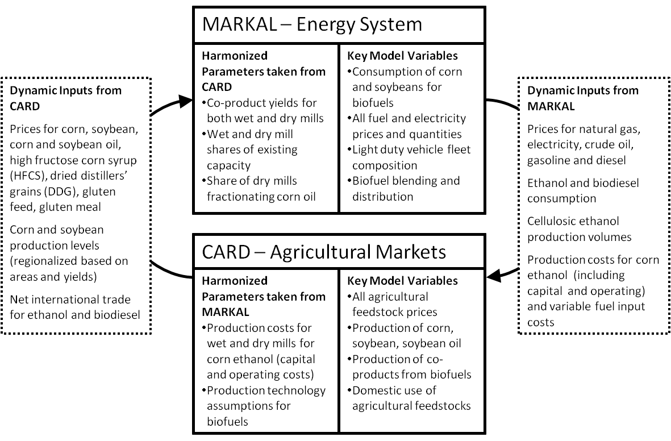
Figure 1. Integrated MARKAL-CARD Framework

The goal of this study is to analyze the impact of energy prices (crude oil and natural gas) on corn-based and cellulostic ethanol consumption levels across the United States in two-steps: (1) with an integrated model and (2) with individual models. Two scenarios are analyzed: Scenario 1 included a 25% increase in the U.S. price of crude oil, Scenario 2 included a 25% increase in both the U.S. price of crude oil and natural gas.

Results
Running the CARD and MARKAL models independently tends to overestimate the markets’ responses to shocks because there are no feedback effects, which can have significant implications on the anticipated level of biofuel production. Linking the models endogenizes the interaction between the two markets and better reflects real world market dynamics, where all markets interact with each other (Elobeid et al., 2013). To demonstrate these hypothesis, all scenarios were run separately in each model and then run using the integrated framework.
For example, in Scenario 1, where only the price of crude oil is increased by 25%, corn-based ethanol production increases by almost 37% in the CARD model only run compared to 19% in the integrated model run. The increased demand for corn used for ethanol production results in an 11% increases in corn prices, more than double the increase in the integrated model. Similarly, with the increased crude oil prices, domestic E85 consumption increases by 29% in the MARKAL model only run compared to only 26% in the integrated model. Nearly all E85 consumption in all scenarios occurs in Midwestern ethanol producing states (i.e. East North Central and West North Central Census Divisions).
In Scenario 2, the natural gas price increase (in addition to the increase in the crude oil price) actually tempered the overall impact on the agricultural sector. This is mainly due to the increase in the cost of production, particularly for corn, which increases by almost 4% in the CARD model only run compared to 2.7% in the integrated model run. The higher cost resulted in a lower increase in the demand for corn used in ethanol production relative to Scenario 1 (38.5% for Scenario 1 versus 21.8% for Scenario 2 in the CARD model run only). Similarly, the demand for corn used in ethanol production in integrated model runs increased by 18.6% and 17.9% in Scenario 1 and 2, respectively.
Moreover, the higher natural gas prices, via higher fertilizer prices increased the cellulosic ethanol production and consumption. Compared to baseline, cellulosic ethanol consumption increased almost 10% for Scenario 1 and 14% in Scenario 2 in the integrated model.

Conclusions
The results showed that the impact of crude oil prices on the biofuel production volumes is much greater than the impact of natural gas prices. This is mainly due to the fact that crude oil is a direct competitor to the biofuels in the end-use demand market, whereas natural gas is affecting the cost of supplying biofuels via the cost of corn production and biofuel refining. Modeling the energy and agricultural markets separately showed greater impacts of the price shocks, whereas the integrated model allowed the impacts on crop prices and biofuel volumes to be moderated.
Even with high crude oil prices raising the demand for ethanol, our results (Scenario 1) indicated that cellulosic ethanol has a disadvantage relative to corn ethanol. Low natural gas prices kept the cost of production for corn feedstock (via low fertilizer prices) and corn ethanol low, therefore allowing corn ethanol consumption to increase. In Scenario 2, we observed that the high natural gas prices provided impetus to increased cellulosic production.

References
Elobeid, A., Tokgoz, S., Dodder, R., Johnson, T., Kaplan, O., Kurkalova, L., Secchi, S., 2013. Integration of agricultural and energy system models for biofuel assessment. Environmental Modelling & Software 48, 1-16.
Lenox, C., Dodder, R., Gage, C., Kaplan, O., Loughlin, D., Yelverton, W., 2013. EPA U.S. Nine Region MARKAL Database, Database Documentation (EPA/600/B-13/203). Air Pollution Prevention and Control Division, National Risk Management Research Laboratory, U.S. Environmental Protection Agency (EPA), Research Triangle Park, NC.

