The Value of LNG Exports when Transportation is Costly

Atle Oglend, University of Stavanger, Department of Industrial Economics and Risk Management, NO-4036,Stavanger, Norway, +47 51832247, atle.oglend@uis.no

Petter Osmundsen, University of Stavanger, Department of Industrial Economics and Risk Management, NO-4036, Stavanger, Norway, +47 51831568, petter.osmundsens@uis.no

[Other Author’s Name, Affiliation, Phone, email]
[Format: single space, 10 point font, Times New Roman]

Overview
This paper considers the value of a policy to open up for LNG exports from the U.S., accounting for the fact that transportation is costly and time consuming. We consider the policy value for a representative marketer of LNG when prices of freight services are endogenous to gas price spreads, and considerable sunk time commitments are necessary in transportation. Technological constraints in transportation affects the magnitude and distribution of the economic rents flowing from relaxing trade restrictions on LNG. When freight capacity is limited in the short run, movements in relative gas prices leads to price adjustment in transportation services. Some economic rent will flow to service providers, which do not necessarily reside in the exporting economy. In addition, when time commitments are involved in transportation, as is the case for long distance LNG transportation, an option value on committing to shipments emerge. Given that commitments to shipments is irreversible, shipping comes at an opportunity cost tied to forfeiting potential future information on the state of the market “at sea”. This adds to the marketing cost of LNG. While economic theory states that relaxing trade restriction increase net economic welfare, the size and distribution of benefits will depend on the constraints involved in transportation.
We put our analysis in the context of LNG exports from the U.S. to Japan. We consider two export locations in the U.S.: the Pacific North West and the Gulf of Mexico. We proceed to analyse the value of exports to marketers under different market scenarios. We investigate the sensitivity of the policy value to the degree of market integration, the responsiveness of freight rates to prices spreads and the responsiveness of freight capacity to freight rates. Our analysis highlights that the value of LNG exports is sensitive to the state of the LNG shipping market when the policy becomes operational, as well as the time necessary to commit to transportation. In a recent report commissioned by the U.S. Department of Energy, the US was projected to gain net economic benefits from allowing LNG exports (Nera, 2012). The report however assumes no limits on LNG shipping capacity. LNG freight capacity is limited in the short run as substantial capital and time investments a necessary to fit new LNG freighters. Trade is also time consuming, requiring shipments over long distances. Our analysis shows that ignoring these elements have non-trivial effects on policy values.

Methods
We use state dependent regression methods to investigate the statistical relationship between freight rates and regional LNG prices spreads. The relationship between freight and price spreads depends on the availability of freight and degree of capacity utilization. State dependent regression methods allows us to differentiate between different states of freight sensitivity to price spreads.
Based on the transportation constraints present in LNG exports, we proceed to develop a stochastic dynamic model to value LNG exports to marketers operating under similar conditions. We use the model to analyse the policy value to gas marketers in the U.S. Our analysis focuses on the policy value of LNG exports under various plausible market conditions.

Results
Recent changes in gas markets has led to substantial regional differences in gas prices. Excess supply from shale production in the U.S. has led to fully decoupled gas and oil prices in the U.S. (Erdős, 2012; Osmundsen et al., 2016). Japan and continental Europe however still trade the majority of gas on oil indexed long term contracts (Agerton, 2014, Hartley et al. 2013). This has led to the strong regional price differences. Our regression results provide evidence that freight rates have been sensitive to these gas spreads. From around 2008/2009, freight rates and the Japan-U.S. and E.U.-U.S. price spreads follow a common stochastic trend. This coincides with a period of higher freight capacity utilization. Figure 1 show the fitted regression line between the Japan-U.S. price spread and freight rates (solid line shows the spread, dotted line the fitted regression). The region shaded grey show flat spreads and freight rates with no significant association between them. In the latter period, a common stochastic trend emerges.

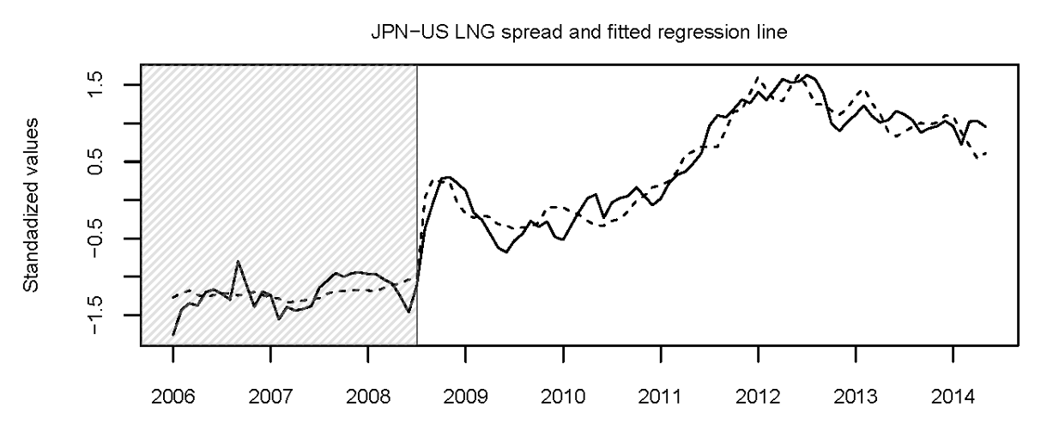
Figure 1. The relationship between spread and freight rate
Our policy value analysis shows that the value of LNG exports to marketers in the U.S. depends on the state of the market when the policy becomes operational. Higher market integration decreases the policy value if it becomes operational when LNG shipments have high capacity utilitization (high rates), but increases the value if shipments come at a low rate. This is because higher market integration reduces the persistence of arbitrage opportunities, but increases the degree of recovery in the spread when shipments come at a low rate. Stronger adjustments in marketing costs to prices spreads have the same qualitative effect as increasing the degree of market integration for marketers. Since the marketer can sit and wait out unfavourable market conditions, but commit when conditions are favourable, the unconditional policy value increases when market integration decreases or marketing costs responds weaker to prices spreads. Longer shipping time reduces the policy value both by increasing the direct marketing cost, but also by increasing the opportunity cost in committing to shipments, the option value. This opportunity cost can be substantial, under plausible market scenarios it could reach as high as 50 percent of the equilibrium direct transportation cost.

Conclusions
We present empirical evidence that LNG freight rates have been sensitive to regional gas prices spreads in recent years. Based on this we develop a stochastic dynamic model to determine the value to LNG marketers in the U.S. of opening for LNG exports to Japan. Our analysis shows that the policy value is highly sensitive to the state of the market when the policy becomes operational. Long shipping time reduces the policy value both in increasing the direct marketing cost but also in increasing the opportunity cost in committing to shipments. Due to this, tankers operating from the Pacific North West are substantially more valuable than those operating from the Gulf of Mexico in terms of shipments to Japan.

References
Nera. 2012. "Macroeconomic Impacts of LNG Exports from the United States."
Erdős, Péter. "Have oil and gas prices got separated?." Energy Policy 49 (2012): 707-718.

Oglend, A., Lindback, M, and P. Osmundsen (2016), “Shale Gas Boom Affecting the Relationship Between LPG and Oil Prices”, Energy Journal, forthcoming, Vol 37, No. 1, 211-232.

Agerton, M. 2014. "Global LNG Pricing Terms and Revisions: An Empirical Analysis."
Hartley, P.R., P.R. Hartley, G. Mitchell, C. Mitchell, and J.A. Baker. 2013. “The Future of Long-Term LNG Contracts”. University of Western Australia, Business School, Economics

