WELFARE IMPACTS OF SINGLE-PROVIDER RESIDENTIAL-ELECTRICITY-SERVICE PRICE DISCRIMINATION - Part 2 with conjectural changes in building stock floorspace

Daniel M. Hamblin, Dan Hamblin & Associates, Inc., 1-260-452-9064, danmhamblin@gmail.com

Overview

The Calgary 2010 paper examined how residential electricity service providers known for price discrimination through declining block rates could additionally discriminate by offering flat-rate service contracts to some customers and by offering bundled services and technologies optimally paired with different base- and peak-load generation sources. Here, we use a significantly revised methodology (depicted below) to look at a shopping list of Energy Star technologies expanded by 5, situated in a housing stock which may be larger or smaller by amounts motivated by changes in household size or wealth. With the 5 additional Energy Star technologies, we expanded the possible price/portfolio options comprising a rehab from 5 to 7. We drive the housing stock size predictions by income elasticities that differ by purpose. Included are helical fluorescent bulbs and two sizes of photovoltaic panels, plus a “renewables in supply” conjecture/prediction of how welfare results are affected if our customer segment is formed from households willing to pay 3 additional cents/kWh for 21.7% of kWh purchased from renewable suppliers (low power cost regime) or 5 additional cents/kWh for 1/3rd of kWh purchased from renewable suppliers (high power cost regime). Estimated parameters enter Version 4.0 of a Nash game, Shadowprice.com Autopilot, where their influence grows or diminishes as market power dictates. The paper defines fifty eight heuristic scenarios used to perform welfare estimation of consumer and producer surplus caused by the single provider's discriminatory behaviors, with scenarios designed to examine changing demographics of suburb and central city.

As in Calgary 2010, we include the Paul Joskow-inspired acid test for the value of electricity technology/service bundles as how well they compete against no-frills direct access to wholesale power, and use Massachusetts Electric default service as our model for awarding it to all new customers for the year of simulation and to existing customers who switch.

Methods

The methods used estimate market potential for new technologies within the context of ESP market power. (See figure.,)
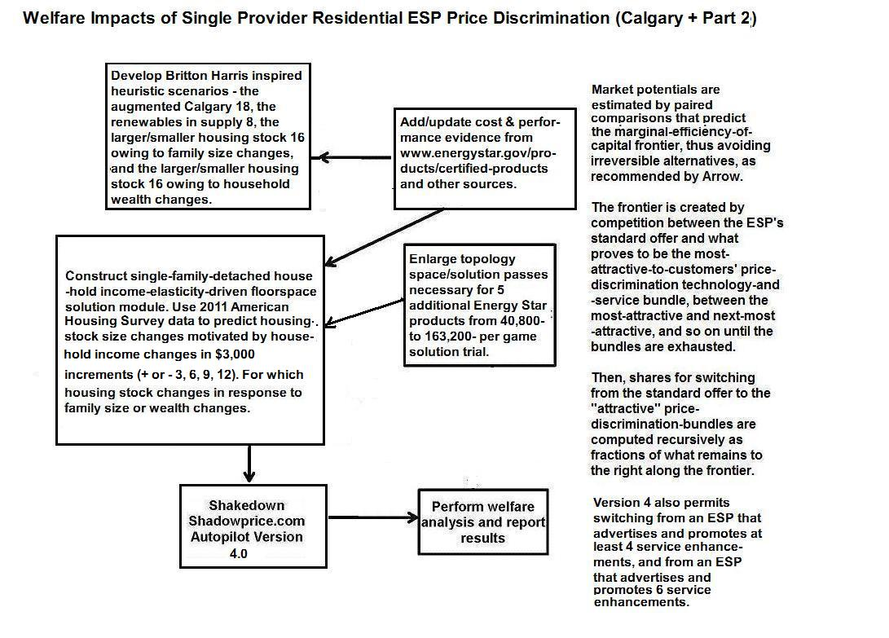

Results

New technologies promise shared energy savings and costs to customers and the utility.
Portfolio selection in Version 4.0 replaces previous versions' Cash-incentive to switch with an HVAC
System upgrade using Energy Star data for central air conditioning. The five additional Energy Star technologies are dehumidifier, dishwasher, water heating appliance, insulation upgrade, and glazing upgrade with controllable window blinds. The utility offers promotional incentives to encourage customer purchase of the new appliances. Additional energy-saving incentive is bundled in "Energy Conservation Assistance" as part of the ESP's Standard Offer. Pareto efficiency does not exclude negative profitability as a game solution for a particular Nash Coalition partner; nor does it exclude negative producer surplus for the market in the last forecast period.

Are household markets as rational as commercial markets?
Multivariate regression analysis failed to show a significant relationship between “household” implicit discount rate and space conditioning capacity need, as was found in the Chicago retrofit commercial buildings market. We therefore changed our focus from numerical quadrature and joint-log-normal integration of a new choice algorithm (as was proposed for Calgary 2010), to development and implementation of the conjectural building stock size shifts differing by purpose and household income. We also updated the installed costs of rooftop photovoltaic collectors to reflect the reduced cost of solar between 2010 and 2015 with the introduction and penetration of cells manufactured in China.

Conclusions
Per customer producer surplus equals market economic profit – equal in Shadowprice.com to total profit less normal profit from the Hayek price per kWh, divided by the number of customers (not including households receiving the Paul Joskow-inspired Basic Electricity Service). The Table’s small average negative charge “added” to the December customer bill is a testament to how well we believe the DOE Energy Star technologies are suited to the differing-sized housing stock we conjured out of whole cloth for this analysis.

Consumer surplus is measured per (20,100 customer service-class) household in the Shadowprice.com game of maximum price discrimination specific to (high or low) price regime.

Along the heuristic-scenario-simulation path, the paper additionally found that Basic Electricity Service could attract a large share of the market in particular competitive settings – above 50% six times and with average-market-share-maximums of 14.21% under a high base load price regime and 33.97% under a low base load price regime.

References

Hamblin, D.M., 2010. “Welfare Impacts of Single-Provider Residential-Electricity-Service Price Discrimination,” 29th USAEE/IAEE North American Conference: Calgary, Alberta.
Asimakopulos, A. 1978. An Introduction to Economic Theory: Microeconomics: 2.15 Income and cross elacity of demand. Toronto, Oxford University Press.
Joskow, P.L. 2001. Why do we need electricity retailers? or Can you get it cheaper wholesale? Unpublished Massachusetts Institute of Technology Department of Economics Discussion Paper.
Massachusetts Electric Co. 2002. Default Service Pricing. www.masselectric.com/res/default/index.htm.
Cost/performance evidence from the U.S. Department of Energy certified products web links page http://www.energystar.gov/products/certified-products , the HHS/HUD/DOE Energy Efficient Rehab Advisor; and from other sources.
Arrow, K.J., 1967. “Values and Collective Decision Making,” in Philosophy and Economic Theory, Frank Hahn and Martin Hollis eds., New York: Oxford University Press, 1979.
Hamblin, D.M., Op. Cit., Fig. 1, p. 6.
Hamblin, D.M., G.D. Pine, R. Maddigan, J.M. MacDonald, H.A. McClain, and J.Y. Rimpo, 1990. “Commercial Sector Gas Cooling Technology Frontier and Market Share Analysis,” Energy Supply/Demand Balances: Options and Costs: International Association for Energy Economics.
Year-to-year PV panel cost reductions extrapolated from David Feldman et al., 2014, Photovoltaic System Pricing Trends: Historical, Recent, and Near-Term Projections. NREL/PR-6A20-62558, http://www.nrel.gov/docs/fy14osti/62558.pdf.

