VEHICLE TAX DESIGN AND CAR PURCHASE CHOICES: A CASE STUDY OF IRELAND
Ivan Petrov, University College Dublin, 00353861277056, ivan.petrov@ucdconnect.ie
Lisa Ryan, University College Dublin, 0035317168212, lisa.ryan@ucd.ie

Overview
On the 1st of July 2008, the motor taxation regime in the Republic of Ireland underwent a complete overhaul. Both Vehicle Registration Tax (VRT) and Annual Motor Tax (AMT) switched from being engine capacity based, to being based on carbon dioxide (CO2) emissions ratings per kilometre. The goal behind this action was to reduce CO2 emissions from passenger car use by aligning the emissions externality with the vehicle taxation system, thereby making it more expensive to purchase and operate a highly emitting vehicle. Following the initial change in 2008, a number of subsequent policy changes were implemented to further facilitate the adoption of low-emitting vehicles. A summary of these vehicle policy changes and their respective introduction dates are presented in Table 1.
Table 1. Policy Implementation for Emissions-Based Vehicle Taxation
Policy Phase | Effective Date | Summary Change
Initial Policy Implementation | 1 July 2008 | Transitioned from engine capacity to CO₂ emissions taxation basis; introduced initial A-G emissions ratings for VRT and AMT
Interim Policy Change A | 1 January 2009 | Slight increases (4-5%) in Annual Motor Tax (AMT) amounts; no change to Vehicle Registration Tax (VRT)
Scrappage Scheme | 1 January 2010 to 30 June 2011 | VRT relief of up to €1,500 when trading in a vehicle older than 10 years, provided the new vehicle purchased is A or B rated.
Interim Policy Change B | 1 January 2012 | Substantial increases (up to 54%) in AMT amounts; no change to VRT
Final Policy Change | 1 January 2013 | Introduction of graduated A and B ratings (A0, A1, A2, A3, A4, B1, B2); and small changes in VRT rates.

In this study, we attempt to quantify and disentangle the effect of each of these policy changes on car purchase decisions in the Republic of Ireland, relative to the counterfactual of no change.

Methods
Quantifying the effectiveness of such policy changes presents a number of challenges. Although on average, the emissions ratings of newly registered vehicles in Ireland have declined in recent years this may be due to vehicle suppliers offering less emitting vehicles, rather than a change in consumer purchasing behaviour which results from the policy change(s). Using a difference in differences quasi-experimental design, we attempt recreate the missing counterfactual of vehicle purchasing patterns in Ireland in the absence of the policy change(s) using the trend in UK
passenger car emissions as a counterfactual.

The UK provides a useful counterfactual for a number of reasons. First, prior to the tax regime change in Ireland in 2008, the average CO₂ emissions rating for newly registered passenger cars in Ireland and the United Kingdom appear to be on a very similar trajectory (as shown in Figure 1). This relationship meets the parallel trends assumption which is central to the application of difference-in-difference analysis applied here. Second, there were no substantial changes to the UK motor taxation system over the period from March 2001 to April 2017. Since March 2001, the annual motoring tax, Vehicle Excise Duty (VED), in the United Kingdom has been calculated based on CO₂ emissions ratings. Third, both Ireland and the UK are EU member states, and are therefore subject to the same EU-level regulations over our period of study. Finally, the United Kingdom and Ireland share similar road infrastructure and driving rules. Both jurisdictions operate under Left-hand Traffic (LHT) rules, and nearly all vehicles registered in both countries are Right-hand Drive (RHD). These characteristics, coupled with the close proximity of the two markets, suggest a similar product offering by car manufacturers in both jurisdictions.

In addition, in our regression specification we control for a number of state specific characteristics which vary over time and which may influence car purchase choices, such as household income and fuel prices. We carry out the analysis with rated emissions as our dependent variable, and then repeat the procedure using fuel type as our outcome variable, taking advantage of data on the complete population of passenger car registrations in both jurisdictions, which amounts to approximately 50 million observations in total.

Results
Figure 1: Average CO2 ratings Figure 2: Diesel Share
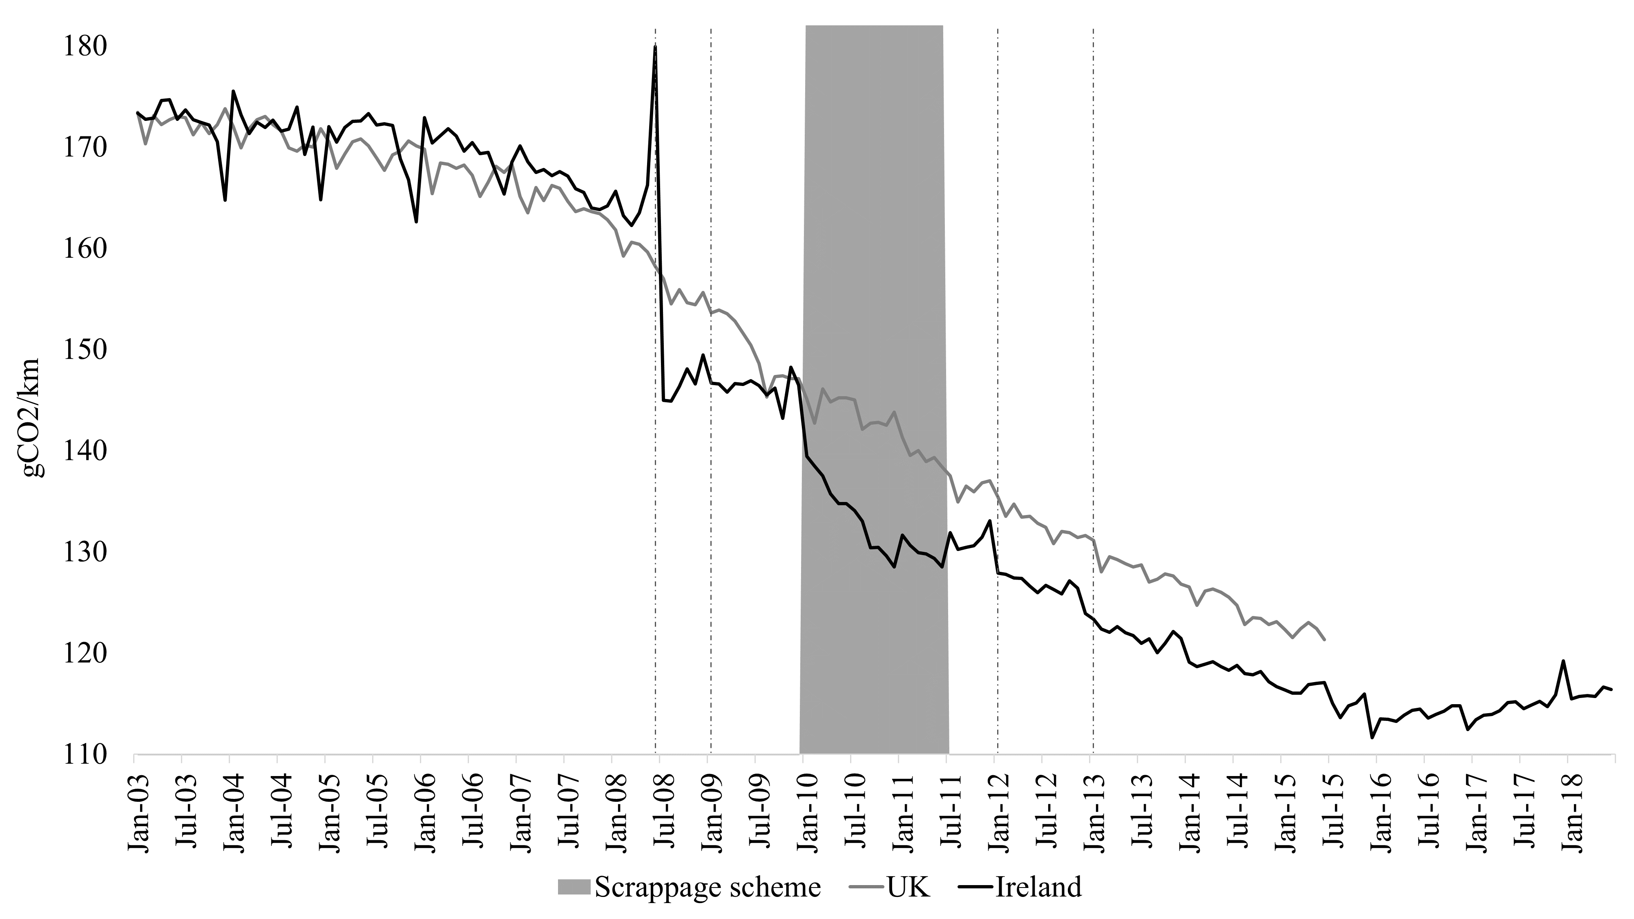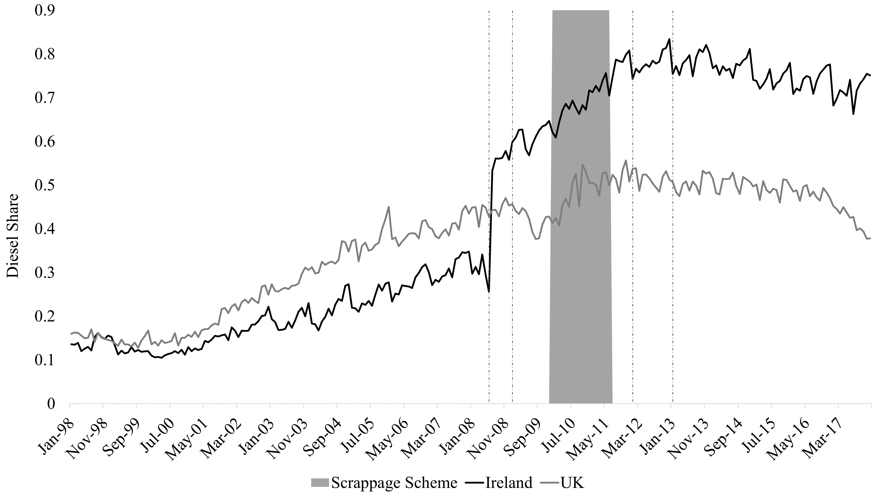
In the above, the vertical dashed lines represent the timing of introduction of the different demand-side policies (as per Table 1), while the grey box represents the duration of the scrappage scheme. We see a significant and immediate impact of the initial policy change on rated emissions and sustained outperformance of rated emissions in Ireland in comparison to the UK following the last policy change. The results from our difference-in-differences specification (Table 2) suggest that the initial policy change in 2008 is responsible for reducing rated emissions of newly registered passenger cars in Ireland by roughly between 8 to 11 gCO2/km. Some subsequent policy changes (such as the introduction of a scrappage scheme) have also had an effect at stimulating the purchase of less emitting vehicles.

Table 2: Results – CO2 Ratings Table 3: Results - Diesel Share
 | (1) | (2) | (3) | (4)
Initial policy change (2008) | 0.3538 *** | 0.2204 *** | 0.1807 *** | 0.1865 ***
 | (0.0073) | (0.0139) | (0.0152) | (0.0157)
Interim policy change A (2009) |  | 0.1063 *** | 0.0816 *** | 0.0826 ***
 |  | (0.0154) | (0.0157) | (0.0157)
Scrappage scheme |  | -0.0138 | -0.021 * | -0.0225 **
 |  | (0.0109) | (0.0109) | (0.0109)
Interim policy change B (2012) |  | 0.0515 *** | 0.0391 *** | 0.0428 ***
 |  | (0.0122) | (0.0117) | (0.0119)
Final Policy Change (2013) |  | 0.0045 | -0.0119 | -0.0051
 |  | (0.0103) | (0.0101) | (0.0112)
Country-specific controls | No | No | Yes | Yes
Country-specific trend | No | No | No | Yes
*** Statistically significant at p<0.01
** Statistically significant at p<0.05
* Statistically significant at p<0.1
 | (1) | (2) | (3) | (4)
Initial policy change (2008) | -8.4341 *** | -10.2867 *** | -9.1726 *** | -11.0948 ***
 | (0.5305) | (1.2322) | (1.5756) | (1.7125)
Interim policy change A (2009) |  | 4.4843 *** | 4.6711 *** | 4.1186 ***
 |  | (1.3622) | (1.5178) | (1.5029)
Scrappage scheme |  | -5.8059 *** | -6.5564 *** | -6.2573 ***
 |  | (0.9632) | (1.0403) | (1.0262)
Interim policy change B (2012) |  | -2.0461 * | -2.4954 ** | -3.3853 ***
 |  | (1.0769) | (1.1108) | (1.1415)
Final Policy Change (2013) |  | -0.1239 | 0.1249 | -0.9659
 |  | (0.987) | (1.0086) | (1.0741)
Country-specific controls | No | No | Yes | Yes
Country-specific trend | No | No | No | Yes
*** Statistically significant at p<0.01
** Statistically significant at p<0.05
* Statistically significant at p<0.1

Next, we apply the same analysis using vehicle fuel type as our dependent variable (presented in Figure 2). The findings suggest a strong and sustained move from petrol-powered vehicles to diesel-powered vehicles as a result of the initial policy change. We estimate the size of this shift to be between 18-35% depending on our specification (Table 3). As before, the initial policy change appears to be the main driver in influencing consumer vehicle purchasing preferences, however, some subsequent policy changes (in particular Interim Policy Change A) also appear to have had a significant effect.

Conclusions
The findings suggest that the initial policy change in 2008 is responsible for reducing rated emissions of newly registered passenger cars in Ireland, relative to the counterfactual of no change. Some subsequent policy changes (such as the introduction of a scrappage scheme) have also had an effect at stimulating the purchase of less emitting vehicles. When looking at the effect of the policy on passenger car fleet composition however, we find that this decrease in rated emissions is driven by a significant shift towards diesel-powered vehicles, which may substitute CO₂ emissions for other types of pollutants such as NOx.

