ENERGY-INTENSIVE ADAPTATION TO PARTICULATE MATTER POLLUTION
: THE CASE OF ELECTRICITY CONSUMPTION BY KOREAN HOUSEHOLDS

Euikon Jeong, KAIST College of Business, +82 10 2994 1084, euikon.jeong@business.kaist.ac.kr
Jaewoong Lee, KAIST College of Business, +82 10 3422 8606, jwlee86@business.kaist.ac.kr
Jiyong Eom, KAIST College of Business, +82 10 8612 1606, eomjiyong@business.kaist.ac.kr

Overview
As with climate change, the health risks caused by particulate matter (PM) pollution have risen to serious levels in many developing economies, and the efforts to mitigate and adapt to air pollution are increasing (Harlan and Ruddell, 2011). The need for a rapid response to air pollution-related disasters has become apparent in recent years. While many countries have focused on reducing emission as a major countermeasure against PM pollution, various adaptive efforts by the citizens are being made in response to its residual impact. For example, the Ministry of Environment proposes a long-term outdoor activity restraint, a mask wearing in the occasion of going out, thorough hand hygiene, sufficient water intake, food washing and closing of the window to block the inflow of PM as a lifestyle on a day of high PM concentration. Our research proposes a new holistic perspective on the residential environmental adaptation under the impacts of air pollutant emissions and climate change due to long-lived greenhouse gas emissions. In particular, it explores the presence of a potential vicious cycle, in which adaptation to PM pollution causes even larger greenhouse gas emissions by inducing increased electricity consumption.
We have conducted an empirical analysis using real-time smart meter data of electricity consumption at the household level to investigate the households’ adaptation behaviour to the impact of PM pollution, establishing the relationship between PM concentration and electricity consumption by the individual Korean households. Under the conjecture that the households would adapt to the impact of PM pollution, for example, by refraining from outdoor activities or closing the windows to block the inflow of pollutants, we hypothesize that higher level of PM will lead to increased domestic electricity use.
Although previous literature points to the sensitivity of residential energy demand to climate change (Amato el al., 2005), no empirical studies are available on the energy-related adaptation behaviour to PM pollution. Given that PM pollution has become one of the most prominent public concerns, an integrated understanding of its impact is highly needed and timely for the development of efficient air pollution control measures. An in-depth investigation of the factors that drive the adaptation behaviour will also be provided.

Methods
We used 15-minute interval electricity usage panel data from 1,505 individual Korean households; households with smart meters from Encored Technologies Inc. We filtered out those who have data for less than 240 days, leaving 283 households. The longest household panel ranges from May 1st 2016 to December 31st 2016, including both weekdays and weekends, but the other panels are unbalanced with either starting or ending in the middle. Next, after transforming the data into the hour level, we combined hourly temperature, humidity, and PM data measured by Korea Meteorological Administration (KMA) and the Ministry of Environment. To control unobservable factors affecting the electricity demand, we added month, weekday, and hour dummy variables.
To test the main hypothesis, a panel regression model with household fixed effect is estimated. The demand for electricity of household $i$ at time-hour $t∈\left[1,5880\right]$ follows the linear reduced-form equation ($t=1$ represents 00:00~00:59 am of May 1st 2016, and $t=5880$ corresponds to 11:00~11:59 pm of Dec. 31st 2016):

$$y_{it}=β_{0}+β_{1}{PM}_{it}+β_{2}T_{it}+β_{3}H_{it}+\sum_{m∈[May,Nov]}{γ_{m}d_{m}}+\sum_{w∈[Mon,Sat]}{γ_{w}d_{w}}+\sum_{h∈[1,23]}{γ_{h}d_{h}}+μ_{i}+ϵ_{it}$$
$y_{it}$: electricity usage of household $i$ at time-hour $t$,
${PM}_{it}$: the level of PM at time-hour $t$ in the region where household $i$ is located,
$T_{it}$: temperature (in Celsius) at time-hour $t$ in the region where household $i$ is located,
$H_{it}$: humidity (in percent) at time-hour $t$ in the region where household $i$ is located,
$d_{m}$, $d_{w}$, $d_{h}$: month ($m$), weekday ($w$) and hour ($h$) dummy variables
(with ‘December’, ‘Sunday’, and ‘00:00~00:59 am’ (or ‘0’) as base levels, respectively),
$μ_{i}$: fixed effect term for household $i$.

* Acknowledgement: We would like to give special thanks to Encored Technologies Inc. for providing the real-time electricity usage data. This research has been supported by the Korean Ministry of Science, ICT, and Future Planning through the Graduate School of Green Growth at KAIST College of Business in 2016 and through Climate Change Correspondence Program with the grant number of 2004001300002.

Results
Table 1. (a) PM & electricity usage for average Seoul residents in July 2016 and (b) parameter estimates
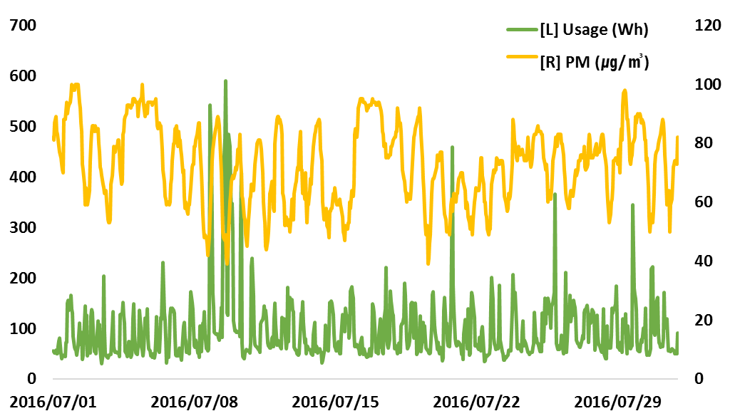 | Variables Estimate  PM 65.52***  Temperature 802.67***  Humidity 41.18***  Month (controlled)  Weekday (controlled)  Hour (controlled)  Adj. R-squared 0.1428  #Households 283  #Data 1,226,860
(a) | (b)

Three major results emerge from our analysis (Table 1). First, the level of PM is indeed a statistically significant predictor of residential electricity consumption, supporting our research hypothesis: 1μg/m³ increase in PM leads to about 66Wh increase in electricity usage. Second, both temperature and humidity remain as important contributors to electricity consumption, which suggests that an increased demand for air conditioning and dehumidification as fulfilled by household appliances are what increases electricity consumption. Third, dummy variables well represent the demand pattern of Korean households: they use electricity most (i) on August, followed by December, (ii) on Sundays, followed by Saturdays, and (iii) in the evening from 6pm to 11pm. Overall, the fitted model differs significantly from the mean model, and has 0.1428 for both R-squared and adjusted R-squared, showing that most of explanatory variables are not redundant. Also, the LM test shows that estimation results using random effect model are not statistically different from those using fixed effect model.

Summary & Future Research
The PM concentration has been shown to increase the electricity usage of Korean households as with temperature and humidity. This can be explained as an adaptation behaviour to minimize the impact of PM pollution. The analysis conducted thus far is only the initial step, and active research is underway utilizing the smart meter data. In particular, various considerations will be given in the future analysis to identify the household behaviour in response to PM pollution. The behavioural considerations of our interest are as follows: (i) Season effect: When heating and cooling become more important, PM concentration will have more significant contribution on the electricity consumption, that is, vulnerability rises as the sensitivity to the impact increases; (ii) Timing effect: Impact will be more significant at the time when people are likely to be at home or weekends because vulnerability rises as the exposure to the impact increases; (iii) Duration effect: Time-varying behaviour will be observed during prolonged period of high PM concentration (e.g., over-adaptation and desensitization after fatigue); and (iv) Alternative effect: Number of shelters near residence or adaptation options will affect the consumption behaviour.

References
Jan C. Semenza, Daniel J. Wilson, Jeremy Parra, Brian D. Bontempo, Melissa Hart, David J. Sailor and Linda A. George (2008) Public perception and behavior change in relationship to hot weather and air pollution, Environmental Research 107 (2008) 401-411
Udo Ebert and Heinz Welsch (2012) Adaptation and mitigation in global pollution problems: Economic impacts of productivity, sensitivity, and adaptive capacity, Environment Resource Economics (2012) 52:49-64
Kavousian, R. Rajagopal and M. Fischer (2013) Determinants of residential electricity consumption: Using smart meter data to examine the Effect of Climate, building characteristics, appliance stock, and occupants’ behavior, Energy 55 (2013) 184-194
Sharon L Harlan and Darren M Ruddell (2011) Climate change and health in cities: Impact of heat and air pollution and potential co-benefits from mitigation and adaptation, Current Opinion in Environmental Sustainability 2011, 3:126-134
Anthony D. Amato, Matthias Ruth, Paul Kirshen and James Horwitz (2005) Regional energy demand response to climate change: Methodology and application to the commonwealth of Massachusetts, Climatic Change (2005) 71: 175-201

