Scenarios for a Low-Carbon European Electricity Sector

Clemens Gerbaulet, TU Berlin and DIW Berlin, cfg@wip.tu-berlin.de
Claudia Kemfert, DIW Berlin, ckemfert@diw.de
Casimir Lorenz, TU Berlin and DIW Berlin, cl@wip.tu-berlin.de
Pao-Yu Oei, TU Berlin and DIW Berlin, pyo@wip.tu-berlin.de

Overview
This paper compares different approaches to decarbonize the electricity sector in Europe using a specific model developed by the authors called dynELMOD. We find that, renewables carry the major burden of decarbonization. Scenario analysis suggests that only in the case of a breakthrough of CCTS some biomass-CCTS plants might play a role by 2050 through their negative CO₂-emissions. Incorporating the climate targets makes the investment into any additional fossil capacity uneconomic from 2025 onwards, resulting in a coal and natural gas phase-out in the 2040s. The model is run using different foresight assumptions. Limited foresight thus results in stranded investments of fossil capacities in the 2020s. Using a CO₂ budgetary approach, on the other hand, leads to an even sharper emission reduction in the early periods before 2030, reducing overall costs. The initial approach, sketched out by the European Union’s “Reference Scenario” (EC, 2011, 2013, 2016) relies on a triad of fossil fuels (with carbon capture, transport, and storage – CCTS), nuclear energy, and renewables. The paper tests this hypothesis by providing a discussion of recent cost trends, and by modeling different pathways for the low-carbon transformation, using a specific model developed by the authors called “dynELMOD (Gerbaulet et al., 2017).

Methods
This paper presents different scenarios for the decarbonization of the European electricity sector in 2050 relying on a detailed model of electricity generation, transmission, and consumption, called dynELMOD. We develop multiple generation capacity scenarios in Europe using a detailed representation of generation as well as multiple storage technologies and demand flexibility options in an electricity sector model for Europe. Furthermore, we take into account the total level of electricity demand, which depends on many influencing factors. We build upon the electricity sector model dynELMOD that models the expansion of generation capacity, as well as grid expansion, need for all European countries in steps of five to ten years starting in 2015 until 2050. Given a set of boundary conditions such as yearly CO₂ emission budgets, technological parameters and technical availability and cost assumptions the model determines the cost-minimal generation portfolio, cross-border transmission expansion as well as the underlying generation and storage dispatch with an hourly resolution.

We calculate the development of the European electricity system with scenarios along two axes: On axis one we vary the model foresight, whereas the second axis presents different boundary conditions such as electricity demand and the decarbonization target.
Axis One: Foresight and CO₂-Paths
- Default Scenario: The default scenario assumes perfect foresight over the entire horizon (2050). The central decision maker is facing a yearly CO₂ constraint, which reduces CO₂ emissions by 2050 to only 2% of the current level.
- Reduced Foresight: By contrast, a reduced foresight scenario considers that the decisions makers are only aware of the CO₂ target of the upcoming five-year period, and thus behave “myopically.” The interest of this scenario is to identify the danger of stranded investments resulting from such a short-term vision
- Emission Budget: This is an alternative scenario to reflect a different CO₂ allocation mechanism implemented in the budget approach: decision makers receive an aggregate emission budget covering the entire period up to 2050 and then can use this budget at their own discretion over the period. The budget approach has become popular among climate policymakers and academic researchers recently because it allows decision makers a higher degree of decision; in general, abatement decisions are taken earlier to “save” emission rights for the final years where abatement is expected to become very expensive.

Axis Two: Boundary conditions
- “Demand shift”: With increased “smartness” of the system and digitalization of the generation-demand interface, flexible demand, or even temporary demand reduction (without compensation) may play an important role in the future. Thus we design a scenario “demand shift” in which 15% of the peak load can be shifted at no cost. At the same time, the electricity demand increases linearly due to intensified sector coupling to 1.5 times the 2015 demand.
- 20%: We also envision a less stringent CO₂ emission reduction path, called “20%”, which implies a reduction of CO₂ emissions of 80% to 2050, and to set off this reduction process linearly starting in 2020.

Results
Our results show, that regardless of the scenario neither new nuclear power plants nor large-scale CCTS infrastructure is built by the model. Only Biomass CCTS emerges in small quantities in the 2040ies. The largest share of the abatement is carried by renewable sources, wind (onshore and offshore) and solar photovoltaics. In the “competition” between the renewables, wind clearly dominates, obtaining a share of over 60%; in 2050 to accommodate the fluctuation of the intermittent renewables, a total of 300 GW of storage capacities are built, mainly towards the latter half of the period. New pumped storage capacities are negligible, so the battery storage obtains almost all investments. Demand side management (DSM), although fully implemented in the model, only plays a marginal role.
Comparing the Default scenario and reduced foresight scenario, preliminary results show that the Default scenario has better overall planning than with reduced foresight. Large quantities of “stranded” investments would occur with reduced foresight, e.g. in Germany (10 GW of natural gas) and Switzerland (4 GW of natural gas). The grid investments and generation costs are slightly higher in the default scenario, but overall cost reduction is still achieved.
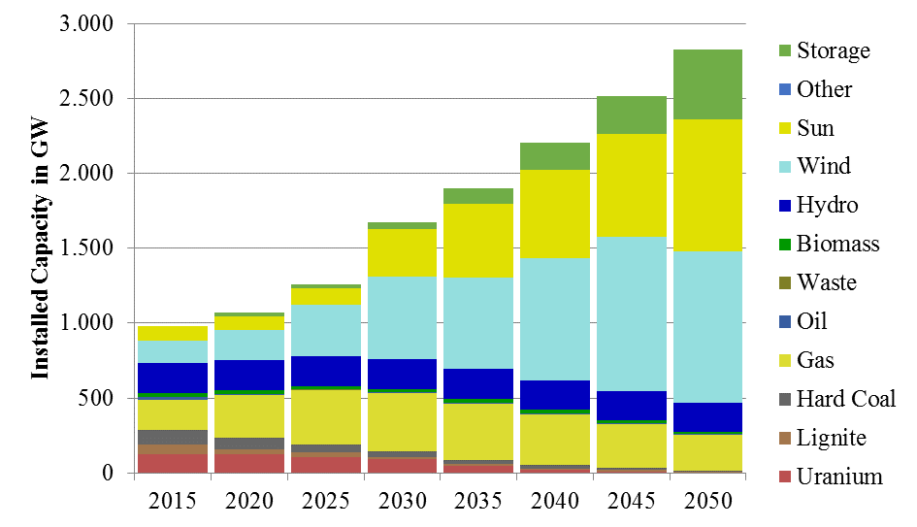
The budgetary approach shows the lowest overall system cost. Here, earlier decarbonization than in the other scenarios until 2030 can be seen, then “plateauing” of emissions with further reduction directly before 2050. One interpretation of this result is that the new degrees of freedom invite the decision maker to use “low hanging fruits” of abatement earlier, mainly by reducing coal electrification. This strategy allows some emissions, primarily from natural gas plants, towards the end of the period under consideration.
Figure 1: Installed capacity in Europe in the standard scenario
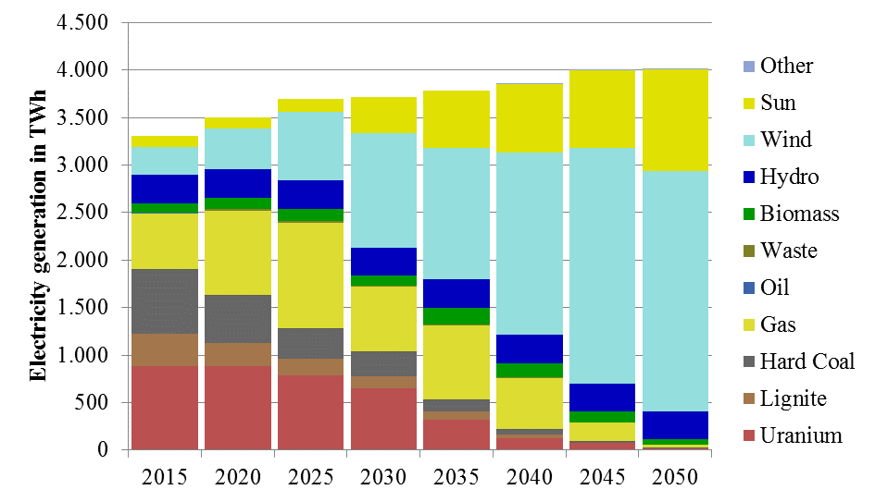
The demand shift scenario leads to significantly more investments in generation capacities and storage until, 2050 but remains tractable; varying the CO₂ emission path shows that under the cost assumptions given, renewables still play the major role in the future electricity system, as they are cost-competitive in the future.
Figure 2: Electricity generation in Europe in the standard scenario

Conclusion
We find that in a default reference scenario, renewables carry the major burden of decarbonization, while nuclear and carbon capture technologies appear to be too expensive. Incorporating the climate targets makes the investment into any additional conventional capacity uneconomic from 2025 onwards, resulting in a coal and phase-out in the 2040s. Limited foresight is resulting in stranded investments of fossil capacities in the 2020s. Using a CO₂ budgetary approach, on the other hand, leads to an even sharper emission reduction in the early periods before 2030, reducing overall costs.

References
EC (2011). A Roadmap for moving to a competitive low-carbon economy in 2050.
EC (2013). EU Energy, Transport and GHG Emissions Trends to 2050: Reference Scenario 2013. Brussels, Belgium.
EC (2016). EU Reference Scenario 2016: Energy, transport and GHG emissions – Trends to 2050. Brussels, Belgium.
Gerbaulet, C., C. Lorenz (2017) dynELMOD: A Dynamic Investment and Dispatch Model for the Future European Electricity Market. DIW Berlin Data Documentation (in print). Berlin, Germany.

