On INTEGRATING LARGE SHARES OF RENEWABLES INTO THE ELECTRICITY SYSTEM

Reinhard HAAS, Hans AUER
Energy Economics Group, Vienna University of Technology, 1040 Wien, E-mail: Haas@eeg.tuwien.ac.at

Overview
The European Commission has set ambitious targets for increasing the share of electricity from renewable energy sources (RES-E). In recent years especially electricity generation from variable sources like wind and solar has increased remarkably. Mainly in Germany, electricity generation from renewables has been growing at a remarkable rate. Between 1990 and 2012 in the EU-28 “new” renewables excluding hydro grew from less than 1% to about 12%, mainly from wind. In addition, the EU has set further ambitious targets of a share of 27% (compared to about 14% in 2012) energy from renewable energy sources (RES) by 2030. This target is for all uses, heat, electricity and transport. Consequently, also RES-E will grow further continuously, despite it is not clear to which absolute level, Fig.1. Yet, variable RES-E do not provide electricity simultanuously with demand. It is important to note, that almost all other generation technologies do not either.
The core objective of this paper is to provide insights on the conditions to integrate this higher quantities of RES-E into the electricity system and how straightforward a sustainable electricity systemcould work. Our analysis is mainly based on Western European countries using data from Germy and Austrai but in principle the findings of this analysis cam also be transformed to every other country.
Method

Our method of approach is based on the following cornerstones:

On an hourly base over a year for load profiles, RES-E generation and flexibility measures are modeled identifying residual load (residual load (= difference between final electricity demand and generation provided by non-flexible electricity generation from variable RES as well as coal and nuclear power plants) in every hour. Based on this residual load on the electricity market side we use a fundamental approach where the intersection of supply and demand at every point-of-time gives the corresponding electricity market price including scarcity respectively excess pricing in the extreme situations.

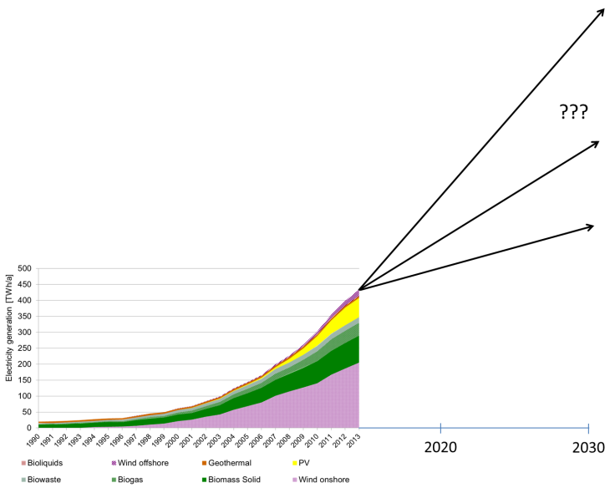 | 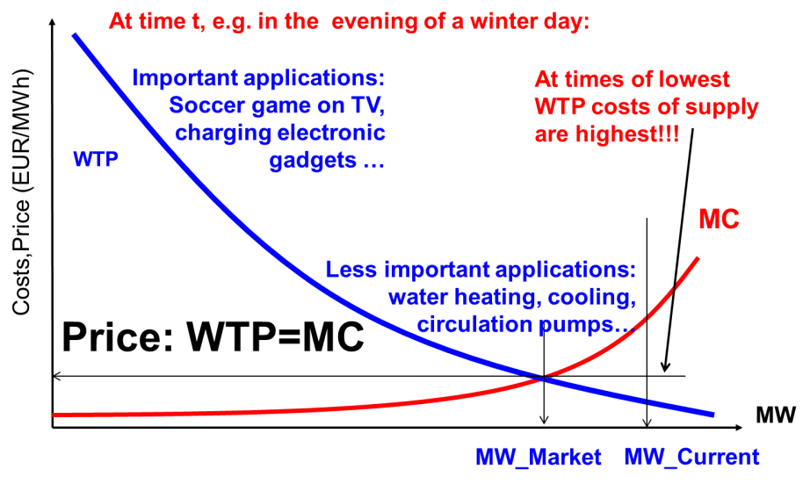
Figure 1. Past development and future scenarios for electricity from RES-E | Figure 2. A market-based approach to supply security

Results

A key pre-condition for integrating larger shares of RES-E is a market-based approach which would take into account customers WTP and where on the demand-side the equilibrium between demand and supply would come about at lower capacities, see Fig. 2. Note, that where WTP is lowest the MC of providing capacity are highest. A market approach will consider also other options on the supply- and demand-side as there are::
- DSM (technical): Measures conducted by utilities like cycling, control of demand, e.g. of cooling systems)
- Demand response due to price signals: Response of mainly large customers to price changes
- Transmission grid extention: if the grid is extended there is in principle always more capacity available in the system and the volatility of RES a well as demand evens out;
- Smart grids: They allow variations in frequency (upwards and downwards regulation) and switch of voltage levels and contribute in this context to a load balancing
- Storages: short-term and long-term storages – batteries, hydro storages, or chemical storages like hydrogen or methane – can help to balance significant volatilities of RES generation.

Currently there is no incentive to harvest these flexibility options because of very low price spreads, see Fig. 3. An important aspect in this context is how the price spreads will develop. These price spreads will depend on the development of the duration curve of residual load. In Fig. 4 the development of residual load in Austria 2013 and in a scenario up to 2030 with a much higher share of intermittent renewables is described. The major finding of Fig. 4 is that the duration curve of the residual load profile will become steeper and that the number of hours with excess generation will become higher. This effect will lead straightforward to higher price spreads and will also increase the attractiveness of storages and other flexibility options.

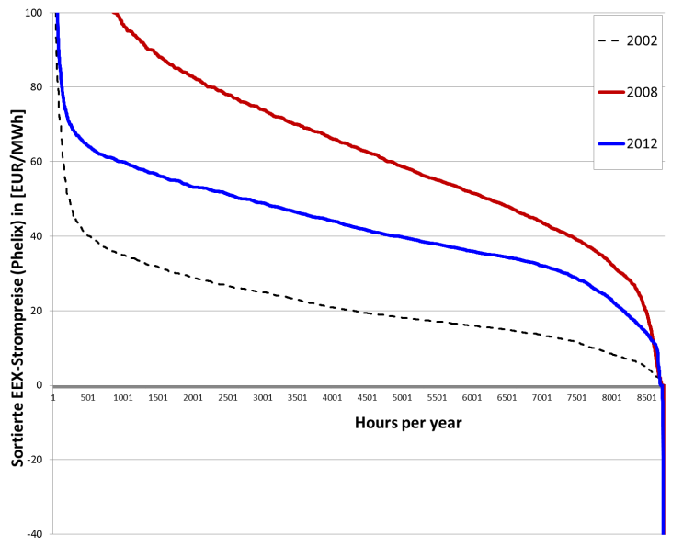 | 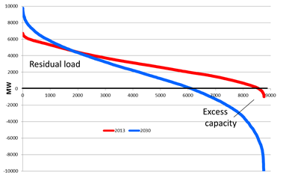
Figure 3. Distribution of electricity prices over several years in Western European markets | Figure 4. Development of residual load in Austria 2013 and in a scenario up to 2030 with high share of variable renewables

Conclusions
The major conclusions are: Most important for integrating larger shares of RES-E into the energy system is to ensure that flexibility options have a fair chance in the electricity markets based on correct price signals from the market coordinator. This applies also to transfers to the heat and transport sector. Yet, these flexibility options will only then be harvested when sufficiently high price signals from the electricity markets trigger these options, when “the exploration principle in the markets work” (Erdmann, 2012). Yet this will only be done if the market is not distorted by e.g. centralized capacity payments.

References
Erdmann, G.: Das Entdeckungsverfahren des Marktes nutzen. In: Energie & Management, 15.8.2012, S. 6.

