REal-time versus day-ahead market power in a hydro-based electricity MARKET

Thomas Tangerås, Research Institute of Industrial Economics, +4686654526, thomas.tangeras@ifn.se
Johannes Mauritzen, Norwegian School of Economics, +4755959269 , johannes.mauritzen@nhh.no

Overview
Hydro power stands for more than half of the annual electricity production in more than one third of the countries in the world (Førsund, 2007). A problem with evaluating market performance in electricity markets that rely heavily on hydro power is that hydro marginal costs are unobservable to outside observers. In a hydro power plant, the decision problem facing management is how much of the plant's reservoir to release today and how much to save for future production. The trade-off depends on management's expectations about the future value of the resource. The marginal production cost in a hydro power plant consists mainly of this opportunity cost of water, the water value.
We show in a theoretical model that the evolution of real-time prices in a hydro power market can be traced down to (i) differences in the exercise of market power across time; (ii) reservoir and production constraints that restrict resource extraction; (iii) uncertainty and risk aversion; (iv) unexpected price shocks. To isolate the effects of market power, one would therefore have to control for the technological constraints and the effects of risk aversion on output and prices.
Liberalized wholesale electricity markets in reality consist of a collection of submarkets. Typically, generation companies can sell production up front at a day-ahead market, or they can take contractual positions in a forward market. But they can also reserve capacity to the delivery date and sell their production closer to real-time at various balancing markets. A theoretical contribution of this paper is to recognize that firms' multi-market presence can be used to control for unobservable covariates when evaluating market performance.
We apply the theoretical results to evaluate market performance at the Nordic power exchange, Nord Pool Spot (NPS). The Nordic countries rely heavily on hydro power for electricity supply. Half of the installed generation capacity is hydro power, predominantly located in Norway and Sweden. Remaining generation capacity is for the most part Finnish and Swedish nuclear power and other thermal power.

Methods
We consider the following theoretical model of an electricity market: In any period t, the manager in every firm maximizes expected utility by deciding how much to bid into the real-time market this period, how much to sell in the day-ahead market for delivery the subsequent period t+1 and how much of the firm’s profit to extract this period. With this timing, the day-ahead price for delivery the subsequent period, f _{t+1}, and the real-time price the current period, p_{t}, are determined simultaneously in equilibrium.
The bulk of Nordic electricity production is sold on the NPS’ day-ahead market, Elspot. Market participants submit simultaneous bids for physical delivery every hour of day t+1 at noon of day t. NPS clears the market by means of a uniform price for each hour and price area. We treat Elspot for the Swedish price areas as our day-ahead market. Firms can rebalance their positions on a subsequent intraday market, Elbas, which opens after the day-ahead market has closed and remains open until delivery. Elbas is then our real-time market. Trading on Elbas is continuous. In our regressions, we include only trades completed between 8 and 12 in the morning to make the information set of Elbas trades comparable to the information set upon which the day-ahead prices are based. Individual trade data from Elbas are then matched to the hourly Elspot prices. This procedure yields approximately 22,000 pairs of Elbas and Elspot prices in the sample period January 1, 2010 to December 31, 2013.

Results
We first compare equilibrium prices for products that are delivered simultaneously: the real-time (Elbas) price at t and the day-ahead (Elspot) price for delivery at t (determined at t-1). Production and reservoir constraints do not matter for goods delivered at the same time, so all systematic price differences between the Elbas price, p_{t}, and the Elspot price, f_{t}, must be due to risk aversion or market power.
The below figure plots the price difference between Elbas and Elspot (in Euro per MWh) for electricity in each of the four different price areas in Sweden, ranked by Heating Degree Days (HDD). Higher HDDs are associated with colder weather and higher consumption. The dots represent raw data, the black line is a best-fit polynomial, whereas the grey lines represent uncertainty in the form of draws from the posterior distribution as calculated by a bootstrap.
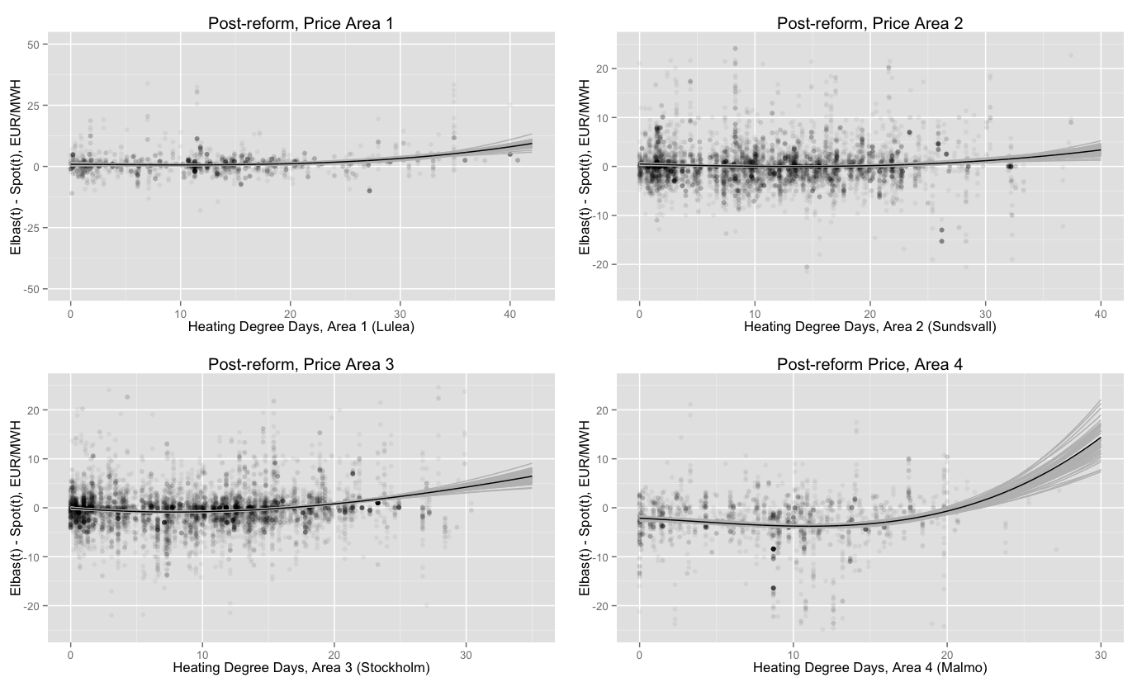
Fitted price differences are close to zero price in areas 1-3, except for high values of HDD where they turn positive and significant. Elbas prices are more volatile in colder weather, so the price pattern could be explained by risk averse producers demanding increasing risk premia for postponing sales to the next day. The price difference is significantly negative for low values of HDD in price area 4. This could be explained by risk averse consumers demanding a risk premium for postponing purchases to the next day. One would then expect the price difference to become even more negative for high values of HDD because of increased price volatility. Instead, the price difference switches sign and becomes significantly positive. This price pattern is consistent with perfect competition only if risk averse buyers dominate for low HDD values whereas risk averse sellers dominate for high HDD values in price area 4, but not in any of the other markets.
It seems unlikely that risk aversion could explain all systematic price differences in the above figure, but it cannot be ruled out. To control for risk aversion, we estimate price differences for products that are sold simultaneously, i.e. the Elspot price for delivery at t+1 and the Elbas price at t. Trades completed simultaneously have the same information sets, so the effects of risk aversion cancel out in the price differences. All systematic price differences between the Elbas price, p_{t}, and the Elspot price, f_{t+1}, must then be due to technology constraints or market power.
The below figure plots the observed price differences against daily differences in production. The solid black line is a best-fit polynomial of the sample observations when day-ahead (Elspot) prices were the same in all four price areas. In price areas 1-3, the Elspot price tends to be higher than the current real-time (Elbas) price when production increases from one day to the next, whereas the opposite is true when production decreases. This pattern is consistent with price differences picking up expected changes in demand between days.
The dotted black line is a best-fit polynomial of the price observations for the subsample of observations when there were price differences between the four price areas, i.e. when the Swedish transmission network was congested. Transmission bottlenecks increase local market concentration and makes it easier to exercise market power. In price-areas 1-3, the day-ahead (Elspot) price now was higher than the real-time (Elbas) price in situations when production fell between the two days. This pattern appears to be inconsistent with perfect competition, but is consistent with exercise of market power in the congested day-ahead (Elspot) market.
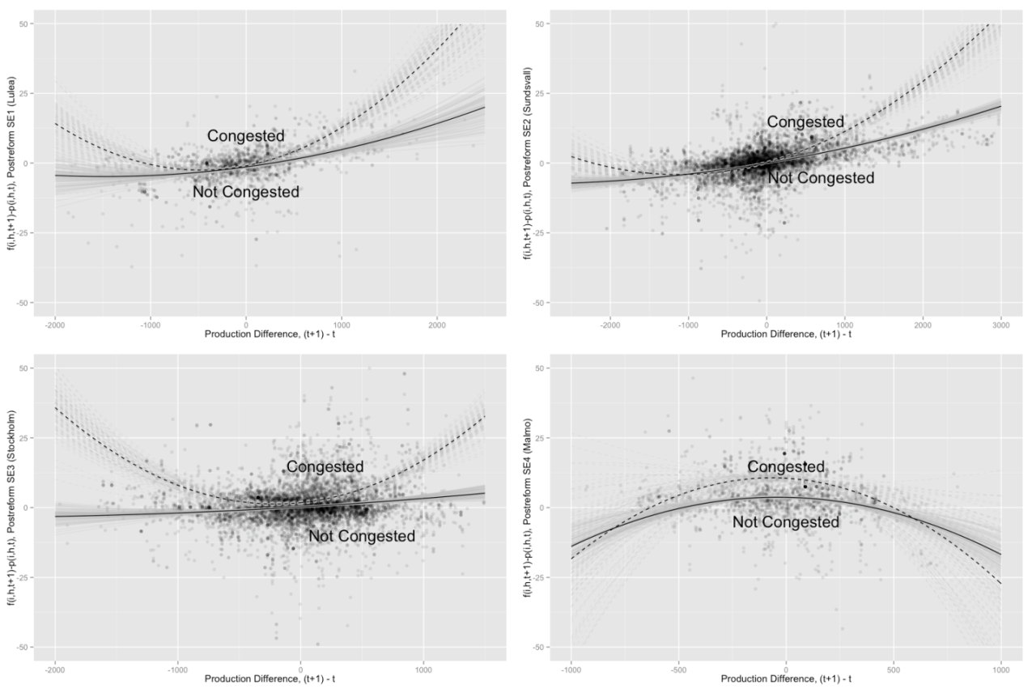

Conclusions
We have analyzed the link between day-ahead and real-time market performance in a hydro-based wholesale electricity market. The results have been applied to evaluate the Nordic power exchange, Nord Pool Spot (NPS). We reject the null hypothesis that NPS was characterized by perfect competition throughout the period of investigation.
An advantage of our approach is the mild informational requirements of the methodology. It only relies on equilibrium prices and production. Individual bid data are not necessary (as in Wolak, 2003; McRae and Wolak, 2009), nor is it necessary to estimate demand and marginal cost functions (as in Kim and Knittel 2006; Bask et al., 2011; Graf and Wozabal, 2013).
A simple methodology necessarily contains some drawbacks. It is only a diagnostic test of whether the market can be considered competitive. Also, we run the risk of underestimating market power because price relations consistent with perfect competition are also consistent with the exercise of market power. Hence, the methods proposed in this paper are by no means perfect substitutes for elaborate simulation models (e.g. Bushnell, 2003; Kauppi and Liski, 2008; Philpott et al., 2010) or estimation methods built upon detailed bid data. Rather, we see the methodology as a first and relatively simple step in the analysis of the performance of hydro-based electricity markets.

References
Bask, M., J. Lundgren and N. Rudholm (2011): Market power in the expanding Nordic power market. Applied Economics 43, 1035-1043.
Bushnell, J. (2003): A mixed complementarity problem of hydrothermal electricity competition in the western United States. Operations Research 51, 80-93.
Førsund, Finn R. (2007): Hydro Power Economics. New York, NY: Springer.
Graf, G. and D. Wozabal (2013): Measuring competitiveness of the EPEX spotmarket for electricity. Energy Policy 62, 948-958.
Kauppi, O. and M. Liski (2008): An empirical model of imperfect dynamic competition and application to hydroelectricity storage. HECER Discussion Paper 232.
Kim, D.-W. and C. Knittel (2006): Biases in static oligopoly models? Evidence from the California electricity market. Journal of Industrial Economics 54, 451-470.
McRae, S.D. and F.A. Wolak (2009): How do firms exercise unilateral market power? Evidence from a bid-based wholesale electricity market. Manuscript, Stanford University.
Philpott, A., Z. Guan, J. Khazaei and G. Zakeri (2010): Production inefficiency of electricity markets with hydro generation. Utilities Policy 18, 174-185.
Wolak, F.A. (2003): Measuring unilateral market power in electricity wholesale markets: The California market, 1998-2000. American Economic Review Papers and Proceedings 93, 425-430.

