Modelling the Australian Domestic Gas Market: A Mixed Complementarity approach to with Oligopolistic Behaviour
Dr Liam Wagner, Energy Economics and Management Group,
School of Economics The University of Queensland
l.wagner@uq.edu.au

Overview

Australia is in a key geographic and strategic position to supply a sizable proportion of the regions LNG demand, and potentially be the world’s largest supplier. The impending entry of the Eastern States of Australia as exporters of LNG will also bring previously quite cheap domestic gas up to parity with international prices. Current trends in the development of the natural gas industry, particularly in Western Australia, have shown that the internationalisation of prices can have a significant impact on electricity prices (Simshauser and Wild 2009), carbon emissions (Ball, Ehmann et al. 2011; Foster, Froome et al. 2013; Wagner, Molyneaux et al. 2014) and the availability of gas for industrial users.

A number of competing interests are also apparent, particularly between state governments who are likely to receive a significant boast in resource rents and the availability of cheap supply for domestic consumption. While the demand for natural gas in Australia pales in comparison to its export potential (BREE 2013), there a numerous concerns surround the effects on industrial and electricity generators.

This paper will address the following: Firstly that domestic reservation in the eastern states may only trigger further production issues later in the development of coal seam gas; Secondly that Australia’s position, while geographically closer to Asia, has high production costs relative to US shale; Thirdly that Australia’s gas exports from the east coast will likely have only temporally impact users with exceedingly high prices. This paper will outline the model “Ateshgah” purpose built for Australia’s natural gas markets via the implementation of a Mixed Complementarity Problem (MCP) to examine agent based behaviour.

Methods
This paper applies the Mixed Complementarity based framework “Ateshgah: an Australian Domestic Gas Model”, which was developed in GAMS, to examine the Eastern Australian natural gas market. This model examines multi-producer oligopolistic agent behaviour via Nash-Cournet equilibrium (Harker 1986) in a MCP formulation (Egging, Gabriel et al. 2008). More specifically the deterministic model examines the production trends, system adequacy and capacity, nodal spot prices, over a multi-period time scale (2015-2034). The network infrastructure consists of 67 nodes and 130 arcs (see Figure 1), are also represented as a spatial equilibrium problem to ensure proper market clearing. The model will also provide the Short Run Marginal Cost (SRMC), of production for each nodal producer agent, while also providing locational prices following market clearing.

Figure 1: Eastern Gas Pipeline Network
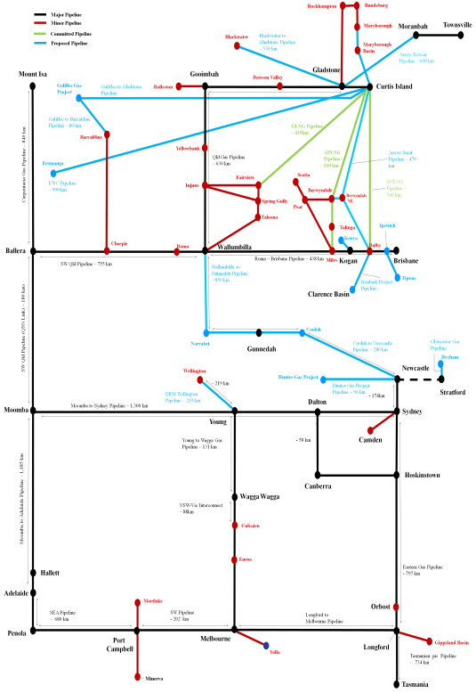
The model is parameterized using data from (AEMO 2012; AEMO 2013; BREE 2013; CoreEnergy 2013; DoM 2013); with: production reserves for ~130 production
areas; pipeline capacity and tariffs; demand projections. While many pipelines are still under construction, we have estimated the tariff costs based on a standard discounted cash flow model based on data obtained on the technical specifications at construction. The gas flow constraints are derived historical data and construction estimates. Furthermore the use of compression and reverse flow along each pipeline arc in the network (subject to technical capability) are also considered. Estimates of coal seam gas production have been established using well head data for new and existing fields to parameterize a Weibull distribution, which in turn is applied to provide the likely production capability. Production prices are determined by a parameterized Golombeck marginal cost curve (Golombek, Gjelsvik et al. 1995), for each nodal producer agent. Supply contracts have been included for not only LNG exporters but also electricity generators, town gas and large industrial users, particularly given the impact of high prices.

Following parameterization, the model will examine the effects of this new exportable commodity and its effects via the following sensitivities:

- World availability of LNG and their effects on Japanese Cif prices
- Domestic reservation policies which may impact on availability
- Production uncertainty due to moratoriums on coal seam gas development.
- Demand from electricity generation and the consequences of price parity.

Results

The initial results of this modelling suggest that the impact of natural gas exports could have marked consequences on electricity generation and its ability to exploit cheap natural gas. As reported earlier in (Wagner, Molyneaux et al. 2014), the shift to gas which is being driven by the quest for lower emissions could have dire consequences once export markets begin to open. Furthermore, this paper will build on earlier results and explore the tension between producers, governments and large natural gas users to skew Australia’s energy policy well away from the ideal required for a resource. This paper will also provide forecasts for Australia’s natural gas prices, both for domestic use and export to China and Japan. We also expect that the level of granularity that this model offers over others in the literature which include Australia, will also inform producers on the likely impact that Australia will have of global LNG markets.

Conclusions

The implementation of a MCP framework to assess the possible production, pipeline adequacy and price of natural gas in Australia offers much over the standard marginal cost dispatch models used by many in making more informed policy decisions. Further, this paper will provide both an analytic and simulation framework to show that domestic reservation, price concerns and availability due to moratoriums on production will have little impact on Australia’s energy security.

References
AEMO (2012). Gas Statement of Opportunities. Melbourne, Australian Energy Market Operator.
AEMO (2013). Gas Statement of Oppurtunities, Australian Energy Market Operator, Melbourne.
Ball, B., B. Ehmann, et al. (2011). Delivering a competitive Australian Power System Part 1: Australia's global position. Brisbane, University of Queensland.
BREE (2013). Resources and energy statistics Annual. Canberra.
CoreEnergy (2013). Gas Production Costs.
DoM (2013). Update on CSM. D. o. M. 2013, Queensland Government.
Egging, R., S. A. Gabriel, et al. (2008). "A complementarity model for the European natural gas market." Energy Policy 36(7): 2385-2414.
Foster, J., C. Froome, et al. (2013). Delivering a competitive Australian power system: Part 2: The challenges, the scenarios, University of Queensland.
Golombek, R., E. Gjelsvik, et al. (1995). "Effects of liberalizing the natural gas markets in Western Europe." The Energy Journal(1): 85-112.
Harker, P. T. (1986). "Alternative models of spatial competition." Operations Research 34(3): 410-425.
Simshauser, P. and P. Wild (2009). "THE WESTERN AUSTRALIAN POWER DILEMMA." Australian Economic Papers 48(4): 342-369.
Wagner, L., L. Molyneaux, et al. (2014). "The magnitude of the impact of a shift from coal to gas under a Carbon Price." Energy Policy(0).

