Overview

CARBON EMISSIONS IN THE WESTERN INTERCONNECT – ESTIMATING THE IMPACT OF VERs
Amy Sopinka, IESVic, University of Victoria, 250-853-3628, asopinka@uvic.ca
Lawrence Pitt, IESVic, University of Victoria, 250-853-3676, lpitt@uvic.ca

One of the distinctive features of the Western Interconnect is the prevalence of low carbon electricity production. As early as 2002, hydroelectric facilities provided 29% of the region’s total electricity generation. Strong government policies and investor-driven behaviour will result in further additions to the low carbon resource base. The impact of these policies is that low carbon capacity, predominantly the variable energy resources (VER) of wind, solar and run-of river hydro, will grow by approximately 200% between 2011 and 2020. Due to the relatively high cost of the intermittent output associated with VER technologies, along with the already significant amount of low carbon resources in the system, CO₂ abatement may cost in the range of $64 - $96/ton prior to any subsidy or tax incentive. We compare this scenario to one in which low carbon and coal volumes remain the same as in 2011 and incremental demand is met by natural gas-fired capacity. In this case, emissions reductions more modest but are achieved at a cost of approximately $8 per ton of CO₂.

Methods

We estimate the both the quantity and the cost of reducing a ton of CO₂ in the Western Interconnect given that the region is already replete with low carbon energy sources. The first step is to determine the cost of the resources that will be required to meet the nearly 115 TWh of incremental demand expected by 2020. We simplified the analysis by creating three scenarios and allowing only one category of generation to change in each case we examined. Our base case is one in which we assume that all new demand will be met by coal-fired generation and production volumes from other technologies are held constant at their 2011 levels; we denote this 2020 COAL. In the next scenario, incremental demand is met exclusively by natural gas-fired generation (2020 NAT GAS). Finally, we examine the case where coal, natural gas, hydro and nuclear volumes are held constant, and the supply gap is met by both variable energy resources and from geothermal and other renewable generation; we call this 2020 RENEW.

The range of average levelized costs per MWh associated with each of the low carbon technologies, are from the Energy Information Administration (EIA) and are net of available production or investment tax credits.With respect to the costs of the coal and natural gas fired generation, we assume that the existing underutilized fleet (either coal or natural gas, depending on the scenario) can provide the required energy at a cost equal to the heat rate in MMBtu/MWh multiplied by the fuel cost in $/MMBtu. We find that to meet the supply gap with existing coal resources would cost approximately $2,877.29 million, while using natural gas generation in place of the incremental coal would cost about $3,194.97 million. Variable energy resource and geothermal technology would be the most expensive way to meet the 2020 demand, with the cost ranging from $9,473.1 to $12,690.5 million.

Historical carbon emissions in the Western Interconnect were calculated by determining the amount of generation by fuel type and multiplying those values by emissions factors provided by the EIA We apply these emissions factors to each of the three scenarios described above.

Results
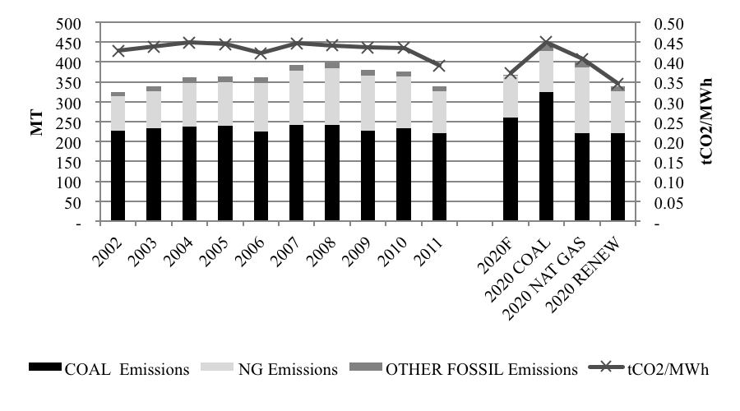
Figure 1 : Estimated Carbon Emissions from Western Interconnect generators

The historical variability in the emissions levels is in large part due to fluctuations in the amount of hydroelectric production, which in turn is the result of precipitation levels. The firm energy used to replace hydroelectric production historically has come fossil fuel-fired units. The difference between the 2020 COAL and 2020 RENEW emissions levels is the estimated impact of adding 115 TWh of low carbon generation, and is calculated to elicit a 102.7 megaton (MT) reduction. Meeting demand with natural gas rather than coal-fired generation would reduce emissions by 42.2 MT. At present this carbon mitigation figure includes the low carbon production that would have come from SONGS in California. If the nuclear output is replaced by natural gas fired facilities, then the CO₂ abatement figure will differ from the estimated 42.2 and 102.7 MT values.

Using both the cost information and the aggregated CO₂ abatement figures from above, we estimate that the abatement cost associated with mitigating 42.2 MT using natural gas generation is approximately $8/tCO₂. The addition of low carbon resources to displace coal fired generation reduces emissions by just over 102.7 MT, resulting in a per unit emissions reduction cost in the range of $64 to $96/tCO₂. Note that these lower bound cost estimates do not include any specified tax incentives such as the production and investment tax credits which are available for some technologies in some Western Interconnect jurisdictions and the addition of these subsidies will raise the cost of meeting demand using renewable resources. A recent study of the US energy system by the National Academy of Sciences found that the production tax credit (PTC) and investment tax credit (ITC) combined yielded a $4 - 5 billion dollar revenue loss per year for the U.S, while the resulting CO₂ reductions were small.

Conclusions

Electricity generation within the Western Interconnect is significantly low carbon, due to the massive amounts of storage hydroelectric facilities located in the Pacific Northwest and along the west coast of the United States. At the same time, public policies are driving additional amount of low carbon capacity into the system, at a significant cost. This new capacity is predominantly variable in nature and must be backstopped by firm energy sources. Policies that attempt to replicate the WECC choice of renewables without utility-scale storage are bound to fail, as the generation mix within the WECC is unique and cannot be replicated widely. Emissions are expected to increase in the Western Interconnect even with the vast amounts of low carbon capacity that are forecasted to come on line by 2020. We estimate that the cost of carbon abatement using low carbon resources is approximately $64 and $94 per ton, a figure that is significantly higher than the existing market price of carbon. In British Columbia the combustion of fossil fuel is taxed at $30/tCO₂ for the near future while California’s cap-and-trade system has CO₂ permits valued at about $14/tCO₂ for the 2016 vintages. Managing the incremental demand with natural gas fired generation instead would also cause emissions to rise over the 2011 values; however the cost of emissions abatement would be about $8/tCO₂. While the additional low carbon resources reduce emissions, the alternative uses for the expenditures allocated to achieving these relatively small reductions may be food for thought.

