Overview
Stochastic modeling of the feed in of wind using a second order markov chain
Thiemo Pesch, Research Center Jülich, Germany, +49 2461614764, t.pesch@fz-juelich.de
Jürgen-Friedrich Hake, Research Center Jülich, Germany, +49 2461616363, iek-ste-sekretariat@fz-juelich.de
Hans-Josef Allelein, RWTH Aachen University, Germany, +49 241 80 95440, allelein@lrst.rwth-aachen.de
The integration of rising shares of fluctuating renewables such as wind and PV is a major challenge for the future energy system. Especially high shares of wind in the generation mix lead to growing uncertainties in the system since a large part of the actual feed in can drop out in a very short period of time. Likewise, the electricity generation from wind can increase drastically within a short time. It is therefore of particular importance to address these uncertainties in energy system models. One approach to meet this task is the stoachastic modeling of the feed in from wind converters.
We will present an approach for a second order markov chain model which is suitable to generate synthetic time series for wind feed in. The model uses original ex post time series of wind as training data. After the model is conditioned, it is possibe to randomly generate time series that have the same stoachastical characteristics as authentic ex post time series for wind. It is therefore possible to analyse a multitude of different situations and scenarios regarding the feed in from wind converters. The synthetic time series can also be used as input for further approaches to address uncertainty in energy system models, e.g. scenario trees.
The presentation is organised as followed: After an introduction to markov chains the second section describes how original feed in data has to be prepared before it can be used to train the model. This is necessary because the requirement for markov chains is weak stationarity of the training data. In the case of wind, the original time series therefore needs to be deseasonalised. Afterwards, the modeling of the second order markov chain in MATLAB is described. Thereby the effect of varying the different parameters of a markov chain on the synthetic time series is shown. Subsequently, a suitable variant for the case of wind feed in time series for Germany is presented that varies from other publications. The quality of the approach is determined by comparing the original and the synthetic time series in terms of stochastical characterisitcs such as arithmetic mean, standard deviation or probability distribution.

Methodology
Second order markov chain.

Results
An exemplary extract of an original feed in time series for wind and a synthetic time series generated with the second order markov chain model is given in figure 1.
Figure 1: Original (left) and synthetic (right) wind feed in time series
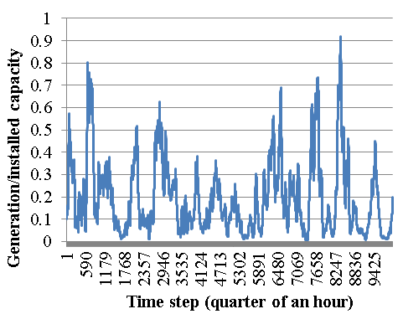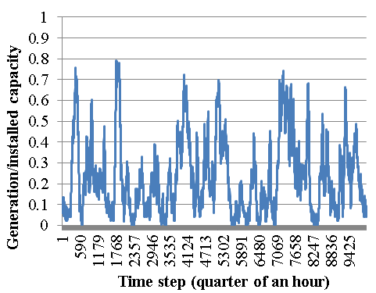
The values of the actual feed in are normalised to the installed capacities. Each time step corresponds to the quarter of an hour. A first optical analyse already shows that the characteristics of the wind feed in are well met by the synthetic time series. The model is able to simulate the typical volatility, the steepness of ramps and the range of values.
The proper range of values and occurrence of specific values over the whole synthetic time series can be verified by comparing the probability distribution functions of both time series (Figure 2). The range from 0 to 50 on the x-axis corresponds to the normalized feed in between 0% and 100% of the installed capacity. In this example it means that the continuous range of the normalised wind feed in has been discretised in 50 different states in the model.
As it can be seen, the probability density functions are almost similar for both time series. This means that specific values occur comparably often in both cases.

Figure 2: Probability density functions of original and synthetic wind feed in time series

Conclusions

The second order markov chain is a suitable stochastical approach to generate synthetic wind feed in time series. The presentation shows that the stoachstical parameters of original wind feed in time series can be reproduced very accurately. Of particular importance is the adequate justification of the markov chain model. The synthetic time series can be used for further approaches to address uncertainty in energy system models.

References
Brokish, K. & Kirtley, J. (2009):”Pitfalls of modeling wind power using Markov chains”, Power Systems Conference and Exposition, 2009. PSCE '09. IEEE/PES, 15-18 March 2009.
Chen, P (2010):”Stochastic Modeling and Analysis of Power System with Renewable Generation”, Ph.D. thesis, Department of Energy Technology, Aalborg University.
Papaefthymiou, G. & Klöckl, B. (2008):”MCMC for Wind Power Simulation”, IEEE TRANSACTIONS ON ENERGY CONVERSION, VOL. 23, NO. 1.
Shamshad, A., Bawadi, M.A., Wan Hussin, W.M.A., Majid, T.A., Sanusi, S.A.M. (2004):”First and second order Markov chain models for synthetic generation of wind speed time series”, Energy, Volume 30, Issue 5, April 2005, Pages 693-708.

