Overview
ANALYZING SUBSIDY POLICES WITH EXPERIENCE AND MARKET CURVES

Eric Williams, Golisano Institute for Sustainability, Rochester Institute of Technology, 585-475-721, exwgis@rit.edu
Seth Herron, WSP Environment & Energy, Seth.Herron@asu.edu
Schuyler Matteson, Golisano Institute for Sustainability, Rochester Institute of Technology, swm3850@rit.edu

Subsidy programs for new energy technologies are motivated by the experience curve: increased adoption of a technology leads to learning and economies of scale that lowers costs. In this research we investigate two modeling aspects of modeling that link experience curves to inform appropriate levels of technology subsidy.
The first aspect studied is the interaction of the experience curve with the willingness-to-pay in different submarkets. Heterogeneity of markets implies different consumers will pay more than others for an energy technology. Part of the heterogeneity is purely “economic”, i.e. differences in climate, energy prices and demand for the energy service provide. Part of the heterogeneity is due to differences in preferences. Initial subsidy values can be set to bridge the gap between cost and willingness-to-pay in the most favorable submarkets. Initial adoption in favorable markets can lead to cost reductions that make the technology more attractive in less favorable circumstances. A dynamic subsidy can be tuned to follow the gap between current cost and willingness-to-pay new markets, such a subsidy stimulate more diffusion with lower public investment. We develop a modeling for subsidy as a function of experience curves and market curves and implement via a case study of residential solid oxide fuel cells (SOFCs) for combined heating and power. We consider diffusion paths within U.S. states and internationally. We construct market willingness-to-pay curves and estimate future manufacturing costs via an experience curve. Combining market and cost results, we find that for rapid cost reductions (learning rate =25%), a modest public subsidy can bring make investment in an SOFC profitable for 20-160 million households. If cost reductions are slow however (learning rate =15%), residential SOFCs may not become economically competitive. Due to higher energy prices in some countries, international diffusion is more favorable than domestic, mitigating much of the uncertainty in the learning rate.
The second aspect studied is the timing or tapering of subsidy reductions. To control public spending, subsidies should be tapered down to follow reductions in manufacturing costs. Frequent reductions reduce subsidy investments but are more difficult to administer. We develop a model that characterizes the total subsidy investment needed to bring a technology to market competitiveness as a function of the frequency of tapering and implement the models for lithium ion batteries for vehicles.

Methods
Experience Curve - The experience curve is a mainstay of retrospective cost forecasting for energy technologies. Developed first to describe cost reductions in aircraft manufacturing, the experience curve is an empirically observed power law decay of some characteristic of industrial processes and cumulative experience implementing that process. In the energy domain, the experience curve takes the form:
C (P) = C₀(P/P₀)^{-α} (1)

where P is a measure of cumulative adoption of the technology (e.g., the total watt capacity of solar cells produced) C is the price per energy unit (e.g., $/W_{p} or $/kWh), C₀ and P₀ are initial cost and production values, α is a (positive) empirical constant, known as the learning coefficient. The fractional reduction in cost for every doubling of production is known as the Learning Rate (LR) and is given by
(2)

Market curves – These are developed by binning a market for a product into a number of sub-markets. For example, the U.S. markets for energy technologies vary significantly state-by-state depending on utility and fuel costs as well as climate. Willingness-to-Pay (WTP) here refers to the maximum investment a consumer will pay to meet an economic criteria for an investment, such as payback time or rate of return. Only purely “economic” factors are included, differences in preferences are not considered here. WTP is estimated for each sub-market (e.g. U.S. state) and the market curve, WTP (P), is constructed by sequencing WTP in decreasing order, with the width of each market corresponding to total market size.
Subsidy analysis - the minimum subsidy needed to bring the cost from initial value C₀ to some target C(P) is given by integrating the difference between the curves:

(3)

Results
Integrated experience curve/market curve/subsidy analysis for residential SOFC: For the analysis of residential SOFC systems, we use an economic criterion of discounted payback time of five years. The energy simulation model e-Quest is used to estimate difference in utility use between a typical home placed in different states equipped with a SOFC system and a home where all electricity comes from the grid heat is generated with a natural gas furnace and boiler. Figure 1 shows results for U.S. diffusion of SOFC for residences. For optimistic learning rate (LR =25 %), initial adoption in states such as Alaska and New York will reduce costs to make the technology economically attractive in other states. For lower learning (LR=15%), the technology never becomes economically attractive.
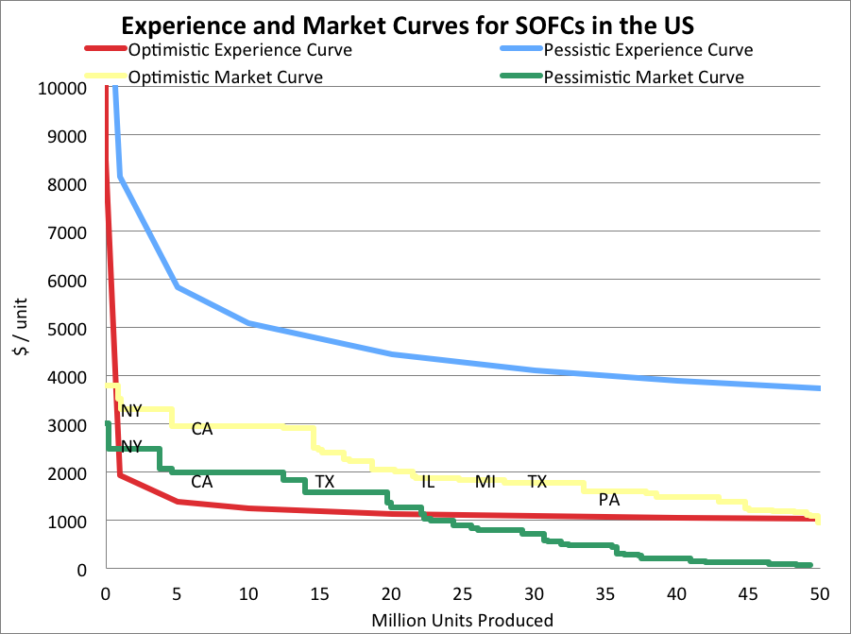
Figure 1: US market curves with experience curves. State rankings (from highest to lowest willingness-to-pay) for optimistic market curve: CT, AK, NY, CA, NJ, NH, RI, MA, ME, MD, WI, CO, VT, IL, MI, TX, DC, PA, NV, DE, NM, OH, IA, IN, MT, HI, UT, MS, MN, KS, SD, NE, VA. For pessimistic market curve: AK, NY, CT, CA, MA, TX, NH, RI, NJ, VT, NV, WI, CO, ME, MI, MN, DE, IA, NM, IL, MT, UT, WY, MS, SD, OH, OK, PA, NE, IN, KS, ND.

Tapering of Subsidies for Electric Vehicles: With learning rates from 9.5-22% and a target of reaching a $300/kWh battery cost in ten years, a subsidy tapered annually yields total costs of $2-27 billion over the life of the program, compared to $7-134 billion for a flat subsidy of $6,000 per vehicle. Figure 2 shows results for learning rate = 9.5% of the effect of changing tapering frequency of subsidies for electric vehicles on the total investment to bring lithium ion batteries from $600/kWh to $300/kWh.
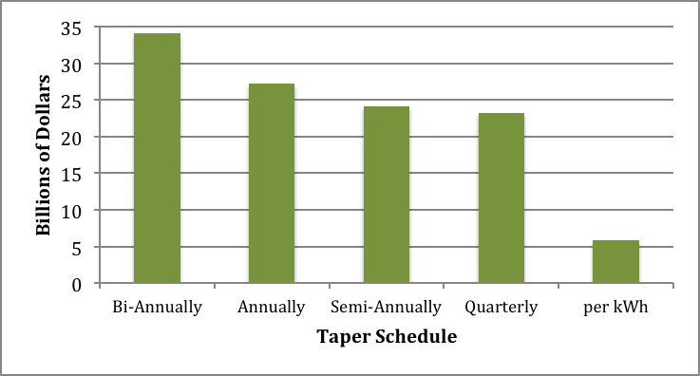
Figure 2. The effect of tapering frequency on electric vehicle subsidy program cost: learning rate = 9.5%

Conclusions
The modeling approaches presented here have broad applications in the planning of energy technology subsidy programs. There is a need to explore “in-model” uncertainty, such as better characterization of learning rates, and to consider how broader system boundary, e.g. including how increased demand might influence prices.
References
Herron and E. Williams S. (2013). Modelling cascading diffusion of new energy technologies: case study of residential solid oxide fuel cells in the U.S. and internationally", Env. Sci. Tech. 47 (15), 8097–8104 (2013)
Matteson, S. & Williams, E. (2013). Learning Dependent Subsidies for Lithium-ion Electric Vehicle Batteries, under review.

