Overview

Role of Residential and Commercial Sectors in Meeting California’s 80 Percent GHG Emissions Reduction Goal by 2050 using CA-TIMES model
Mohammadsaleh Zakerinia, Institute of Transportation Studies, University of California Davis, mzakerinia@ucdavis.edu
Sonia Yeh, Institute of Transportation Studies, University of California Davis, slyeh@ucdavis.edu
Christopher Yang, Institute of Transportation Studies, University of California Davis, ccyang@ucdavis.edu

Climate change is one of the most important issues in todays world and there is an increasing concern about it. State of California is the leading states in the United States in cutting greenhouse gas (GHG) emissions, it sets an objective of achiving 1990 emission level by 2020 and also long-term objective of emission reduction to 80% of 1990 level by 2050. Short-term policies and necessary steps to take in short term are well-defined and California is on the right track of achieving 2020 goal. Yet, it is unclear what kind of policies and technological transformation will be needed in order to get to the long-term goal. We use the CA-TIMES model, an economy-wide bottom-up, technology-rich optimization model, to study the role of commercial and residential sectors in mitigating GHG emissions by 2050. Commercial and residential sectors contribute to 30% of total energy consumption. Therefore, it is very crucial to study implication of policies in these sector to reach our long-term goal.
There are many energy models developed for California such as BEAR model, SWITCH model, IEPR, etc. However, none of them addresses cost implications of GHG mitigation in California. CA-TIMES is the first model that calculates the cost of mitigation. We defined different scenarios each having a fixed demand which is derived form economical derivers. We have an elastic demand scenario in which demands change with a change in price of service demands, this may be a more realistic case than the fixed demand. We have performed a decompositions analysis to see the role of efficiency improvement, fuel switching from fossil-based energy sources, predominantly natural gas, to low-carbon electricity, and demand reduction in different scenarios. Our results show that the cost of mitigation is much higher with having a binding emission constraint. However, if we deflate the prices to the real price by overlooking the hurdle rates, the mitigation cost will be much lower than the apparent price. We have also calculated the compliance curves which shows the carbon price will be much more expensive in the last periods.

Methods
The residential and commercial sectors are modeled based on projected energy service demands that are independent of technology and fuels.The residential sector consists of end-use demand technologies used to satisfy thirteen residential end use service demand, including space heating, space cooling, water heating, lighting, cooking, refrigeration, clothes washing, clothes drying, dish washing, freezer, TV, pool pumps, and miscellaneous (Figure 1). Likewise, commercial sector end-use demand technologies comprise cooking, lightning, water heating, refrigeration, space cooling and heating, ventilation, office equipment and miscellaneous which are used in our model to satisfy service demand (Figure 2).
Figure 1. The structure of energy demand and supply for California residential sector

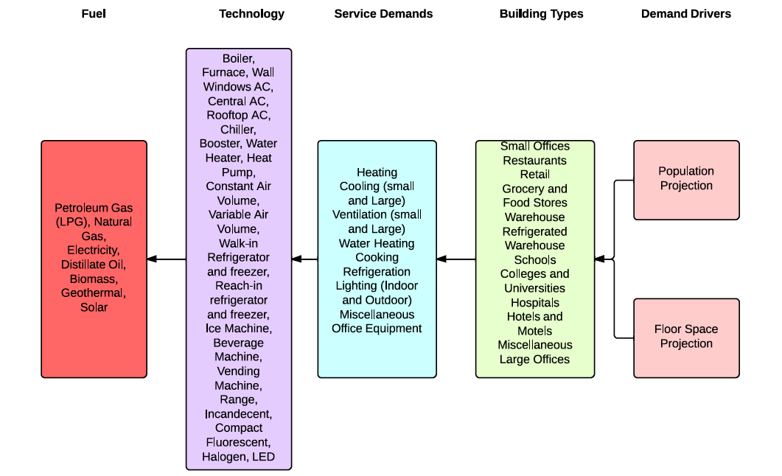
Figure 2. The structure of energy demand and supply for California Commercial sector

The model is described by the energy end-use demand by fuel type (e.g. natural gas, electricity, LPG, solar energy) and end use technologies (e.g. compact fluorescent lamps, furnace, TV) that meet these demands. The energy service demands are projected based on assumed drivers which are population, building size, building heating/cooling coefficient, appliance saturation rate, appliance utilization rate. Future technology adoption and abatement reply on economic factors (including fuel price changes), consumer choices, technology availability, and policy choices to determine total state-wide residential and commercial energy uses over the time horizon. But the final service demands are endogenously projected based on the elasticities of the demands to fuel prices each year. The model selects technologies to meet energy service demand while minimizing net system cost and satisfying other user defined constraints such as policy goals in GHG emission targets, appliance efficiency standards, etc.

Results
The residential and commercial sectors show substantial efficiency improvements and reductions in final energy demand due to the adoption of more efficient technologies as well as technologies that rely on electricity more than natural gas. In 2010, electricity accounted for 58% of commercial energy use and 40% of residential energy use. By 2050, electricity’s share of final energy is 69% in commercial and 75% in residential. Overall, energy weighted efficiency for the sectors are 2.6 and 2.4 times higher in the commercial and residential sectors. This electrification of buildings is interconnected with the increased demand for more low-carbon electricity generation.
The average mitigation costs are -$110 (plus welfare loss, to be further estimated) to $220/tonne CO₂e (or -$51 (plus welfare loss) to $73/tonne CO₂e with 4% discount rate) compared with BAU.

Conclusions
California has taken the first steps towards strong policy action to reduce GHG emissions in the near-term (i.e. 2020). However, considerable uncertainty still exists about the options, resources and technologies that will be used to meet the longer-term goals of deep reductions in GHG emission in the longer term (i.e. 2050 and beyond). These reductions by 80% or more are needed if the state and the rest of the world are to adequately address and mitigate the worst impacts from climate change. California’s policy suite has a near term focus but the frameworks are in place to extend these policies and increase stringency in order to meet the 80in50 target.
Residential and commercial sectors will increasingly rely on low carbon electricity sources under the GHG scenarios. Electricity use in 2050 makes up between 69 to 75% of sector final energy use in the GHG scenarios compared to 40-50% in the Reference scenario. Sector-wide weighted efficiency is a factor of 2.4x higher in 2050 than 2010 for the commercial sector and 2.6x higher in the residential sector.

References
McCarthy, R., Yang, C., & Ogden, J. M. (2008). California Baseline Energy Demands to 2050 for Advanced Energy Pathways.
McCollum, D, Yang, C., Yeh, S., & Ogden, J. (2012). Deep greenhouse gas reduction scenarios for California–Strategic implications from the CA-TIMES energy-economic systems model. Energy Strategy Reviews.
McCollum, David, Yang, C., Yeh, S., & Ogden, J. (2012). Deep greenhouse gas reduction scenarios for California – Strategic implications from the CA-TIMES energy-economic systems model. Energy Strategy Reviews, 1(1), 19–32. doi:10.1016/j.esr.2011.12.003

