Overview

Integrated electric system planning and dispatch: Coal retirement DECISIONS WITH gas market stability issueS

Donald A. Hanson, Argonne National Laboratory, 630-252-5061, dhanson@anl.gov
David K. Schmalzer, Argonne National Laboratory, schmalzer@anl.gov
For a period of five years after the “gas bubble” ended in the U.S., gas and electricity markets were highly volatile, prior to the shale gas extraction boom. With shale gas, it appeared that the U.S. could return to stable, low-price gas availability, and could also address greenhouse gas (GHG) reductions. In this paper we suggest that it will be difficult to have it all, and creative management solutions may be required.

One commonly advocated incentive approach is to impose a price on CO₂ emissions. Consider the effects in the electric power sector (EPS). Under “least-cost” dispatch, electric generator units will be utilized in order of their variable costs (VC). For existing pulverized coal (PC) units, the VC induced by the price on CO₂ will be proportional to the unit’s heat-rate (Btu/kWh) times the CO₂ cost in $ per MBtu (i.e., the price of CO₂ in $/tonne times an emission factor of 0.092 tonnes CO₂ per MBtu of coal). Hence, for a given PC unit with a specific heat-rate, the CO₂ price at time t will determine the VC for that unit. (We are assuming for this analysis that fluctuations in mine-mouth coal prices are relatively small compared with the carbon fee impact.)

Obviously heat-rates play an important role. Heat-rates for existing PC units are typically in the 10,000 to 12,000 Btu/kWh range. According to EIA’s Annual Energy Outlook, a typical heat-rate for a new NGCC unit is 7000 Btu/kWh. And the CO₂ emission factor for gas (0.051 tonnes CO₂ per MBtu) is only about half the value for coal. Hence the CO₂ charge component for an NGCC unit would be much smaller than for an existing PC unit. Over the next ten years, projections show a rapid build-up of new NGCC capacity.

A major insight is that these NGCC units would jump past existing PC units in the dispatch loading order up to a breakeven point where an efficient PC unit’s VC and the NGCC VC are equal. The bumped PC units would end up with low utilization rates. And the least efficient of these bumped units may permanently retire.

How much PC capacity is bumped down the loading order or retired will be a function of the price of gas (for a given CO₂ price). Because there is a lot of coal capacity within a relatively narrow range of heat rates, a small change in gas price will result on a large change in the amount of coal capacity under-utilized.

Methods
For this paper we calculated preliminary gas demand curves for the EPS based on our Electricity Supply and Investment Model (ESIM) [1, 2]. The ESIM model includes a unit inventory of existing PC units. The hourly load distribution function, adjusted for unit outages and reserve margins, is estimated in 2010, yielding the base-year equivalent load duration curve (”Eq. LDC”). The area of the Eq. LDC represents electricity demand. Some of the load is met by intermittent renewables, non-dispatchable sources, or technologies with limited dispatch capability such as hydropower. For these sources, we subtract typical hourly generation profiles from the Eq. LDC to arrive at a “dispatch curve”. Dispatchable units, based on “available” capacity, are stacked on the dispatch curve in order of least VC (which could include a CO₂ emissions charge, a credit for CO₂ capture, or a credit for selling CO₂ to EOR operations.) This process determines the capacity utilization for dispatchable units. The typical loading order is nuclear, new coal capacity, older less-efficient coal capacity, intermediate units, and peaking units. The dispatch curve drops off quickly, thereby reducing the utilization of older existing coal units. Carbon capture and storage (CCS) can be part of the solution under an incentivized CO₂ reduction regime.

Our gas supply scenario model, Alternative Outlooks for Gas Supply (ALOGS), was estimated using identification theory from a set of EIA Annual Energy Outlook sensitivity runs. This model features gas price elasticities with lags, technological progress, and cumulative production depletion effects.

Results
A family of gas demand curves given three alternative CO₂ prices ($25, $50, and $75 per tonne) is shown in the figure for the year 2025. For a given CO₂ price, the gas demand curves are very elastic. A small change in gas price leads to a large change in EPS gas demand. We see that in a regime in which the EPS faces a price on CO₂ , the delivered price of natural gas, within a fairly small range is primarily determined by the CO₂ price, and is quite sensitive to this price.

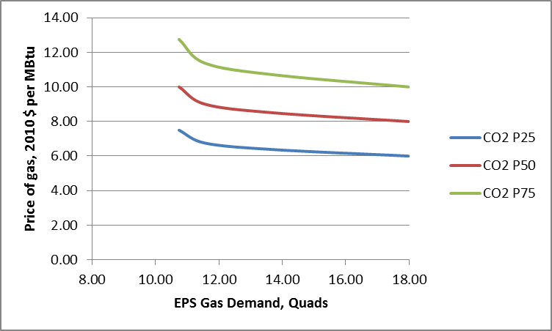

At least to some extent, gas is a CO₂ abatement option compared with coal, and gas backup is an enabler of renewables. It is well known in the environmental economics literature that the marginal abatement cost of CO₂ should be set equal to the price of CO₂. Hence, if gas is part of an abatement solution, gas price must be an increasing function of the price of CO₂, as demonstrated analytically in the figure above.

Conclusions
How should the price of CO₂ be set? It would appear from the figure above that the price of CO₂ should not be set above $25 per tonne in order to avoid a frenzy of shale gas drilling and fracturing attendant with very high gas prices that we think would arise under higher CO₂ prices. There is a great deal of public resistance to intensive shale drilling and fracking [3].

In the previous decade we saw large volatility in gas prices in order to meet changing gas demand conditions.
Now it appears that under a CO₂ tax, gas prices could be amazingly stable, but quite high. We may be in a situation where we trade off gas price volatility for large fluctuations in gas demand quantities in response to external shocks on the gas supply or demand side.

In the absence of a large CO₂ tax, other types of electricity market incentives or regulations may be needed to achieve deeper CO₂ reductions. For example, a small CO₂ tax would be a useful revenue source and could be used to finance CO₂ capture credits.

Acknowledgements
This work does not reflect the views of Argonne National Laboratory or the National Energy Technology Laboratory

References
- Hanson D.A., and Schmalzer D.K. “An Adoption Scenario for Carbon Capture in Pulverized Coal Power Plants in the USA,” Greenhouse Gases Science and Technology, 3:1-6 (2013) John Wiley and Sons.
- Hanson D.A. and D.K. Schmalzer, 2013, “Avoiding Risks to Power Sector Investments from an Unstable Carbon Market,” Proceedings of the Carbon Management Technology Conference, Alexandria VA, http://www.aiche.org/resources/proceedings
- See for example: http://www.gsuphoenix.com/fracking-in-starved-rock-1.3149174

