Market Structure and Subsidy Pass-through for Distributed Solar: Lessons from California
Changgui Dong, University of Texas at Austin, +1 512 970 0168, cgdong@utexas.edu
Varun Rai, University of Texas at Austin, +1 512 471 5057, raivarun@gmail.com
Ryan Wiser, Lawrence Berkeley National Laboratory, +1 510 486 5474, rhwiser@lbl.gov

Overview

Several federal and state programs offer upfront capital subsidies to remove adoption barriers for environmentally-friendly energy technologies like solar photovoltaics (PV). With a budget of over $2 billion and program life of a decade (2007-2016), the California Solar Initiative (CSI) is a good example of such a large-scale program. While some studies have demonstrated the effectiveness of the upfront rebates in increasing solar photovoltaics (PV) installations (Hughes and Podolefsky, 2013), little research has been conducted on how much these rebates have been passed through from installers to consumers. Similar pass-through research is prevalent in other areas, such as taxes, customs and exchange rates, but it is still very rare for PV subsidies. Some exceptions are two unpublished studies using the CSI data (Peterman, 2012; Podolefsky, 2013); however, Podolefsky (2013) only estimated the pass-through for federal Investment Tax Credit. Early work of Wiser et al. (2006) also looked at the impact of upfront PV subsidy on pre-rebate installed costs, but not specifically from a pass-through perspective.

Though the CSI program is now at its end, studying the pass-through question has important, broader implications for policy design. First, retrospectively, policy-makers may be interested to know the degree to which the $2 billion in CSI incentives flowed through to PV customers, as they were intended, versus being absorbed by installers. Second, since the federal government (through the ITC) and many state and local programs continue to offer financial incentives for PV, the CSI analysis conducted here may have implications for other programs. Third, and related, if the pass-through rate is found to be low (i.e., a large portion of the subsidy is absorbed by installers), this may signal to policy-makers that they should focus more of their efforts on lowering entry barriers and increasing competition among installers; on the other hand, a high pass-through rate may suggest a reasonably competitive, and well-functioning market for PV in which incentives increase demand for PV by directly reducing the cot of PV for purchasers.

Methods

We use both a structural modelling approach and a regression discontinuity approach to estimate the pass-through rate for the California general market. Data include all the smaller than 10 kW PV systems within the Emerging Renewables Program (ERP) and CSI program spanning from 2001 to 2012. The structural approach follows the established line of pass-through literature (Delipalla and Keen, 1992; Stern, 1987; Wolfram, 1999), and estimates a PV demand function, a supply relation, and a conduct (market power) parameter (Genesove and Mullin, 1998) simultaneously; the pass-through rate can then be calculated from the parameters obtained, with appropriate confidence intervals. The regression discontinuity (RD) approach makes use of stepwise changes in rebate (i.e. stepdown) over time that occurred at a particular day once the capacity target for each step is achieved. It is highly possible that systems right before the stepdown are similar to those systems right after it and the only major difference between these two groups is the rebate level, which is essentially the idea of RD. The RD design can be used to infer the causal effect of the rebate level change on the post-rebate PV installation price, i.e. the subsidy pass-through rate. One can then cross-validate these two methods on pass-through questions.

Results

Based on the structural approach, results show that for the 49 counties with most PV installations, the pass-through rates vary from 0.60 to 1.02 depending on the local market conditions, and 34 counties have a pass-through rate above 0.90 (Fig. 1). A pass-through rate of one indicates that, on average, all of the subsidy and changes in the subsidy amount have been passed through from installers to consumers, and suggests sufficient competition among installers in such local markets. A lower-than-one pass through rate, on the other hand, suggests weaker competition among installers. Based on our analysis, we find that the competition among installers in a local market is generally high (based on the conduct parameter) and that the average pass-through rates have been high, too, approaching one in most counties.

Results from the regression discontinuity design tend to show the same pattern, though at different geographic levels and for the CSI program only (Fig. 2). Fig. 2 shows the result for one stepdown happened within Pacific Gas and Electric (PG&E) when the rebate decreased from $2.5/W to $2.2/W. We found a pass-through rate close to 1, though statistically insignificant due to a relatively small sample size and data noises. However, when we pooled all the available stepdowns together, we still found a pass-through rate of 1, which was statistically significant. Both results from the structural modelling and the RD design reveal that changes in the CSI rebates have been fully passed through from installers to consumers.

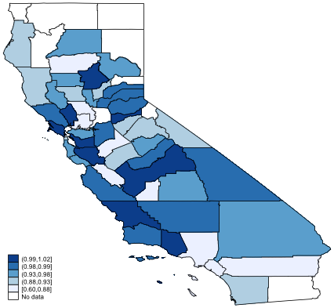
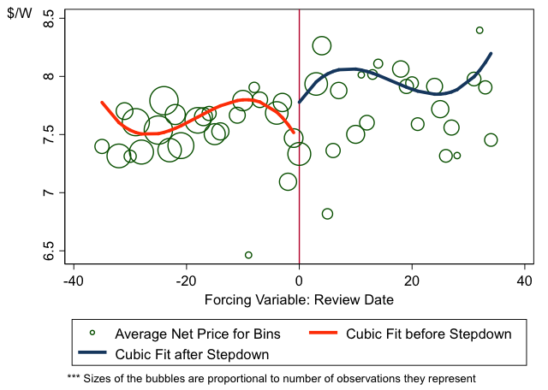
Fig. 1. Pass-through Rate Results for California Counties
Fig. 2. Results of Regression Discontinuity with a Cubic Fit of Net Price: PG&E Stepdown 2-3

Conclusions

Overall, we find nearly complete pass-through rates for the ERP and CSI rebates, though clearly with market and installer heterogeneity. This is in line with the qualitative observation that installers tend to consider the rebates as exogenous factors when they make pricing decisions, and is generally suggestive of a competitive market and a smoothly operating subsidy program. However, though it seems that there have been enough installers active in most local markets leading to high subsidy pass through, this does not mean that these installers are all equally cost efficient and competitive. Indeed, we observe a sizable difference in installed PV prices among installers, suggesting that some level of installer consolidation may occur even with a complete pass-through rate.

References
Delipalla S., Keen M., 1992. The comparison between ad valorem and specific taxation under imperfect competition. Journal of Public Economics, 49: 351-367.
Genoseve D., Mullin W.P., 1998. Testing Static Oligopoly Models: Conduct and Cost in the Sugar Industry, 1890-1914. Rand Journal of Economics 29(2): 355-377.
Hughes, J.E., Podolefsky, M., 2013. Getting Green with Solar Subsidies: Evidence from the California Solar Initiative. Available from: <http://spot.colorado.edu/~jonathug/Jonathan_E._Hughes/Main_files/PV_Subsidies.pdf> (Accessed 12.10.13).
Peterman, C.J., 2012. Subsidy Pass-through for PV Customers. Presentation at EI Camp, Berkeley, CA.
Podolefsky, M., 2013. Tax Evasion and Subsidy Pass-Through under the Solar Investment Tax Credit. Available from: < http://www.colorado.edu/economics/papers/Wps-13/wp13-05/wp13-05.pdf> (Accessed 12.10.13).
Stern N., 1987. The effects of taxation, price control and government contracts in oligopoly and monopolistic competition. Journal of Public Economics, 32: 133-158.
Wiser, R., Bolinger, M., Cappers, P., Margolis, R., 2007. Analyzing historical cost trends in California’s market for customer-sited photovoltaics. Progress in Photovoltaics: Research and Applications 15, 69–85.
Wolfram C., 1999. Measuring duopoly power in the British electricity spot market. The American Economics Review, 89(4): 805-826.

There is another discontinuity exists for a different RD design, i.e. the shared boundaries between two utilities. One can create a small buffer area around the utility boundaries and use the distance to the common boundary as the forcing variable. This RD design is a little more challenging since there are multiple discrete changes from one utility to another (i.e. retail rates and PV interconnection process). The authors are currently exploring this geographic RD design idea and solve the possible challenges.

