IMPROVED AVAILABILITY OF CLEAN NON GRID ENERGY IN NIGERIA TROUGH THE USE OF RENEWABLE ENERGY SOURCES AND EERGY EFFICIENCY PRINCIPLES
Prof Titilayo A. Kuku
Department of Electronic and Electrical Engineering,
Obafemi Awolowo University,
Ile-Ife, Nigeria
E mail: titilakuku@yahoo.com, takuku@oauife.edu.ng
tel: +2348062541929

[Lead Author’s Name, Affiliation, Phone, email]
[2nd Author’s Name, Affiliation, Phone, email]
[Other Author’s Name, Affiliation, Phone, email]
[Format: single space, 10 point font, Times New Roman]

Overview
Energy is an essential ingredient for the development and economic growth of any country. Energy access is also key to poverty alleviation and has been shown to facilitate other development indicators. Conventional energy resources are limited with every individual and in every nation. This is depleting at a very fast rate apart from the fact that it is non clean and is not environmentally friendly. Renewable energy is now an alternative preposition but still far from rapid commercialization due to high initial capital investment. Nigeria is endowed with renewable energy resources of solar, wind, biomass and hydro power among others. That Nigeria is currently facing an energy crisis is an understatement. With the current generated capacity of about 4,000MW, for a population of about 170 million, with an energy per capita of 30 Watts, the country is in a dire state regarding energy sufficiency with the attendant consequences on all developmental indicators of employment, growth, production, cost of production, security, general wellbeing e.t.c. Promotion of renewable energy and energy efficiency in Nigeria will address the challenges highlighted above. Renewable energies are cleaner sources of energy, and therefore are sustainable form of energy.

Methodology
The Energy Commission of Nigeria has worked on the required energy needs of the nation as part of the National Energy Plan. Associated with this is the Renewable Energy Master Plan (REMP), which articulates the relative contribution of Renewable Energy Resources to total energy. With determined growth rates of 7.5, 10, and 11.5 % for the GDP, the electricity demand projection for the nation is as shown in Table 1 for the short, medium and long time considerations. Also shown in Table 2 is the projected access to grid electricity by households in Nigeria. The essence of this is that a number of households would still not be connected to the grid even for the long period. There is thus the need to meet the shortfall for each period with clean, non grid renewable electricity.

Table.1 Electricity peak demand projection for Nigeria (Ref. REMP2)
Scenario | Demand (MW)
Scenario | 2010 | 2015 | 2020 | 2025 | 2030
Reference Growth (7%) | 15,730 | 28,360 | 50,820 | 77,450 | 119,200
High Growth (10%) | 15,920 | 30,210 | 58,180 | 107,220 | 192,000
Optimistic Growth (11.5%) | 16,000 | 31,240 | 70,760 | 137,370 | 250,000

Table 2. Projected Access to Grid Electricity by Household for Nigeria
(Note that electricity can be from fossil, nuclear or renewable energy source) (Ref REMP 2)
Scenario | 2010 | 2015 | 2020 | 2025 | 2030
Reference growth (7%) | 60 | 75 | 80 | 85 | 90
High growth (10%) | 72 | 86 | 93 | 94 | 95
Optimistic growth (13%) | 72 | 86 | 93 | 94 | 95

However, shown in Table 3 is the possible contribution of Renewables to the total energy provision over the short, medium and long time periods. It is expected that by 2030, Renewables would be able to generate equivalent of 23 % of total energy.
Table 3. Contribution of Renewables into the projected Electricity Demand For the High Growth Scenario
S/N. | RESOURCE | SHORT | MEDIUM | LONG
1. | Hydro (large) | 1,930 | 5,930 | 48,000
2. | Hydro (Small) | 100 | 734 | 19,000
3. | Solar PV | 5 | 120 | 500
4. | Solar Thermal | - | 1 | 5
5. | Biomass | - | 100 | 800
6. | Wind | 1 | 20 | 40
 | All Renewables | 2,036 | 6,905 | 68,345
 | All Energy Resources | 15,920 | 30,210 | 192,000
 | % of Renewables | 13% | 23% | 36%
Source: REMP 2

Results
The deployment of renewable energy devices have been taking place across Nigeria with the Federal, State and Local government and donor agencies being actively involved. Mostly deployed are solar home devices, water heating/pumping, street lightning, wind turbines for electricity generation and mini and big hydro facilities. Some of these are as shown inb Figs. 1 and 2.
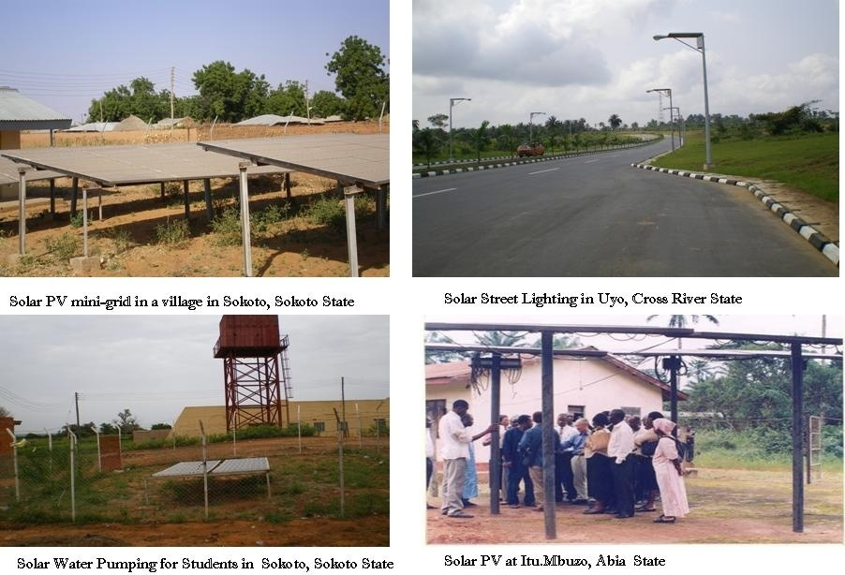
Fig. 1. Different possible photovoltaic power provisions

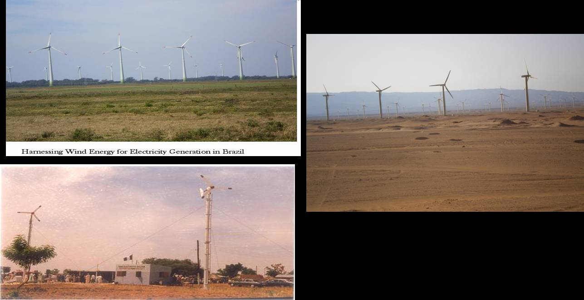
Fig.2. Wind energy deployment for wind electricity production in Northern Nigeria

Conclusions
The provision of Renewable energy sources especially for non grid connected areas and the adoption of energy saving/ energy efficiency measures and devices has had a lot of impact on the socio-economic lives of residents of such areas. More deployment to meet the statement of REMP are strongly advised for improved development of the well being of the nationals.
References
- Renewable Energy Master Plan 2nd Edition, Energy Commission of Nigeria, November 2012.

