EFFECTS OF PUMPED HYDRO STORAGE ON CONSUMERS, THERMAL GENERATORS, AND CO₂ EMISSIONS IN THE IBERIAN ELECTRICITY MARKET
Colleen Lueken, Carnegie Mellon University, chorin@andrew.cmu.edu, 240-413-4685
Pedro Carvalho, Instituto Superior Tecnico, pcarvalho@ist.utl.pt, +351-21-841-7706
Jay Apt, Carnegie Mellon University, apt@cmu.edu, 412-268-3003

Overview
Portugal plans to more than double its pumped hydro storage capacity by 2020 to accommodate an increasing penetration of renewables. The new pumped hydro storage will take the form of hydroelectric dams equipped with turbines and pumps. While new hydroelectric capacity will bring market prices down across the board, we consider only the storage function of the dams on the markets and other stakeholders. Such an increase in storage capacity and renewables has the potential to affect the market price of electricity in the Iberian market, MIBEL. We use a nonlinear optimization program to analyze the affect of storage on market prices, consumer expenditures, thermal generator revenues, and storage owner profits. We define the social welfare effect of storage as the net change in CO₂ emissions of the electricity system. We find that storage produces a social welfare benefit at the expense of thermal plants. Other works that examine the welfare effects of electricity storage are Walawalkar, Apt, and Mancini (2007) and Sioshansi et al. (2009).

Methods
We calculate the benefits and costs of storage to consumers, storage operators, and thermal generators using a nonlinear optimization program. Depending on the storage owner, the objective function of the optimization changes. We consider three cases: an independent storage owner, thermal generator-owned storage, and consumer-owned storage (storage owned by a PUC, for example). The objective function for the independent storage owner maximizes net revenues from electricity arbitrage. In the case where one entity owns thermal generation and storage, the owner maximizes revenues from the storage and thermal operations combined. For consumer-owned storage, the objective function minimizes the consumer expenditure on electricity, with the assumption that consumers pay market prices for each unit of electricity consumed.

We relate market volume to market price using two best-fit lines per day corresponding to high and low demand periods (Figures 1 and 2). We define low demand as the period between midnight and 9 am, and high demand as the period from 10 am to 11 pm.
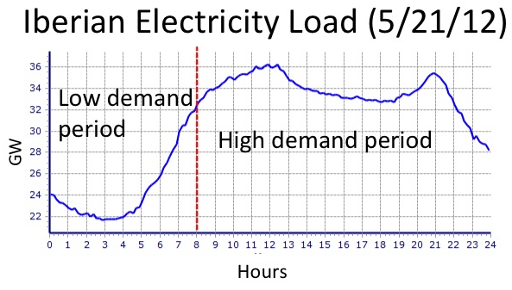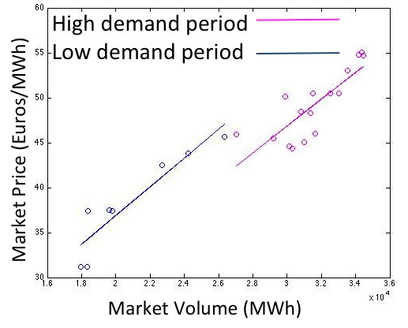

Figure 1. One day of load in the Iberian (Spanish and Figure 2. Best fit lines relating price and market volume for
Portuguese) Electricity Market high and low demand periods

Results
We find that large-scale storage shaves peak prices in the MIBEL market while increasing prices during off-peak periods (Figure 3). This leads to decreased revenues for thermal generators in the Portuguese utility EDP (Figure 4).

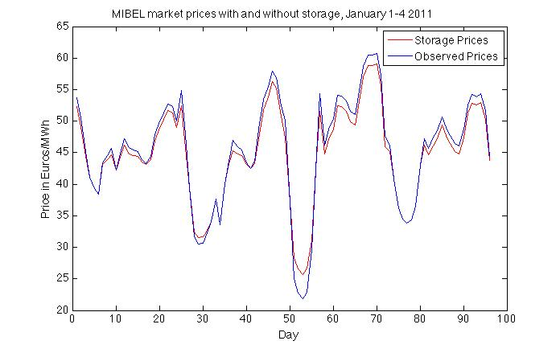
Figure 3. MIBEL market price of electricity with and Figure 4. Daily thermal generator revenues with and
without storage without storage in the system. Error bars represent
revenue level uncertainty from using forecast market prices to operate storage
Changes in electricity generation from thermals affect overall CO₂ emissions. Further, changes in CO₂ emissions and stakeholder benefits will be different depending on the objective function of the storage owner (independent, thermal generator owner, or consumers). Consumer-owned storage will seek to minimize consumer expenditures on electricity, while thermal generator-owned storage will need to balance the competing objectives of storage revenues and generator revenues. Finally, time of year factors into the potential net revenues from storage. Highest revenue potential occurs during the most volatile price periods of the year (i.e. periods with large price spreads). Analysis of MIBEL prices in 2011 shows the highest potential for revenues occurs in winter (Figures 5 and 6).

Figure 5. Maximum difference between minimum and Figure 6. Daily profits from storage of each new dam
maximum price per two week period in 2011 in spring and winter. Profits are much higher in winter due to higher maximum price spreads

Conclusions

We show that planned hydropower storage capacity in Portugal will affect Iberian electricity market prices, consumer expenditures on electricity, thermal generator revenues, and CO₂ emissions. Our conclusions are relevant beyond the Iberian Peninsula; any electricity market facing significant new storage capacity will experience changes in peak and off-peak prices, and consequently changes to consumer expenditures and thermal generator revenues.

References

Sioshansi, Ramteen, Paul Denholm, Thomas Jenkin, and Jurgen Weiss. 2009. “Estimating the Value of Electricity Storage in PJM: Arbitrage and Some Welfare Effects.” Energy Economics 31 (March): 269–277. doi:10.1016/j.eneco.2008.10.005.
Walawalkar, Rahul, Jay Apt, and Rick Mancini. 2007. “Economics of Electric Energy Storage for Energy Arbitrage and Regulation in New York.” Energy Policy 35 (4) (April): 2558–2568. doi:10.1016/j.enpol.2006.09.005.

