Overview
Modeling US Climate Policy And Equivalent Carbon Tax: A Hyrid Approach

Kemal Sarica, Purdue University, (765) 494-3259, ksarica@purdue.edu
Wallace E. Tyner, Purdue University, (765) 494-0199, wtyner@purdue.edu

In the United States, the general perception is that we have two major energy problems – greenhouse gas (GHG) emissions and the connection with global warming, and energy security associated with our high level of dependence on foreign oil. Most economists would argue that a carbon tax is the most efficient way of dealing with objectives of reducing energy consumption and GHG emissions. However, in the US, politicians, at least for now, have roundly rejected both the carbon tax and cap and trade options. Instead, they are more focused on mandates to move towards a cleaner economy. President Obama has increased CAFE standards to effectively double auto mileage to 54.5 mpg by 2025 and has proposed a CES for the electricity sector that would move from the current 40 percent clean electricity to 80 percent clean by 2035. Included in clean electricity are coal with carbon capture and sequestration, nuclear and renewable electricity generation (solar, wind, and biomass). Natural gas is considered 50 percent clean. In addition, the US has a renewable fuel standard (RFS) mandating 35 billion gallons ethanol equivalent of biofuels plus one billion gallons biodiesel by 2022. Thus, current energy policy is targeted directly at the transport and electricity generation sectors, which produce 33 and 42 percent respectively of CO2 emissions in the US .

The basic question being addressed in this research is how this package of a CES, CAFE standards, and RFS compares with a carbon tax that would generate the same level of emissions reductions. A carbon tax would apply to 100 percent of emissions, whereas the current policy set applies to about 75 percent of current emissions. In this regard, a hyrid approach is selected to cover socio economic impacts of the proposed policies under an integrated energy environment framework. Besides the effectiveness of the policies, socio-economic cost of those policy options are quantified, and investigated in comparison to each other and to the carbon tax.

Methods
MARKAL (an acronym for MARKet ALlocation), an integrated energy, environmental and economic model, is a dynamic linear programming model based on reference energy system (RES) which minimizes the total discounted energy system cost, including the investment cost, the variable and fixed operational and maintenance costs on both the supply and the demand sides. The model is a bottom-up, partial equilibrium, data driven, energy systems economic optimization model which incorporates a full range of energy processes, exploitation, conversion, transmission, distribution and end-uses. MARKAL is based on data regarding resources used, fixed and variable costs, technology availability, performance and emission pollutants for each technology used in the reference energy system (RES). It calculates the least cost way to satisfy the specified demands, subject to constraints imposed by the user. Full details of the of the optimization methodology can be found in Loulou et. al. .
A database that is representing a particular energy system must be developed to analyze it with MARKAL. The U.S. EPA developed MARKAL databases that represent the US energy system at the national and regional levels. Both databases cover the period 2005 through 2055 in five-year increments and represent the sectors: resource supply, electricity production, residential, commercial, industrial and transportation sectors. Characterizations of current and future energy demands, resource supplies, and technologies within the databases were developed primarily from the Energy Information Agency’s 2006 Annual Energy Outlook (AEO’06) report , extrapolated to 2055 using National Energy Modeling System (NEMS) outputs published by DOE . The latest version of the data base is used which is calibrated according to Energy Information Agency’s 2010 Annual Energy Outlook (AEO’10) report . Additional data sources include the AP-42 emission factors from US EPA , and Argonne National Laboratory’s Greenhouse Gas, Regulated Emissions, and Energy Use in Transportation (GREET) model .
A major methodological extension to US EPA MARKAL has been the integration of this rich technological characterization of the US energy system with a macro-economic neoclassical growth model. This hybrid modelling approach was developed by Manne and Wene . The resulting general equilibrium model is one of the very few hard-linked top-down bottom-up hybrid modelling approaches. Under the overall maximization of consumer utility (consumption), useful energy services from MARKAL are aggregated to form the energy input in the production function of the Macro-module. The first stage of model calibration matches base year 2005 model outputs to actual resource use, energy consumption, electricity output and installed technology capacity. The principal calibration source for macro indicators and energy system is DOE’s Annual Energy Outlook . This entails a corresponding definition of residual technology capacities and use, and characterisation of final retirement dates. The second calibration stage is an iterative process to match base-case projected energy service demands and projected GDP growth rates. In the Macro-module, economic output can be used towards consumption, capital accumulation or energy service purchases, and this information is passed back to MARKAL. Following calibration to a baseline, MARKAL MACRO then calculates resultant changes technology choices, energy consumption, carbon emissions, and GDP.

Results

Results are illustrated in the figure below. The major conclusions are as follows:

Energy use in transport is considerably lower for the combined policy set mainly due to the CAFE standard.

Coal consumption is reduced drastically under both policy cases, but oil consumption is changed much less.

The CES seems well “calibrated” to the carbon tax and achieves similar results.

The CAFE standard achieves substantially more savings in oil product use than the carbon tax but at a very high cost.

For the combined policy set, most of the emissions reduction is due to the CES, but most of the cost in the out years is due to the CAFE standard.
- In the short run, GDP losses are lower for the combined policy set, but in later years the carbon tax leads to substantially lower GDP losses due primarily to the high cost of the CAFE standard. In essence, the CAFE standard achieves “too much” fuel economy if the objective is GHG reduction.

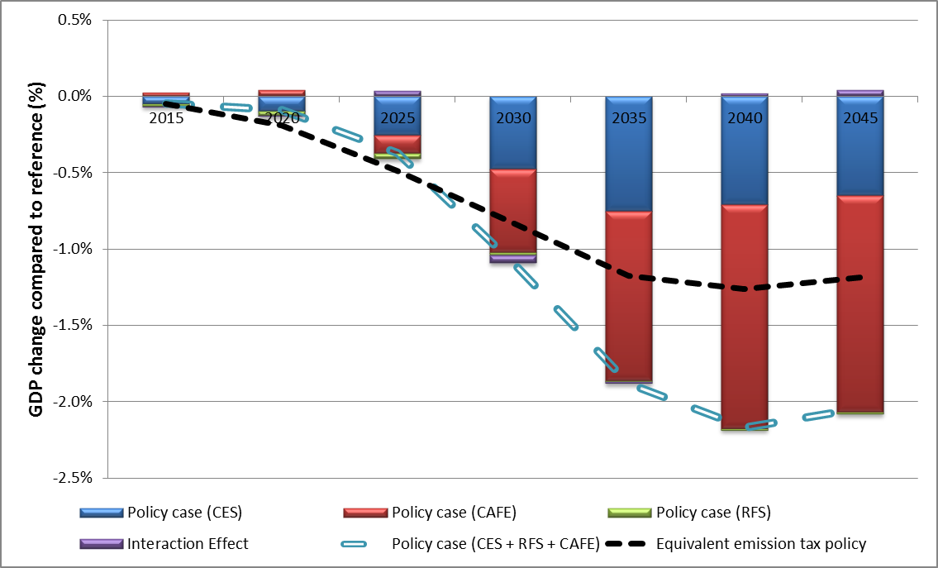

References

