RISK-AVERSE LEVEL DEPENDENT COMPOSITE INDICATORS FOR ENERGY SECURITY UNDER VARIOUS CLIMATE CHANGE POLICY SCENARIOS

Anca Costescu Badea, Ecole Nationale Supérieure de Mines de Saint-Etienne, 158 cours Fauriel, 42023 Saint-Etienne cedex 2, France, +33 4 77 42 0117 anca.badea_co@yahoo.fr
Claudio M. Rocco S., Universidad Central de Venezuela, Caracas, Venezuela, croccoucv@gmail.com

Stefano Tarantola, Institute of the Protection and Security of the Citizen, JRC, European Commission, TP 361, Via E. Fermi 1, 21020 Ispra (VA), Italy, stefano.tarantola@jrc.ec.europa.eu

Ricardo Bolado, Institute of Energy, JRC, European Commission, ES Unit, PO Box 2, 1755 ZG Petten - The Netherlands, ricardo.bolado-lavin@jrc.nl

Overview
There is no precise quantitative definition of energy security, even if it had been accepted that its main dimensions are the 4 As (availability, accessibility, affordability and acceptability).
Depending on the context, researchers or decision makers might use one or several of these dimensions to measure the extent of the energy security for different countries.
Using a composite indicator to assess this multi-dimensional reality is an added value, because it summarizes the information, benchmarks the countries and monitors the efforts made to improve the security of supply and the time trends.

Many composite or simple indicators for security of energy supply have been developed in the recent years. Among them, the composite vulnerability index developed in [1] is used in the World Energy Council’s study on the Europe Vulnerability to Energy Crises [2] and the Supply/Demand index [3] aims to provide a model, based on standards, for the EU Member States to assess energy supply security. The indicators for security of supply are overviewed in [4]. Finally, Energy Policy has consecrated in 2010 a special volume “Energy security—concepts and indicators with regular papers” to this topic [5].

On another hand, a business-as-usual future for the energy sector is no longer sustainable due to concerns related to both the EU security of supply (such as increasing dependence on non EU energy sources) and the climate change. To address the environmental changes, the European Commission (EC) proposed in 2008 a full policy package of implementation measures to meet the EU's objectives on climate change and renewable energy for 2020. This policy package had been analysed and scenarios derived, among others, with the PRIMES model [6 - 7].

Methods
The purpose of this article is to assess the effects of climate change mitigation policies on energy security, using composite indicators. These composite indicators, defined in [8], have been built such that they take into account the risk-averse level of the decision-maker in a range varying continuously from risk-prone to risk-averse. They are based on an aggregation rule derived from the Group Decision Theory: the ordered weighted averaging. Individual indicators for the EU Member States which are relevant for the different dimensions of energy security are computed from historical data (for the time period 1990 – 2005) and from projections of PRIMES model under different scenarios (for the time period 2010 – 2030), and used to build the set of composite indicators (with different risk-averse levels).

Results
We compare the evolutions in time of the countries performances obtained under two different scenarios (the business-as-usual scenario and the EC proposal without RES trading scenario). In Figure 1 the results obtained for four Member States (MS) are presented. The composite indicator have been computed such that the higher its value, the higher the level of energy security. The thesis we want to support here is that the EU policy package on climate change and renewable will not only address the environmental changes, but it will also increase the energy security.

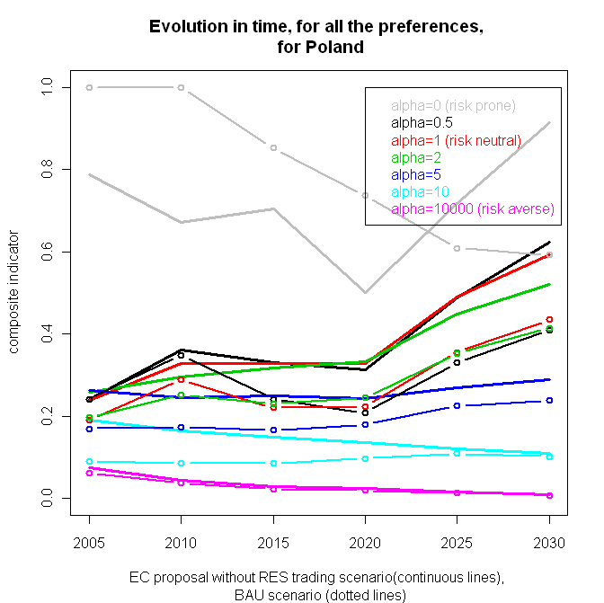 | 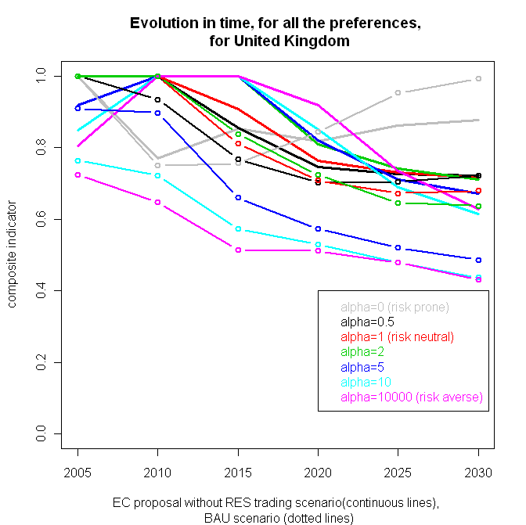
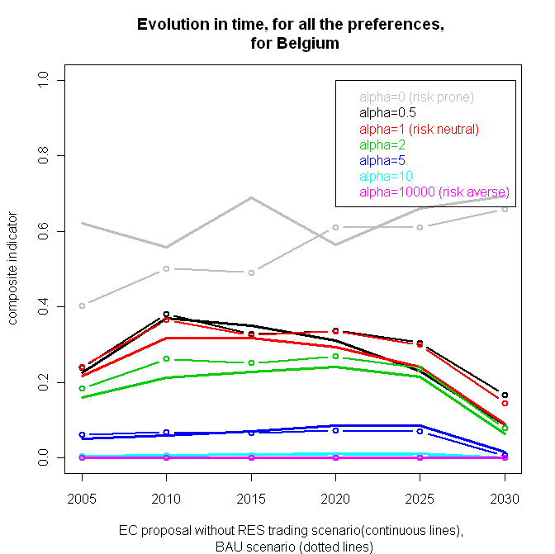 | 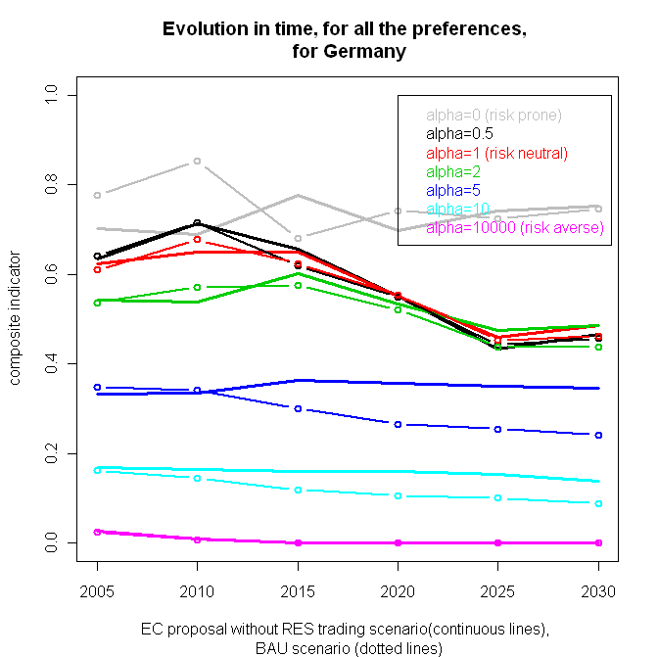
Figure 1: Evolution in time of the composite indicator for energy security for the two scenarios under consideration and for different risk-averse levels of the decision-maker (from risk-prone to risk-averse) for four MS

Conclusions
We provide a family of composite indicators for measuring the security of energy supply, which can be used as decision-making instruments, to trade-off between the different interests of the different MS. The thesis that EU policy package on climate change and renewable increases the energy security holds for most of the MS and for most of the risk-averse levels (the risk-prone composite indicator being the most variable one), as it is the situation in Figure 1 for Poland, Germany and United Kingdom . On the contrary, the thesis is not true for a small group of MS, such as Belgium, for risk-averse levels close to the risk-neutral level, which is the most stable level with respect to te uncertainties of each individual indicator (see [8]). In this situation a straightforward link between climate change and energy security using this composite indicator cannot be established for all the MS. The MS can be however classified in two groups: the MS for which the climate change and renewable policies increase the energy security and the ones for which the opposite holds.

References
[1] Gnansounou E., Assessing the energy vulnerability: Case of industrialized countries, Energy Policy; 2008; 36, 10, p.3734-3744.
[2] World Energy Council, Europe’s Vulnerability to Energy Crises, 2008
[3] Scheepers M.J.J., Seebregts, A.J., Jong, J.J. de, Maters, J.M., EU Standards for Energy Security of Supply, ECN report number ECN-E—07-004, 2007.
[4] Kruyt B., D.P. van Vuuren, H.J.M. de Vries, H. Groenenberg Indicators for energy security, Energy Policy; 2009; 37, 6, p. 2166-2181.
[5] Löschel A., U.Moslener and D.T.G. Rübbelke editors, Energy Security - Concepts and Indicators with regular papers, Energy Policy; 2010; 38, 4; p.1607-2074.
[6] European Commission, DG Climate Action, EU Energy and GHG Emission Trends to 2030 - Update 2009, http://ec.europa.eu/clima/documentation/docs/trends_to_2030_update_2009_en.pdf
[7] European Commission, DG Climate Action, Appendixes to Model-based Analysis of the 2008 EU Policy Package on Climate Change and Renewables http://ec.europa.eu/clima/documentation/docs/analysis_appendix_en.pdf
[8] Badea A.C., et al. Composite indicators for security of energy supply using ordered weighted averaging. Reliab Eng Syst Safety(2011), doi:10.1016/j.ress.2010.12.025

