THE RAPID EVOLUTION OF THE FRENCH ELECTRICITY MARKET
FROM 2002 t0 2008

Margaret Armstrong, Cerna Mines-Paristech, +33 1 40519313, margaret.armstrong@mines-paristech.fr
Alain Galli, Cerna Mines-Paristech, +33 1 40519314, alain.galli@mines-paristech.fr

Overview
This paper analyses the rapid evolution of the French electricity market since it was liberalised in 2001 – much later than the UK or Nordic countries. Unlike some countries in Europe, France benefitted from cheap electricity from the nuclear power stations constructed in the 70s & 80s so that neither the electro-intensive industries nor the historic operator, Electricité de France, were enthusiastic about opening the market to competition and consequently the French government dragged its feet. On July 1 2001, the market was opened for competition for “large consumers” (about 30% of consumers); three years later this was extended to middle sized consumers (bringing the part open to competition to 70%); finally householders were allowed to freely choose their supplier in July 2007.

This late development explains why the French electricity bourse, Powernext, was only created in 2001. At first Powernext provided only a day-ahead auction market, using the clearing system developed by Nordpool. In June 2004, Powernext added futures to its range of products. Recently two continuous trading sections have been added: a day-ahead market and an intraday market. In November 2006, the French, Belgian and Dutch markets were coupled. Offers to buy & sell power on three day-ahead markets are now aggregated & settled together. This means that provided the transmission capacity allows, the three markets have a common (and hence lower) price. Earlier this year (2009), the French & Germany bourses, Powernext & EEX, combined their activities. The common spot market for electricity is in Paris but the derivatives market is in Leipzig, with clearing being done through the European Commodity Clearing AG in Leipzig. The idea is that while it is advantageous for consumers to be able to choose from many suppliers, cooperation between the trading platforms at the wholesale level is important to give a clear signal as to prices.

In addition to these markets, the French TSO, RTE, runs a last minute adjustment market in which power plants can bid to provide or withdraw power at short notice. Its objective is to allow the RTE to balance the power available at all times. Unlike the other markets, it need not take the cheapest bidder. It could take a closer bidder if this improves the stability of the system.

Another important element in the electricity market in France are virtual power plants or VPP for short. The European Commission judged the purchase by EDF, of 34.5% of the German utility EnBW to be anti-competitive. As a remedy EDF agreed to provide competitors with generation capacity rather than break-up the nuclear park. In fact VPP are call options that give their owner the right (but no obligation) to draw power at a specified price per MwH in 30 minute slices over a given period of time ranging from 3 months up to 4 years. They are sold by auction every 3 months. This paper focuses on the impact of the VPP on prices in the day-ahead auction market.

Methods
First, we show that the structure of the market allows VPP holders to exercise strategies of selling power on the exchange when the day-ahead price is above the VPP strike (if they do not need the power) and conversely of buying power on the exchange when the day-ahead price is below the strike of their VPP (if they do want power). By documenting the strike prices of VPP that were active at different times and by carefully examining structure of day-ahead prices we demonstrate that they are doing this. The presence and absence of peaks coincides with the strike prices of active VPP contracts. Our analysis covers the period from 2002 to 2008.

Two types of VPP exist: baseload and peakload VPP. The strike price of the former is set to the marginal cost of nuclear powerplants whereas that of peakload VPP reflects that of thermal powerplants. Otherwise they are the same. One task was to document the evolution of these strike prices from 2002 to 2008.

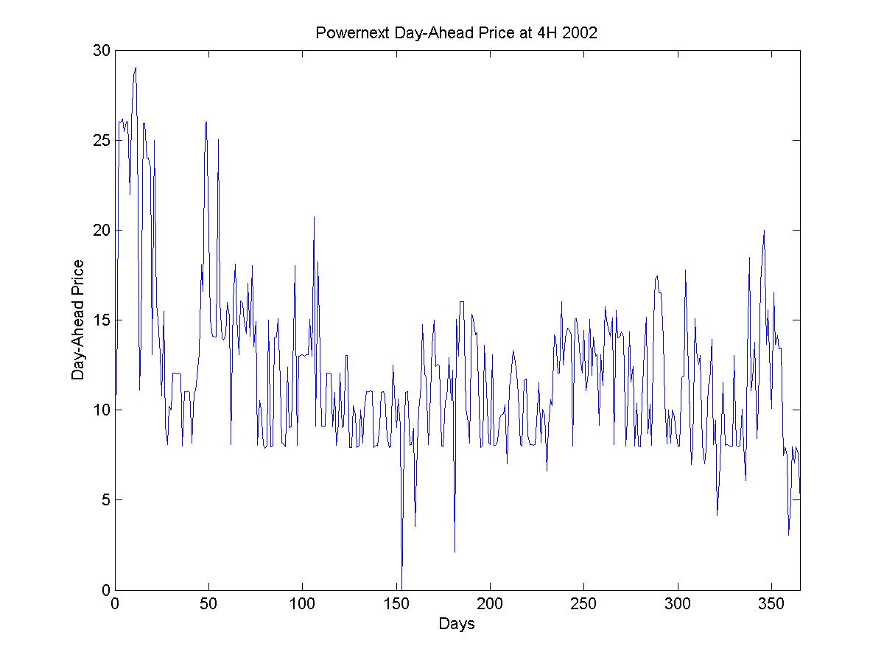
Results
It is easiest to demonstrate the effect of baseload VPP during offpeak periods. We plotted the day-ahead prices at 4H every day in 2002 (right) when the baseload strike was 8 euros per MwH. Prices rarely go below this value. Prices on the German bourse EEX at the same time do not show this “haircut” effect.
The impact of VPP is also apparent when the volumes transacted are plotted against the day-ahead price. The figure below shows this for 4H in 2002 (left) and 4H in 2006 (right). The peaks coincide with the strike price of baseload VPP (8 euros).
Price on day-ahead auction market at 4H each day during 2002

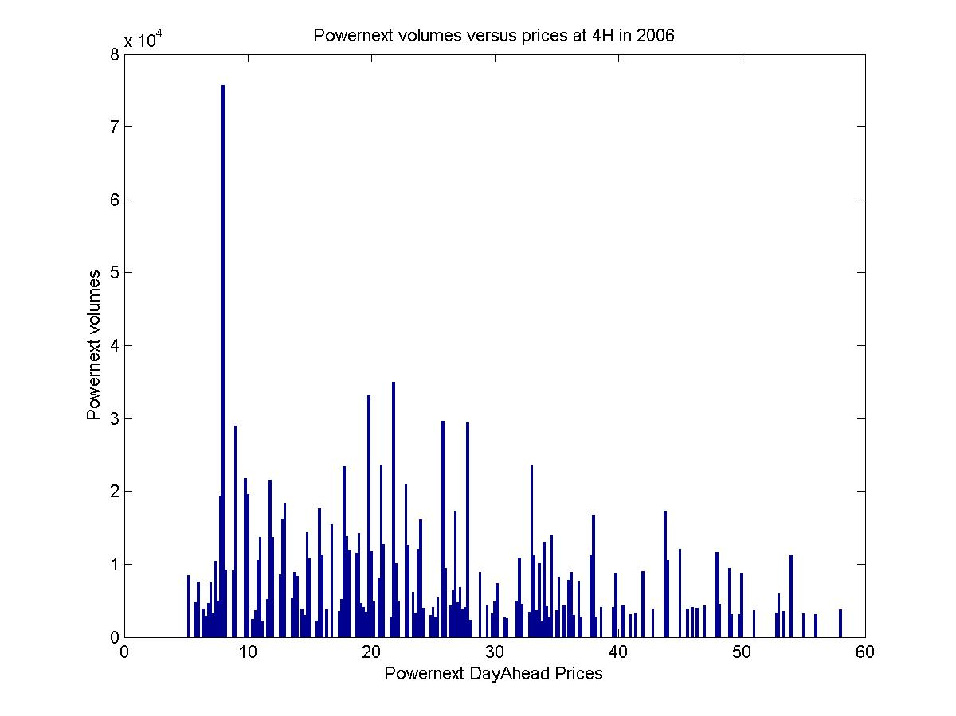
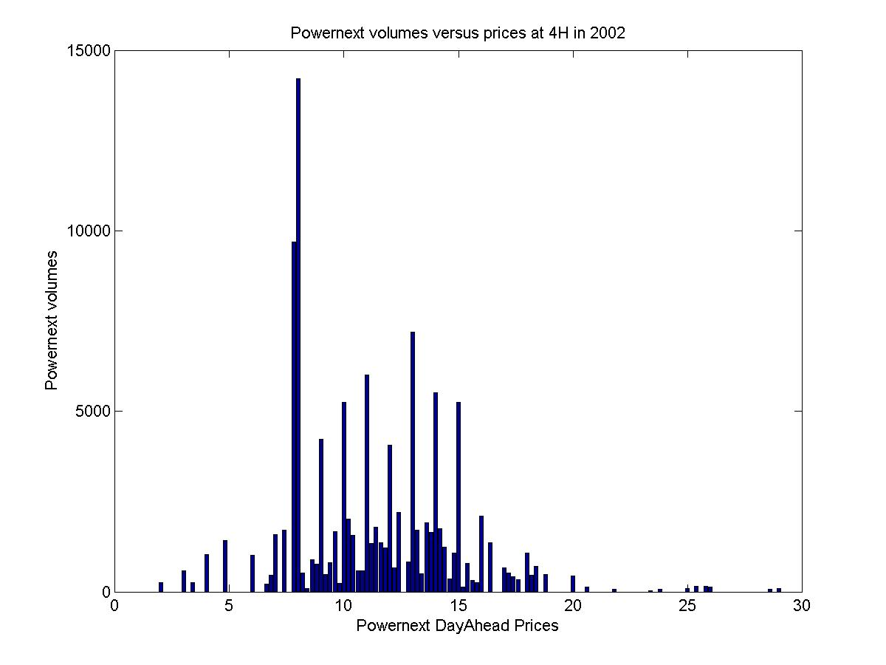
4H 2002
4H 2006
Volumes traded on day-ahead market at 4H as a function of price during 2002 (left) & 2006 (right)

Similar effects can also be demonstrated for baseload VPP during peak hours, and for peakload VPP. However care is required in identifying the strike prices operating at any given date. Going further we show that peaks that were visible in one time period disappear once the VPP with that strike price are no longer active.

Conclusions
After reviewing the evolution of the French electricity market since it was liberalised in 2001, this paper focuses on the interaction of VPP (virtual power plants) on the day-ahead auction market. In some ways this is surprising because VPP are call options that allow their holders to draw capacity in 30 minute slices at a predetermined price per MwH after paying an initial upfront premium. As the duration of VPP options ranges from 2 or 3 months up to 4 years, these are long-term products whereas the day-ahead auction market sells power for delivery the following day.
We show that the structure of the market notably the closing time for offers to buy or sell power on the day-ahead auction market allows VPP holders to sell power if the day-ahead price is above the strike price and if they do not want it during a given one hour period, or conversely to buy power if the day-ahead price is below the strike and if they want power. Going further we demonstrate that market participants are effectively using these strategies. This can be seen by plotting the volume traded as a function of the price on the day-ahead market. Peaks show up precisely at the strike prices of current VPP and that the peaks disappear when the VPP in question are no longer active.
This begs the question: What overall effect do VPP have on the efficiency of the market? Understanding the impact of VPP on the day-ahead market is important because they have been introduced in several other countries recently (Belgium, Spain, Germany and Denmark) and in three of the four cases exactly the same type of descending clock auction is used.

