[SIMULATION-SUPPORTED QUANTIFICATION OF DEMAND RESPONSE ACTIONS APPLIED IN A BLOCK OF RESIDENTIAL BUILDINGS]
[Xiubei Ge, European Institute for Energy Research, ge@eifer.org]
[Enrique Kremers, European Institute for Energy Research, kremers@eifer.org]
[Malcolm Yadack, Stuttgart Technology University of Applied Sciences, malcolm.yadack@hft-stuttgart.de]
[Ursula Eicker, Stuttgart Technology University of Applied Sciences, ursula.eicker@hft-stuttgart.de]

Overview

Concerns about the secure and efficient operation and coordination of future energy grids with high levels of distributed generation (DG) and volatile renewable energy systems (RES) motivates the search for ways to integrate and increase flexibility in energy systems at all levels. Concepts, policies and market structures allowing access for flexible assets to markets have become one part of the discussion of a wide variety of changes coming to worldwide power markets in the coming decades. Current net-loads on electrical grids have become more volatile due to the high levels of DG and RES and requires adjustment to operation schedules plants on the supply side, which is challenging the system. Demand response (DR) measures that utilize the flexibility from the demand side can serve to mitigate these adustments in the operation of plants and can serve to reduce over all system costs (e.g., by avoiding reductions in conventional plant efficiency due to more volatile generation schedules).. However, dynamically controlling of a number of flexible loads at the houseload level such as heat pumps and batteries introduces new complexity for all market participants. Individual, non-linear properties and constraints of the small assets must also be considered, and thus small distributed flexible assets have yet to be marketed on a large scale as DR on flexibility markets. Furthermore, the rebound effect that occurs when a change in electricity consumption leads to an increase or decrease in consumption at a later point in time has to be considered in control strategies and in markets and e.g., in bidding rules. In this work, we present and study a method for quantifying DR actions of large clusteres of small distributed assets while accounting specifically for their associated rebound effects. Energy systems of 100 single-family buildings are modelled with heat pumps, electric boilers, heat storages, PV and batteries, and the DR actions applied on the houses are designed with fixed shifting power and action duration assumed to be requested by traders or system operators (e.g., for general ancillary services and/or balancing energy). We then quantify the aggregate response and aggregate rebound effect for these specific actions with a parameterized generalized model of the flexibility response. Identifying this relation between a DR action of a cluster of buildings’ assets and their collective rebound effect, leads us to describe conditions for energy systems’ flexibility markets to ensure inclusion of clusters of small flexible assets such as household heat pumps in combination with prosumers’ battery storages. These results should inform further market and policy studies.

Methods
In modelling the cluster of flexible households, we apply system dynamics (SD), discrete event (DE) modelling and agent based modelling (ABM). Combining these, we present a comprehensive representation of the household complex systems. We then statistically summarize the aggregate behaviour of the households, thus presenting a simplified representation of the aggregated individual complex systems.
In this modelling task, processes in a building such as the operation of energy conversion devices, storage charging and discharging are modelled in detail as individual agents based on differential equations that are modelled with SD. We call this agent model Flexbox hereafter. System operation controls on the building level are modelled with DE, which represents the operation and reaction to discrete events. In an ABM framework, we replicate instances of Flexboxes in order to represent the system on the scale of of a block of buildings or cluster. The agents are allowed to be heterogeneous, by incorporating differing environmental conditions and asset sizes.
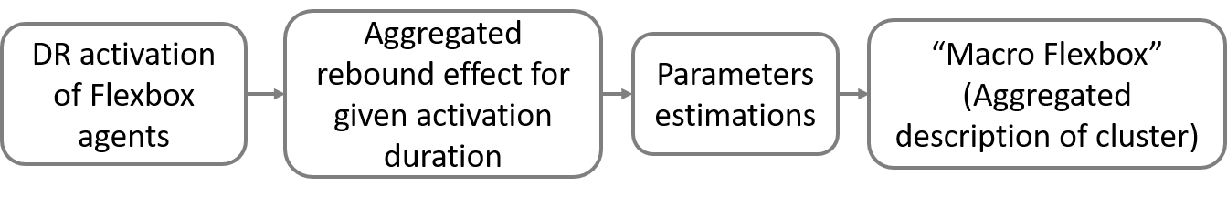
Figure 1: Modelling approach of Macro Flexbox

A DR activation signal represented with the direction, power and duration of the requested change in electricity consumption and is sent to the Flexboxes at a certain moment. The Flexbox agents react to the signal by switching their loads on or off, and charging or discharging their storages under the constraints that the predicated demand that each Flexbox supplies has to be met. After DR activation, a rebound effect in each activated Flexbox occurs in form of refilling storages or keeping devices idle. The aggregated effect of the entire processes on block level is then quantified including the DR described with the duration and capacity, the rebounded energy described with duration and capacity, and energy loss or win caused by DR compared to the reference load traces. The resulting traces of simulations with and without DR actions for typical days of each season are fitted using partial linear fits to obtain the main characteristics of the DR and rebound curve. Such parameters are formed into a descriptive model which we term “Macro Flexbox”.
DR activations are simulated for directions of increasing and decreasing load, durations of 1, 2, and 3 hours and the corresponding capacity in winter, spring/autumn and summer seasons. We derive different representative Macro Flexbox models for each scenario.

Results
We find that DR activations at the same time of a day and the respective rebound effects show similar behaviors in the same season despite different activation durations. With this observation, we paramarize in our framework using the parameteric description shown in the following figure and table:
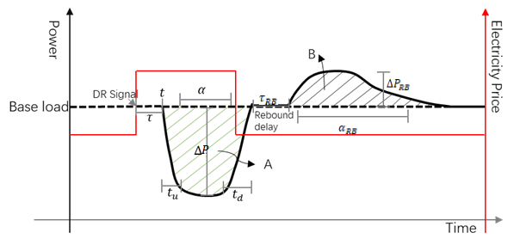
Figure 2: scheme of a DR activation and its rebound effect based on a normalised base load

Table 1: General Parameter of a macro-flexbox
Parameter | Symbol | Data type | Example Value
Response delay | $$τ\left(t\right)$$ | Static | 30 sec
Ramp-up time | $$t_{u}\left(t\right)$$ | Static | 5 mins
Ramp down time | $$t_{d}\left(t\right)$$ | Static | 5 mins
Flexible capacity | $$∆P\left(t\right)$$ | Dynamic | +100 kW
DR activation starting time | $$t$$ | Dynamic | 3 am
DR activation duration | $$α\left(t\right)$$ | Dynamic | 1 hour
Rebound Capacity | $$∆P_{RB}\left(t\right)$$ | Dynamic | -20 kW
Rebound Duration | $$α_{RB}\left(t\right)$$ | Dynamic | 5 hours
Rebound Delay after DR | $$τ_{RB}\left(t\right)$$ | Dynamic | 1 hour
Energy Losses / Gains | $$ϑ\left(t\right)$$ | Static | +2%

The resulting parametric description varies significantly for each use case, which differs according to the energy system carrying out the DR action and according to the applied system operation strategy. The time at which the DR happens, the duration and capacity of DR and the seasonal effect influence the parameters significantly. For example, when comparing winter to spring/autumn, the rebound duration and capacity are both reduced (which can be explained due to less use of space heating). However, a rebound delay increase could be observed in spring/autumn, because the load has a different shape than in winter. Dynamic variables have thus to be adapted for each season. Compared to the simuated DR activations, parameterized macro flexboxes have error of 3% to 10% in relation of the DR capacity differing each season.

Conclusions
In this work, we model an energy system of a block of buildings with DR activation in order to observe and quantify the DR and and the respective rebound effects with the aim of obtaining a general parameterized description of the actions. DR activations in different seasons, as well as at different time of a day for different activation durations are simulated. After numerous simulations, we learned the shiftable capacity differs depending on the DR duration, howerver the shifted energy has a similar quantity and the rebound effects have similar pattens, which allows us to describe DR activation and rebound effect as macro Flexbox and quantify its paramters for each season. This parameterized models can be used in future market and policy studies.

