BENEFITS OF SPATIAL INTEGRATION: OPTIMAL ALLOCATION OF WIND CAPACITY IN EUROPE ACCORDING TO MODERN PORTFOLIO THEORY
Javier López Prol. Wegener Center for Climate and Global Change, University of Graz, Austria. javier.lopez-prol@uni-graz.at
Fernando de Llano Paz. University of A Coruña. Spain. fernando.de.llano.paz@udc.es
Anxo Calvo Silvosa. University of A Coruña, Spain. anxo.calvo.silvosa@udc.es
Sungmin O. Max Planck Institute for Biogeochemistry, Jena, Germany. sungmin.o@bgc-jena.mpg.de

Overview

Renewable energy sources are set to become the main component of decarbonized electricity systems. However, due to their variability, integration cost may hamper their diffusion due to the increasing difficulty of managing higher shares of intermittent resources. Spatial integration softens volatility by integrating regions with opposite generation patterns. We calculate the optimal allocation of wind capacity in Europe to achieve the maximum possible average capacity factor (CF) per unit of volatility (defined as the capacity factor standard deviation: SD). By optimizing the CF-SD trade-off we can build an efficient frontier of portfolios (understood as shares of installed capacity per country) that yield the minimum possible SD for each given level of CF. Once we have the efficient frontier, we can derive the optimal portfolio as the one that maximizes the Sharpe ratio, i.e. yields the maximum average CF per unit of SD.
We calculate efficient frontier and optimal portfolios for Europe as a whole and for specific smaller configurations (Epex Spot and Nord Pool markets, and western Europe energy union), to assess the benefits of spatial integration in terms of reducing volatility while achieving high average CF, and how this trade-off changes depending on the different levels of integration. The analysis is performed for current CF conditions (i.e. existing technologies and generation locations) and also for long-term conditions (improved technologies and higher share of off-shore locations). We can therefore derive the optimal shares of wind capacity in Europe as a whole and for different markets, for current conditions and long-term scenarios, and derive policy considerations regarding the benefits of electricity system integration and wind deployment coordination.

Methods
We apply modern portfolio theory to assess the CF-SD trade-off of wind generation in Europe. We use hourly wind capacity factor data for each country during 30 years provided by Staffell and Pfenninger (2016). The problem consists in minimizing the portfolio SD $\left(σ_{p}\right)$for every attainable average CF according to eq. (1):
$$min\left(σ_{p}\right)=min\left(\sqrt{\sum_{i=1}^{n}{x_{i}^{2}σ_{i}^{2}+\sum_{i=1}^{n}{\sum_{j=1}^{n}{x_{i}x_{j}p_{ij}σ_{i}σ_{j}}}}}\right)\left(1\right)$$
where the first added is the sum of variances ($σ_{i}^{2}$) times the squared shares of wind installed capacity in each country ($x_{i}^{2}$) and the second addend is the covariance of hourly CF between countries, with ($p_{ij}$) as their respective correlation. This minimization is subject to a non-negativity constraint (i.e. all shares must be positive or zero: $x_{i}∈R≥0$), and a “full investment” constraint (i.e. the sum of shares must equal one, $\sum{x_{i}=1}$).
We first calculate the optimal portfolios without any additional constraints to see the maximum potential benefits of integration, and then build more realistic scenarios setting “resource constraint” (i.e. the share of a country cannot be higher than its generation potential (Dalla Longa et al., 2018)), a “transmission constraint” (i.e. no country can have higher share of wind installed capacity than its share in electricity consumption plus 15%, which would represent the maximum possible transmission within the system), and a “distributive constraint” (i.e. countries must have at least the share of wind installed capacity committed in the EU reference scenario 2030 (EC, 2016).

Results
Our results show the optimal wind installed capacity per country for Europe as a whole (Fig. 1 panel top left), and for the Epex Spot and Nord Pool electricity markets (Fig. 2 panel top right) in the current circumstances. The mapped shares would yield the maximum CF per unit of SD. The countries with the highest shares are Finland, Spain, Portugal and Greece. Countries such as Germany would have no wind capacity because they have lower CF and higher SD than other countries with the same generation patterns. Since this is a politically unrealistic situation, we set the aforementioned constraints to ensure minimum and maximum shares per country, obtaining more evenly distributed results.
The down-left panel of Fig. 1 shows the current and the long-term efficient frontiers and the optimal portfolios (dots) in relation to the position of individual countries in current conditions (crosses) and long-term (triangles). The long-term frontier has higher average CF and SD because most countries improve both wind technology and locations (moving to off-shore areas not currently exploited). Finally, the CF probability density functions of different configurations are shown in the down-right panels, showing that the optimal portfolios (Max. SR) have higher CF that the minimun variance portfolios, and also lower probability of low generation events.
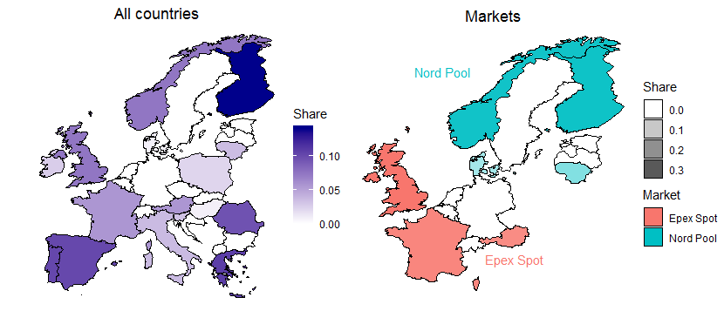
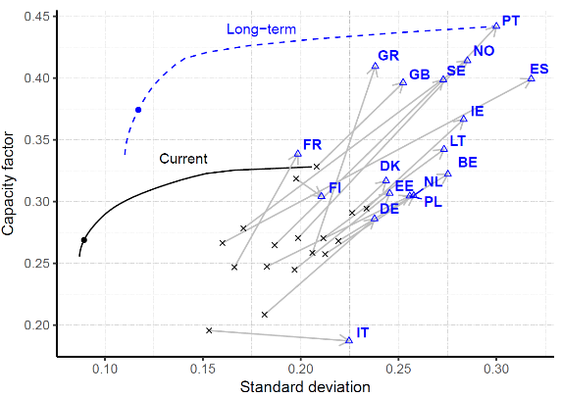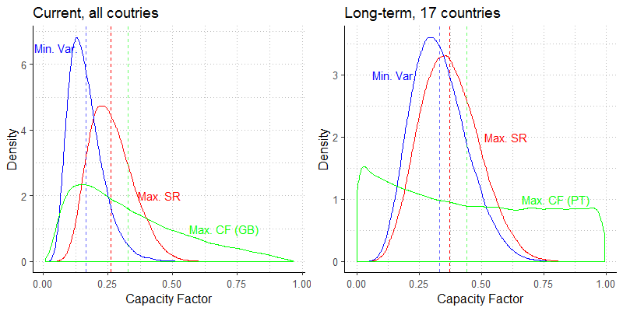

Figure 1. Top: optimal shares of installed wind capacity in Europe (left) and in the Nord Pool and Epex Spot electricity markets (right). Down-left: current (black solid) and long-term (blue dotted) efficient frontiers with respect to individual countries. Down-right: probability density functions of CF in the minimum variance (blue), maximum CF (green) and optimal portfolios (red) in current and long-term conditions.

Conclusions

Since SD is scale-dependent on the level of CF, the increasing average CF provided by better technologies and locations entails that spatial integration and wind deployment coordination will be increasingly important in the future to allow the high penetration of variable renewables at the minimum possible cost. We show how modern portfolio theory can be applied to derive optimal portfolios of country shares of wind installed capacity that minimize the total SD for every level of average CF. Spatial integration and deployment coordination at European level would bring significant benefits in terms of lower volatility and lower probability of low generation events on one hand, and in terms of higher average capacity factors on the other hand. This would contain integration costs derived from variability and reduce aggregate wind levelized and system cost per unit of electricity generated.

References
Dalla Longa, F., Kober, T., Badger, J., Volker, P., Hoyer-Klick, C., Hidalgo Gonzalez, I., Medarac, H., Nijs, W., Politis, S., Tarvydas, D., Zucker, A., 2018. Wind potentials for EU and neighbouring countries. https://doi.org/10.2760/041705
EC - European Commission, 2016. EU Reference Scenario 2016. Energy, transport and GHG emissions trends to 2050. EU Ref. Scenar. 2016 27. https://doi.org/10.2833/9127
Staffell, I., Pfenninger, S., 2016. Using bias-corrected reanalysis to simulate current and future wind power output. Energy 114, 1224–1239. https://doi.org/10.1016/j.energy.2016.08.068

Data freely available at renewables.ninja.

