Model-Based Analysis of the contribution of the gas supply system to the integration of fluctuating renewable electricity generation
Hedda Gardian, German Aerospace Center (DLR), +49 711 6862-8819, hedda.gardian@dlr.de
Hans Christian Gils, German Aerospace Center (DLR), +49 711 6862-477, hans-christian.gils@dlr.de

Overview
The research project "MuSeKo – multi sector coupling" aims at investigating the use of different technology options for the flexible use of electricity in all sectors of the future energy system in Germany with an integrated model-based analysis. For this application, particular attention has been paid to the gas sector and the contribution that synthetic gases can make to energy system transformation. The flexibility in the production of these gases as well as the interactions with other flexibility options were investigated. In order to quantify the flexibility potentials of electrical equipment in the gas network, these were explicitly modelled and considered. For different scenarios, this work shows the impact of the energy system transformation on the use of the gas infrastructure, the possible contribution of an adapted operation of the electrical equipment in the gas network to the integration of fluctuating renewable power generation, and the potentials of the production and use of synthetic fuels (hydrogen, natural gas). Furthermore, the demand for different types of storage (power, heat, hydrogen, natural gas) as well as converters (e.g. heat pumps, cogenerators, hydrogen electrolysers and methanation facilities) in an integrated energy future energy system with high renewable energy supply share is evaluated.
The model results show a positive interaction between different technologies in balancing fluctuating renewable power generation. These technologies include power transmission and storage as well as flexible electric heat and hydrogen production, controlled battery electric vehicle charging and other demand response. The results furthermore indicate that the installation of a hydrogen transport network infrastructure can be a viable option to reduce the costs of the energy system transformation.

Methods
The REMix model by DLR comprises the pre-processing tool EnDAT used for the analysis of resource potentials, and the optimization tool OptiMo used for the determination of cost-minimal supply systems. The modulary structured GAMS model comprises the sectors electricity, heat, transport and gas, the latter being further developed within the MuSeKo project.In addition to the production and conversion of synthetic fuels, the REMix gas system also includes the storage and transport of gases and their use in the electricity and heat sectors. A special focus of the gas model is on the electrical equipment in the gas system, i.e. the systems for gas preheating and compression. The extended model allows the integral consideration of the electricity and gas system as well as the associated elements of the heat supply and transport sector (see figure 1).
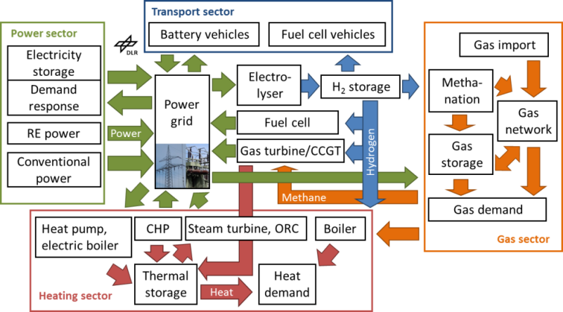
Fig. 1: Sector coupling in REMix
The model is used to investigate long-term investment decisions by optimization of operation and expansion of all system components on an hourly basis. The regional resolution of the model allows for the identification of differences in system design and operation between different parts of Germany. The German neighbouring countries were also modelled to take account of electricity and gas exchange.
Another methodical focus of the project lies on the connection between the business perspective and the economic perspective by iterative simulations between user-specific and macroeconomic level. For the implementation, a model coupling of the two models REMix (DLR) and MuGriFlex (Fraunhofer IFAM) is aspired, which illuminate the problem from both different perspectives. A coupling ideally leads to a business and economic optimum of a future energy system.
Various scenarios are examined for the sensitivity analysis. First, a baseline scenario was defined, which is characterized by an 80% CO₂ emission reduction and an increase in efficiency in 2050. Further scenarios examine more ambitious greenhouse gas reductions and a variation in efficiency improvements.

Results
Model runs are currently performed and preliminary results are under evaluation. The analysis is focused on electricity production and the load balancing through electricity transfer, storage, flexible heat production and electromobility, as well as flexible production, storage and transport of synthetic gases. According to the baseline scenario, 85% of the electricity supply in 2050 will be covered by renewable sources (see figure 2). The demand will be met primarily by onshore wind energy in the north of Germany and to a lesser extent by photovoltaics in the south, thus making optimum use of potential. Since the phase-out of coal and nuclear energy in Germany will be completed by 2040, the remaining electricity production will be taken over by gas-fired power plants that can use natural gas, biogas and synthesis gas as energy sources.
The investigation of the load balancing options shows spatial differences. Battery storage systems, for example, are built model-endogenously only outside Germany, e.g. in areas of Italy and France with high solar power production. In addition to an increase in electricity transmission by more than four times since 2020, which is made possible by a 25% expansion of the grid, the flexibility options in the heating sector are used in particular (see figure 3). In this context, it becomes apparent that in 2050 flexibility through electromobility and electric heat production (heat pumps and electric boilers) in combination with heat storages in the heating networks will gain in importance.
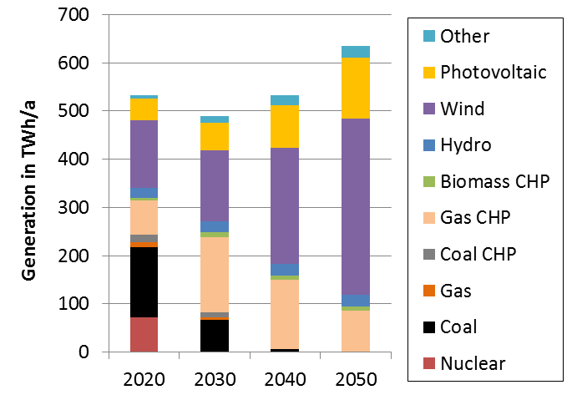
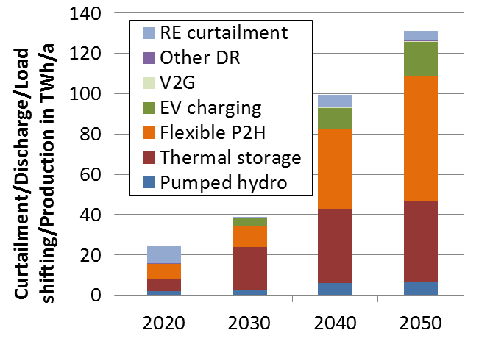

Fig. 2: Electricity generation
Fig. 3: Load balancing through sector coupling

In the gas sector, flexibility is achieved through the construction of a hydrogen network and the expansion of hydrogen storage capacity, however, methanization is not used in the optimized system. While hydrogen transport and storage are cost-effective flexibility options, further processing of hydrogen to methane is not profitable in the scenario under consideration, as the considerable energy losses leave the choice to other technologies.

Conclusions

The MuSeKo project points out that an integrated consideration of all sector coupling options is desirable. Although there is still a need for modeling improvement, a positive interaction between the options of flexible sector coupling is already visible. As a central result, the studies show that the flexible production of hydrogen can make a significant contribution to balancing renewable energies and that the partial conversion of natural gas infrastructure to hydrogen is an attractive option. It is also noteworthy that methanization does not play a role in the 80% CO₂ reduction scenario.
The next steps will be the integration of the business perspective by carrying out the model coupling of REMix and MuGriFlex and further sensitivity analyses to shed more light on the partial conversion of hydrogen into gas. In addition, further scenarios with more ambitious CO₂ reduction targets are investigated in which increased methanisation is expected. These issues will be addressed in the presentation.

References
Gils, H.C. and Simon, S. (2017) Carbon neutral archipelago – 100% renewable energy supply for the Canary Islands, Applied Energy, 188: 342-355. http://dx.doi.org/10.1016/j.apenergy.2016.12.023
Scholz, Y., Gils, H.C., Pietzcker, R. (2017) Application of a high-detail energy system model to derive power sector characteristics at high wind and solar shares, Energy Economics, 64, 568–582. http://dx.doi.org/10.1016/j.eneco.2016.06.021
Gils, H.C, Scholz, Y., Pregger, T., Luca de Tena, D., Heide, D. (2017) Integrated modelling of variable renewable energy-based power supply in Europe. Energy, 123: 173-188. http://dx.doi.org/10.1016/j.energy.2017.01.115

