Investments: Effect of oil prices

Bård Misund^{1,*}
Petter Osmundsen²

Abstract
This paper studies the impact of oil prices on investment behaviour among oil and gas companies. In particular, we study the impact of dividend commitments, leverage and extent of vertical integration on the oil companies’ investment responsiveness to oil price changes. We conjecture that when the oil price is falling, investments are held high by a high degree of vertical integration, but constrained by high debt levels and dividend payments. Similarly, we posit that when the oil price is falling, investments will fall most in companies with a high level of dividends or leverage, or low degree of vertical integration. Our results suggest that the extent of vertical integration affects investments. On the other hand, we find that dividend payments of companies with high level of dividends are not affected by falling oil prices. This suggests that oil companies are very committed to their dividend policies, and which is not affected by impaired financial performance.

¹ Associate Professor, University of Stavanger Business School, Stavanger, Norway
² Professor, Faculty of Technology, Department of Industrial Economics, University of Stavanger, Stavanger, Norway
* Corresponding author. Email: bard.misund@uis.no, Phone: +47 41681729, Address: University of Stavanger Business School, Stavanger, Norway.

Keywords: oil and gas companies, investments, capital formation, dividends, oil prices

Introduction
This paper examines the investment behaviour in the energy sector, and in particular, how commodity price uncertainty influences investments among oil and gas companies. This topic is very relevant and topical given the recent downturn in the industry. The energy sector is undoubtedly important for the world economy, and changes in investments in oil and gas companies can have an impact beyond the energy industry. According to the International Energy Agency (IEA), energy investments represent approximately 2-3% of global GDP. During 2000-2014, investments more than tripled in nominal value (Figure 1). Although renewable energy production has increased its importance in recent years, investments in fossil fuels also tripled in the same period.

Figure 1. Global investment in energy supply 2000-2016.
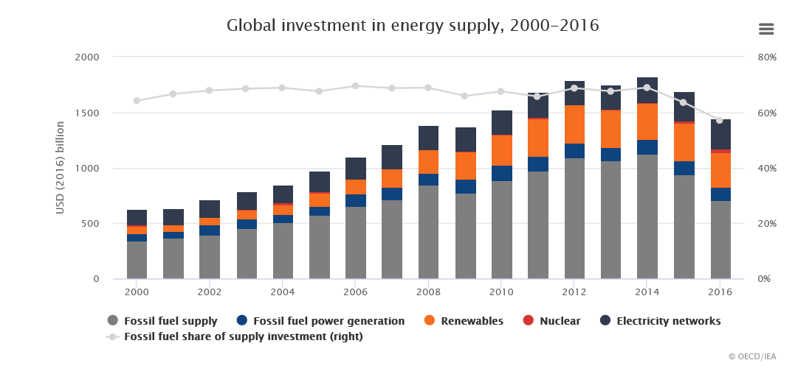
Source: IAE

Since 2014, energy investments have declined. From an all-time high level of 1826 billion USD in 2014, investments have plummeted to 1394 billion USD in 2016, a decline of 432 billion USD (23.6%). However, fossil fuels seem to have taken the brunt of the investment decline -418 out of the 432 billion USD reduction comes from fossil fuel investment cutbacks, representing a whopping 99% of the investment decline during 2014-2016.

The reason for the cutbacks in fossil fuel investments can be attributed to the recent oil price crisis (Figure 2). Since June 2014, oil prices have fallen dramatically, from above 114 USD per, going below 28 USD per barrel in January 2016.

Figure 2. Oil and gas price development 2000-2016

Visual inspection of Figures 1 and 2 suggest that investments in fossil fuels broadly follow the development in the crude oil price. On an aggregate level, there seems to be a clear relation between commodity price and investments. On the company level, the relationship is more complex, affected by a multitude of factors, such as uncertainty, cash flows, and financial constraints.

One factor affecting investments is uncertainty. The oil industry is characterised by its risky nature, both in terms of geological and commodity price risks, but also for the substantial lead times between when exploration is carried out and the onset of production from an oilfield. Decade long lead times are not uncommon. In the face of uncertainty, managers have to take the decision of whether or not to make an investment. However, neither theory nor empirics provide a clear-cut explanation for how uncertainty impacts investments. According to standard neoclassical theory of producer behaviour, uncertainty will increase the value of an investment due to the convexity of the profit function, and therefore lead to a positive effect of uncertainty on investment (Oi, 1961; Hartman, 1972; Abel, 1983). Contrasting this view is the work on real options by Cukierman (1980), Bernanke (1983) and McDonald and Siegel (1986). Many investment decisions, especially in the oil and gas sector, involve sources of flexibility. In other words, firm and project managers can make new decisions in a project after the initial investment decision has been made. Typical examples include the flexibility to extend the lifetime of a project, to extend the scope of the project, or to postpone investment decisions. This type of project flexibility are called real options (for relevant examples from the energy industry see e.g. Biondi and Moretti, 2015; Xian et al., 2015; Fleten et al., 2016; Locatelli et al., 2016). The option to postpone an investment (also referred to as a deferral option or a waiting option) has attracted the attention of investment researchers. The real options view on the uncertainty-investment relation assert that there is a negative relation between uncertainty and investments since uncertainty increases the value of the waiting option. Increased uncertainty makes it more valuable for the decision maker to sit and watch how the uncertainty pans out instead of investing (i.e. exercising the option).

A limitation of the ‘waiting option’ view of the investment-uncertainty relation, is that by only focussing on the option to defer an investment decision, it excludes other types of real options. As stated above, an investment project can involve several types of real options. Kulatilaka and Perotti (1998) argue that an early investment can lead to a strategic advantage (‘strategic investment’) for a company. Under certain conditions, higher uncertainty can increase the value of this strategic benefit (also referred to as strategic growth options). The presence of several types of real options (basket of options) can lead to complex relations between uncertainty and investments (Kulikatala and Perotti, 1998; Sarkar, 2000; Folta and O’Brien, 2004; Henriques and Sadorsky, 2011). Hence, the theories do not provide a clear-cut indication of how increased uncertainty affects investments. Similarly, the empirical evidence is also mixed (Carruth et al., 2000).

One reason for the lack of ‘unified’ empirical evidence explaining how investment decisions are affected by uncertainty may lie in the selection of the uncertainty variable. Typically, empirical studies use historical volatility based on spot oil prices (Mohn and Misund, 2009; 2011), or oil futures prices (Henriques and Sadorsky, 2011). A more recent study uses implied volatility (Kellogg, 2014). It is well-know that the direction of price changes affect the size of volatility (Black, 1976). The ‘leverage effect’ is the term for the observation that volatility increases asymmetrically with positive versus negative changes in the price. Kristoufek (2014) provides evidence of a standard leverage effect in crude oil futures, i.e. a negative relationship between returns and volatility, suggesting that an oil price decrease impacts volatility more than an oil price increase does. Hence, the actual direction of oil prices can have an impact on the perception of uncertainty among oil company managers. It is therefore important to consider the oil price changes when investigating investment behaviour in the oil and gas sector. Instead of examining the impact on investment from oil price uncertainty in the form of volatility, we examine the impact of oil price changes, thereby capturing the asymmetric impact of oil price uncertainty.

The empirical literature also find that financial constraints can dampen investments. In the literature, the impact of how sensitive investments are to changes in cash flow is often used as a measure of financial constraints. The studies on the impact of cash flows on investments are typically based on the q theory of investment behaviour (e.g. refs). According to the q theory, cash flows should not affect investment rates since Tobin’s average q should be an exhaustive metric for investments. However, several empirical studies have found evidence that investments are sensitive to cash flows (e.g. Fazzari et al., 1988). A recent study suggests that when oil companies are hit with a ‘wall of cash’ due to record high oil prices, the sensitivity of investments to cash flow decreases (Andrén and Jankensgård, 2015). These results suggests that the impact of cash flow on investment is complex, and not down to changes in profitability alone.

The literature suggests that capital market imperfections adversely affect investments (Hubbard, 1998), especially for the financially constrained firm (Fazzari et al., 1988). This literature asserts that the investment sensitivity to cash flows is a measure of financial constraints. The reasoning is that when firms face financial constraints, external financing is not always available. Hence, investments will be more dependent on internal funds, which come in the form of internally generated cash flows. Although the several studies find that investment sensitivity to cash flow tend to be higher for financially constrained firms, other studies have contested the view that investment sensitivity to cash flows is a measure of financial constraints (Kaplan and Zingales, 1997; Gomes, 2001; Chen and Chen, 2012). However, Moyen (2004) develops a model that reconciles the two opposing views, concluding that financial constraints have an adverse impact on the sensitivity of cash flows on investments.

In our study, we examine the impact of four types of constraints, low degree of vertical integration, high leverage, high dividend payments, and low cash flow levels. The oil and gas industry is typically divided into three segments along the value chain, upstream oil and gas exploration and production, midstream transportation, and downstream processing, refining, chemicals and marketing activities. Among these, the profitability of upstream business area is the most exposed to fluctuating oil and gas prices. The cash flows from the mid- and downstream sections, less so. Hence, a high degree of vertical integration entails that a substantial proportion of cash flows are less affected by oil price volatility, and can act as a buffer against the adverse effects of substantial oil price declines on cash flows. Hence, when the oil price falls, investments in integrated oil and gas companies can be maintained at a higher level than would be the case for exploration and production companies. The investment decisions in the former companies are less constrained by oil price uncertainty.

Leverage can also dampen investment appetite when the oil price falls. Although standard finance theory asserts that under conditions of market perfection, capital structure is irrelevant for the investment decision (Miller and Modigliani, 1960) the trade-off theory of capital structure states that increasing debt levels will increase the probability of default, and therefore the choice between debt and equity matters. Taking on debt is a financial commitment, and increases the riskiness of equity since the borrower needs to repay the loan and pay interest, independently of how the profitability of the company develops. A high debt level can therefore reduce the oil company’s ability to make investments, especially in the case of oil price declines. We therefore expect that when the oil price is falling, investments will fall most in companies with a high debt level.

Moyen (2004, p. 2075) suggests, (although not explicitly part of her model) that “sticky dividends [...] would lead to a larger difference in cash flow sensitivities between firms with financing constraints and without constraint.” Indeed, sticky dividends can in many respects be considered as a form of commitment. A firm’s management is very reluctant to cut dividends, even when facing falling profits. Hence, one should expect an impact of dividend levels on investment rates during an industry downturn. When oil prices fall, oil companies that have in previous years paid high dividends will continue to do so even though their profits have fallen, simply because they are reluctant to cut dividends. We therefore expect that investments will be affected by a combination of oil prices, cash flows, dividends.

Moreover, we expect that when the oil price is falling, investments will fall most in companies with a low levels of cash flow, since low levels of cash flow suggests small financial slack. Moreover, we also expect that vertical integration will affect the impact of oil prices on investments since cash flows of vertically integrated companies will be less exposed to crude oil volatility.

We collect data from oil and gas companies over the period 1992-2015, totalling 3911 firm-year observations, and covering at least two substantial oil price declines, in 2007-2008 and post 2014.

Our results suggest that the extent of vertical integration affects investments. Surprisingly, we find that dividend payments of companies with high level of dividends are not affected by falling oil prices. This suggests that oil companies are very committed to their dividend policies, and which is not affected by impaired financial performance.

