taxation and extraction rates

Aksel Hiorth, University of Stavanger, Department of energy resources, 4036, Stavanger, Norway, +47 51831757, aksel.hiorth@uis.no
Petter Osmundsen, University of Stavanger, Section of industrial economics, 4036, Stavanger, Norway, +47 51831568, ,petter.osmundsen@uis.no

Overview
In research on tax design in the petroleum sector, the emphasis is on the decision on project sanctioning; whether to invest or not, see e.g. Keen and McPherson (2010). The objective of corporate tax design is neutrality, i.e. to develop non-distortive taxes (Osmundsen et al. (2015)). The analysis if often done in a simplified setting, where investment projects are treated like a black box. In this paper we open the box and look at decisions that affect the extraction rate in offshore oil and gas projects. We acknowledge that corporate taxes may not only affect the decision on sanctioning the project or not, but also may affect project design and thereby the extraction rate.
One example is that inadequate tax depreciations may reduce the capital intensity of projects. When cheaper development concepts are chosen, we typically have less pre-drilling and fewer wells, and thus lower production. The same effect will take place if there is less capacity installed for injection wells and other measures of increased oil recovery. Furthermore, with cheaper development concepts the flexibility of the installations may be much lower implying lower production if there are underground surprises. Finally, there is less flexibility to attach adjacent fields (less available space on deck, lower capacity to carry more weight) and fields are likely to be shut down prematurely.
There are few research articles that analyze the economics of extraction rates. Osmundsen (2013) examines the effect of the choice of development concepts on the extraction rate in offshore fields but does not address taxation. Introducing a parsimonious reservoir model, Smith (2014) addresses the issue of tax neutrality on US onshore production. Drawing on Smith (2014), Berg et. al. (2018) analyse the effect on production of the 2014 uplift reduction on the Norwegian continental shelf (NCS), concluding that the result of investment reductions is only to postpone production. Overall production is unchanged. The result, which is contrary to conventional wisdom, seems driven by the assumptions in the model, where the extraction rate is exogenous. In this paper we develop an empirical model where the extraction rate is endogenous, depending on the number of extraction wells, and with data from Norwegian offshore fields. Tax implications are discussed.

Methods
We develop a simulation model that builds on methodology from chemical engineering (Danckwerts, 1953). Our idea is to view the fraction of oil in the reservoir as a concentration. Water is injected, and a fraction of oil is produced. If the reservoir is viewed as a continuous stirred tank, the oil production from the reservoir will follow an exponential decline curve, where the time constant is simply the injection rate divided by the reservoir pore volume. This result is consistent with the empirical results described in Arps (1945), and the formal derivation presented by Fetkovich (1980). Fetkovich solves the conservation of mass and momentum equations for oil and water in simplified geometries to derive the exponential decline curve.
In our model, oil recovery is given by the following formula:
$$q_{oil}=q\sum_{i=1}^{nowells}{\left(1−Γ\left(n,\frac{nN\left(t\right)\left(t−T_{i}\right)}{τ} | \right)\right)Θ\left(t−T_{i}\right),}$$
where $Θ\left(t−T_{i}\right)$ is the Heaviside step function, $q$ is the field production rate of fluids (oil and water), $Γ\left(⋅\right)$, is the incomplete gamma function, $N\left(t\right)$ is the number of production wells at any given time, $T_{i}$ is the time the well went on line, and $τ$ is the time constant. In the simplest case (n=1) $1−Γ\left(⋅\right)=e^{\frac{−N\left(t\right)\left(t−T_{i}\right)}{τ}}$.

Results
The model is tested against data from the Norwegian Petroleum Directorate (NPD).At the NPD website, specifying when a well was drilled for a specific field and which type of well it was (e.g. oil producer or water injector). We find that our model predicts well the recovery of the 45 largest oil field on the NCS, as illustrated in Figure 1. Perhaps the strongest conclusion that can be drawn from the model is that the primary driver for oil recovery is the number of wells drilled. Another technical detail, which is interesting, is that in our model the value of $n$ is an indication of the degree of reservoir heterogeneities. A low number of $n$ represents a heterogeneous reservoir, whereas a high number of $n$ represents a homogenous reservoir. We find that the exponential decline model (n=1) gives overall best fit to the data. This indicates that the reservoir on the NCS are heterogeneous, and that the wells will experience a quite fast water break through.
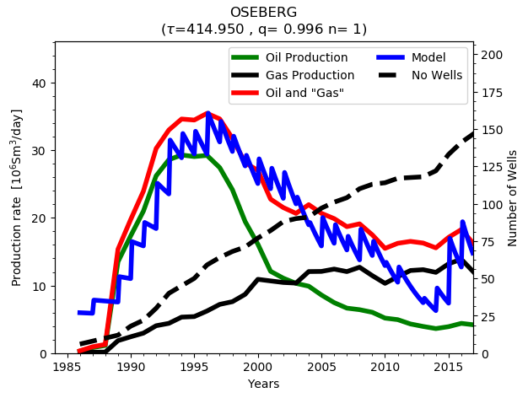 | 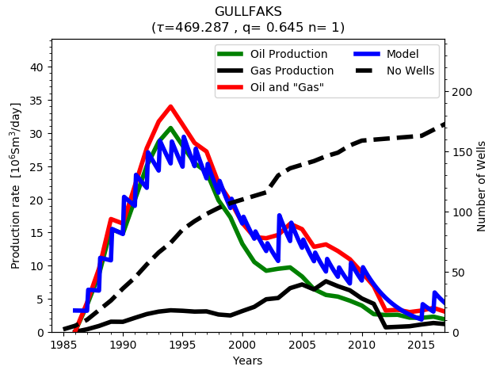
Figure 1: Modelled and actual historical production from the Oseberg and Gullfaks fields at the NCS. The dotted line is the cumulative number of wells drilled in the field.

Conclusions
The result in Berg et. al. (2018) was that a reduction in the number of wells did not affect the extraction rate, only the timing of production. Implicit assumptions for this result is homogeneous reservoirs with a very high permeability, that allows drainage with few wells. Our model, which is tested against empirical data shows the opposite, extensive drilling is crucial to the extraction rate. The physical or reservoir technical reason for this is that most reservoirs are heterogeneous, meaning that they are fractured and compartmentalized. The water injected in one well will only contact a small fraction of the reservoir, and when water breaks through in a producer the water cut will increase, and oil production drop. The challenge is then to divert the water to different places in the reservoir, and to contact unflooded areas to displace oil. To keep a high recovery from such reservoirs is thus a direct result of the activity and efforts by the operators.
As more wells are drilled, and more production data is gathered, more information is gained about the reservoir. This in turns affects the optimal placement of wells. A reduction in tax incentives, that reduces the extent of drilling, thus has a clear and negative effect on the extraction rate which must be accounted for in optimal tax design.

References
Arps, J. J. (1945). "Analysis of Decline Curves." Transactions of the AIME 160(01): 228-247.
Berg. M, Bøhren, Ø. And E. Vassnes (2018), “Modeling the response to exogenous shocks: The capital uplift rate in petroleum taxation”, Energy Economics 69, 442-455.
Danckwerts, P. V. (1953). "Continuous flow systems: Distribution of residence times." Chemical Engineering Science 2(1): 1-13.
Daniel, P., Keen, M. and C. McPherson, eds., (2010), The Taxation of Petroleum and Minerals: Principles, Problems and Practice, Routledge, joint with the International Monetary Fund, April, 2010, ISBN: 978-0-41578-138-1; pg. 425-444.
Fetkovich, M. J. (1980). "Decline Curve Analysis Using Type Curves." Journal of Petroleum Technology 32(06): 1065-1077.
Osmundsen, P. (2013), "Choice of Development Concept – Platform or Subsea Solution? Implications for the Recovery Factor", Oil & Gas Facilities (SPE), October 2013, Volume 2 Number 5, 64-70.
Osmundsen, P., Emhjellen, M., Johnsen, T., Kemp, A. and C. Riis (2015), “Petroleum taxation contingent on counter-factual investment behavior”, Energy Journal 36, 1-20.
Smith, J.L., 2014, A parsimonious model of tax avoidance and distortions in petroleum exploration and development, Energy Economics 43, 140–157.

