Rethinking Renewable Energy Auctions: Revenue Stabilisation Instead Of Support Payments

Lena Kitzing, Energy Economics and Regulation Group, Sustainability Division, Technical University of Denmark DTU,
+24659064, lkit@dtu.dk
Barbara Breitschopf, Fraunhofer Institute for Systems and Innovation Research ISI, Karlsruhe, Germany, +497216809356, barbara.breitschopf@isi.fraunhofer.de

Overview
Market-based, competitive bidding processes, i.e. auctions, are becoming a dominant policy instrument for securing future electricity production from renewable energy sources (RES). The use of auctions to selecting the most competitive RES projects for support has spread from a few implementations in the early 2000s, to over 80 countries by the end of 2017 (REN21, 2018). However, the dramatic drop in technology cost of wind and solar energy projects over the last years raises expectations that RES projects become independent of support payments within the next decade. This may seem to make auctions (in their function of allocating a support price) as policy instrument less relevant for the future. We have already seen zero-subsidy bids for sliding premiums in German and Dutch offshore wind auctions. A six-fold drop in support levels in the 2018 Danish multi-technology auctions led to onshore wind and solar energy projects receiving only expectedly 3-7% of revenues from support (fixed premiums). Indeed, in 2017 as much as 50% of new wind capacity in Europe was already partly exposed to market price risk (WindEurope 2018).
This paper proposes that even if support payments become less relevant for project profitability, auctions can still remain a valuable policy instrument for future RES deployment. This is, because full market exposure will possibly remain a deal breaker for some RES project developers – not because of the lacking prospect of sufficient revenues, but because the exposure to uncertainty and price volatility requires additional measures to assure debt service (Gerhard et al, 2015). This makes project financing complicated, expensive or even impossible. Already today, certain RES developers turn to securing cash-flows and stabilising revenues through alternative options, especially private power purchase agreements. Other market players, such as independent power producers or energy utilities, may not be hit as hard by the exposure as they can better balance risks in their portfolio.
We argue that because of the paradox in renewable energy policy (Blazquez et al., 2018) there is a natural role for goverement to mitigate policy driven impacts and ensure a certain kind of revenue stabilisation. Several economic reasons point towards the government as appropriate counter-party for such assurance (e.g. high risks during the setting up and growth phase of assurance systems), while others point against it and show potential pitfalls (lacking signal through market prices, conflict of interests).
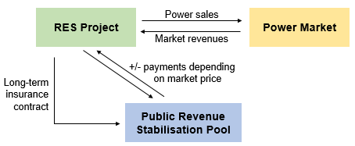
As del Río and Cerdá (2014) point out, a newly implemented policy instrument should complement the existing measures. In light of the prevalence of existing auction implementations and revenue stabilising support schemes, and of growing government efforts in reducing their interference in energy markets while at the same time trying to maintain low energy prices (low financing costs) and high engagement of many different actors in electricity generation, we suggest to supplement or adjust auction schemes through innovative re-design: Instead of allocating support payments, auctions could be used to allocate access to insurance-type schemes that provide minimum revenue streams to investors, enabling appropriate financing for those who need it.
Figure 1: Parties and relationships in the public
revenue stabilisation model

Methods
We develop and compare potential designs of a public revenue stabilisation mechanism and demonstrate why governments could be the socio-economically appropriate counter-party to provide such revenue stabilisation compared to a project-level liquidity reserve that is often required by financing institutions (see Gerhard et al., 2015). In the design of the model, we establish a constraint on zero net support. i.e. payments made to RES projects in some periods should be mitigated through repayments in other periods, so that the mechanism has a revolving nature and causes minimal cost for consumers or tax payers – while still being helpful for investors. We draw from financial engineering practices to create benefits in form of lower bankruptcy risk and better project financing options.
To test the designs for the suggested governmental revenue stabilisation scheme, we develop a multi-year stochastic cash flow model for a sample RES project to estimate the investment incentives as compared to pure merchant operation and project-level liquidity reserve management. As indicator for the bankability of the project, we determine the debt capacity of the project under an exogenously determined Debt Service Coverage Ratio (DSCR), and default probabilities at a confidence level that corresponds to standard financing models of major RES project financing banks. We incorporate a project-level liquidity management option to investigate what advantages the centralised revenue stabilisation pool might have to mitigate financial distress as compared to individual action.
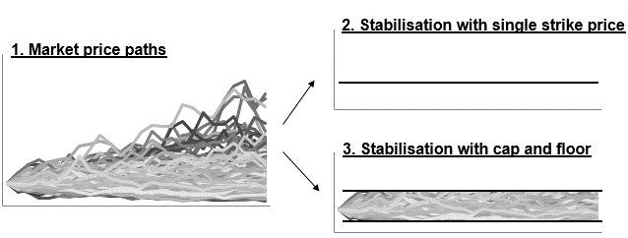
Stochastic power prices are modelled using the two-factor model developed by Schwartz and Smith (2000). Stochastic wind production is modelled using simple time-uncorrelated Weibull distributions. We then run Monte Carlo simulations on the cash flow model to determine the default probability for the given DSCR and from this the debt capacity. We then test mitigation options through active liquidity management, i.e. creating a cash reserve. We then optimise debt capacity including liquidity management. We then compare the different options to conclude on comparative attractiveness of the central pooling idea itself as well as the different suggested designs.
Figure 2: Prices can be fully (2.) or partly (3.) stabilised

Results
We show that public revenue stabilisation schemes can be a favourable policy initiative for the transition between a RES investment world that is dominated by support payments to one based on full merchant market exposure. We expect the following features of a public revenue stabilisation pool to be favourable: 1) It should be voluntary. 2) Access to it should be allocated through auctioning of long-term insurance contracts. 3) The competitive element should be the bidding for a required floor price and (possibly) an associated cap of an individual stabilisation agreement indicating when the insured effect occurs and what range is covered. We expect that especially the more risk averse investors will participate in such scheme. As risk averse investors tend to expect lower returns on their investments when exposed to lower revenue volatility, financing costs and hence electricity costs decrease through the scheme. Furthermore, as the scheme will stabilise DSCR, participating projects will be classified with a better creditworthiness, which entails lower cost of debt. We also show how the central pooling of liquidity reserves diversifies risks and increases operational efficiency, as volatility in yield and prices are dispersed across a large amount of generators.

Conclusions
We consider the described idea of pulic revenue stabilisation as step towards further privatisation of the renewable energy market. When RES technologies were still immature, governments had played a crucial role in revenue stabilisation through feed-in tariffs. Now that support levels are decreasing and RES projects are increasingly exposed to market prices, the proposed public pool could be a vehicle for government towards retracting from significant market influence in a coordinated way, while still caring for the needs of smaller and more vulnerable RES investors.

References
Schwartz ES, Smith J, 2000, Short-term variations and long-term dynamics in commodity prices, Management Science, vol. 46, p. 893-911.
WindEurope 2018, Sustaining a cost-efficient energy transition in Europe, Policy Position Paper, link.
Blazquez, J., Fuentes-Bracamontes, R., Bollino, C.A., Nezamuddin, N., 2018. The renewable energy policy Paradox. Renewable and Sustainable Energy Reviews 82, 1–5. 10.1016/j.rser.2017.09.002.
del Río, P., Cerdá, E., 2014. The policy implications of the different interpretations of the cost-effectiveness of renewable electricity support. Energy Policy 64, 364–372. 10.1016/j.enpol.2013.08.096.
Gerhard, M., Rüschen, T., Sandhövel, A. (Eds.), 2015. Finanzierung Erneuerbarer Energien, 2nd ed. Frankfurt-School-Verlag; Frankfurt-School-Verl., Frankfurt am Main, XXIX, 1150 S.
Neuhoff, K., May, N., Richstein, Jörn,C., 2018. Renewable energy policy in the age of falling technology costs. Discussion Papers of DIW Berlin.
REN21, 2018. Renewables 2018 Global Status Report (GSR). REN21 Secretariat, Paris, 325 pp.

