Run-time reduction FOR
LINEAR OPTIMIZING Energy System ModelS

Yvonne Scholz¹, +49 (0)711 6862 296, yvonne.scholz@dlr.de
Karl Kiên Cao¹, +49 (0)711 6862 459, karl-kien.cao@dlr.de
Manuel Wetzel¹, +49 (0)711 6862 664, manuel.wetzel@dlr.de
Kai von Krbek¹, +49 (0)711 6862 333, kai.krbek@dlr.de
Hans Christian Gils¹, +49 (0)711 6862 477, hans.gils@dlr.de
Benjamin Fuchs¹, +49 (0)711 6862 261, benjamin.fuchs@dlr.de
Frieder Borggrefe¹, +49 (0)711 6862 431, frieder.borggrefe@dlr.de
¹Department of Energy Systems Analysis, Institute of Engineering Thermodynamics, German Aerospace Center (DLR)

Overview
The large numbers of variables and constraints and interdependencies in energy system models makes these large and complex. In order to keep model running times in feasible limits, the resolution in the dimensions time, space and technologies frequently has to be adapted to the computing infrastructure capacity. The error that the applied simplifications bring about is mostly unknown. In the BEAM-ME project (funded by the German Federal Ministry for Economic Affairs and Energy) a consortium of energy system modellers, mathematicians, computer scientists and software developers has implemented and assessed methods for run time reduction. In this talk the methods and assessments are presented, a short introduction on running energy system models on high performance computers is given and the open access best practice guide that is a result of the BEAM-ME project is introduced.

Methods
Methods for run time reduction can be classified in modelling based and technical methods. Modelling based methods on the one hand comprise simplifications such as choosing only parts of the time slices (e.g. [1]) or regions (e.g. [2]) or technology portfolios(e.g. [3]) or aggregating time slices (e.g. [4]) or regions [e.g. [5]) or technologies (e.g.[6]) and heuristics such as rolling horizon (e.g. [7]) or temporal or spatial “zooming”. On the other hand, mathematically exact decomposition methods (e.g. Dantzig-Wolfe, Lagrangian or Benders decomposition) also belong to the class of modelling based performance enhancement strategies.
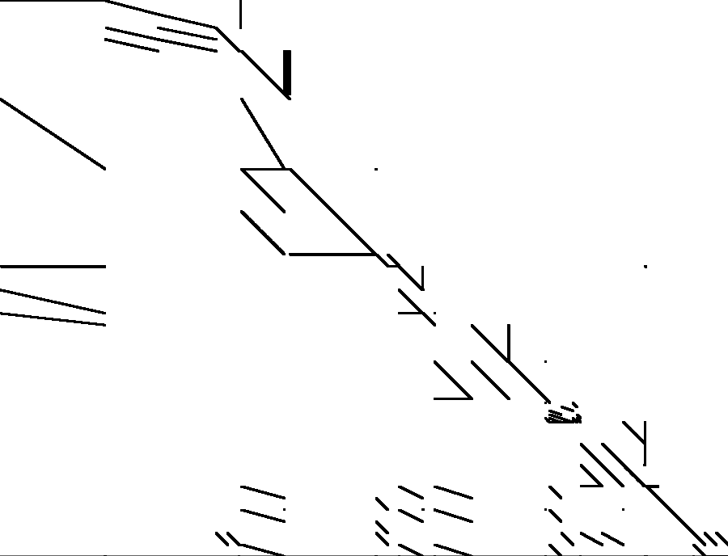

Figure 1: Entries in the model matrix of a REMix instance. x-axis: variables, y-axis: constraints.
Technical strategies utilize computers with higher processing power or more memory up to high performance computers. To do so, the optimization model instances must be divided into blocks that can be solved in parallel. Due to the high amount of temporal, spatial and technological interdependencies in the energy system caused for example by storage, transmission or CO₂ emission limits, energy system models contain so called linking constraints and linking variables, which hinder parallelization. Figure 1 shows the non-zero entries in the model matrix of an instance of the energy system model REMix (developed at the German Aerospace Center DLR). Variables are listed along the x-axis, constraints along the y-axis. Linking variables can be identified by their vertical distribution across two or more rows, linking constraints by their horizontal distribution across two or more columns of the matrix. Permutation of rows and columns allows partly separating the linking elements and forming blocks out of the remaining entries that can be solved in parallel. In the BEAM-ME project, this process of structuring the model instances (the so called annotation), a solver that can utilize the block structure and an interface to the solver were developed.

Results
As an example for the influence of model resolution, figure 2 shows the change of model running times of a REMix instance with the number of variables.
Regarding the annotation for parallelization, more blocks enhance parallelization but also increase the number of global linking elements (vertical block across all constraints on the left of the matrix and horizontal block across all variables at the bottom of the matrix). The goal is an ideal compromise of amount of blocks and amount of global linking elements. Figure 3 shows different block structures of one REMix model instance with differen suitability for parallel solving.
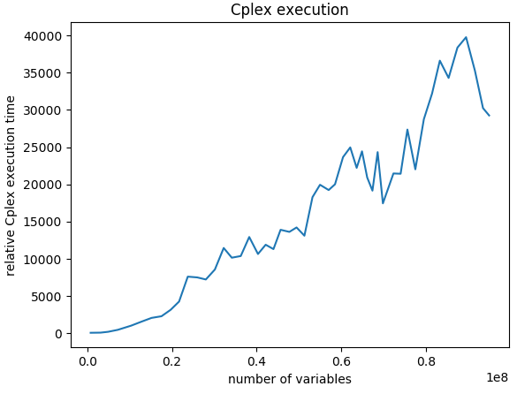 | Figure 2: Dependency of the CPLEX solver running times of the number of variables  Figure 3: Block structure of a REMix model instance. x-axis: variables, y-axis: constraints.  a) few blocks of very different size → poor parallelization, b) many blocks → too many linking elements, c) good compromise of number of blocks and number of linking elements.

a)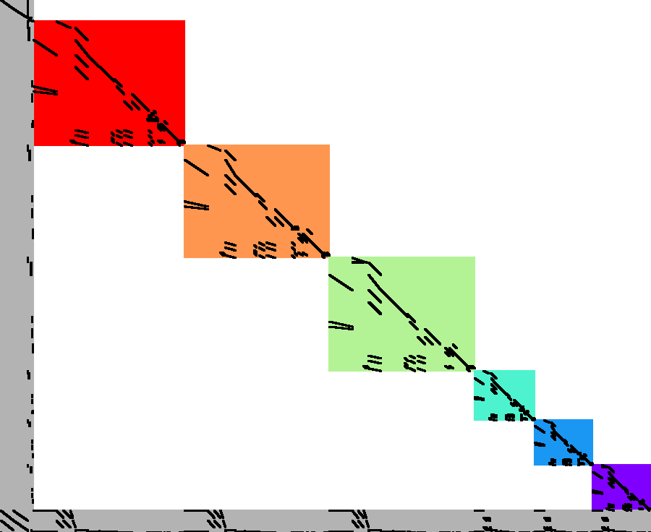 | b)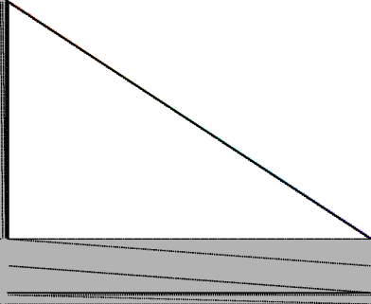 | c)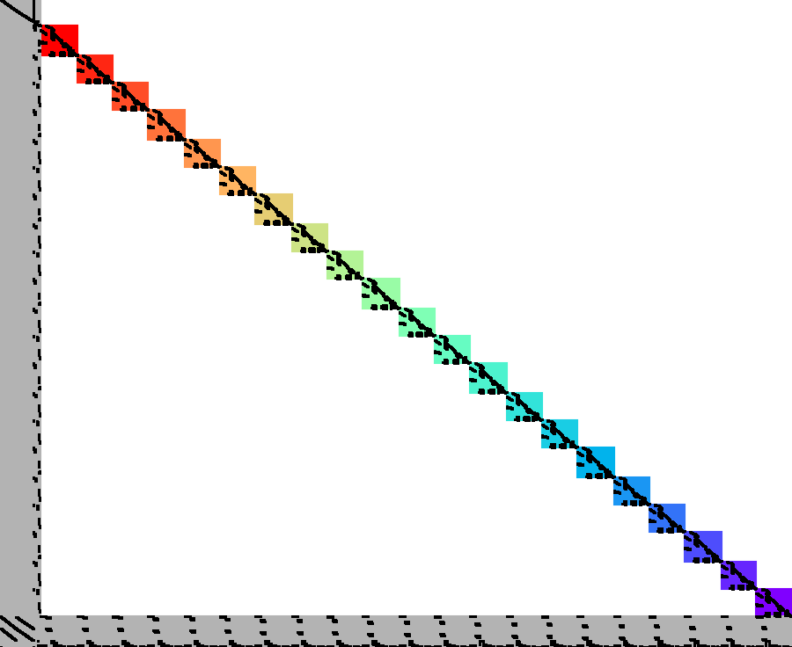
The assessment of the run time reductions that can be achieved through parallelization, the most suitable block structures and the transferability to other energy system models is work in progress in the BEAM-ME project and will be finalized by June 2019.

Conclusions
Many energy system modellers encounter run time problems with their models. The need for run time reduction as well as information on suitable resolutions is addressed in the BEAM-ME project. This talk presents an overview and assessments of run time reduction strategies, gives advice on how to access information about running energy system models on high performance computers and introduces an open access best practice guide for interested energy system modellers.

References
[1] C. Bussar, P. Stoecker, Z. Cai, L. M. Jr., D. Magnor, P. Wiernes, N. van Bracht, A. Moser, and D. U. Sauer, “Large-scale integration of renewable energies and impact on storage demand in a European renewable power system of 2050â€”Sensitivity study,” Journal of Energy Storage, vol. 6, pp. 1–10, 2016.
[2] H. Weigt, T. Jeske, F. Leuthold, and C. von Hirschhausen, “Take the long way down“: Integration of large-scale North Sea wind using HVDC transmission,” Energy Policy, vol. 38, no. 7, pp. 3164–3173, 2010.
[3] A. S. Brouwer, M. van den Broek, W. Zappa, W. C. Turkenburg, and A. Faaij, “Least-cost options for integrating intermittent renewables in low-carbon power systems,” Applied Energy, 2007.vol. 161, pp. 48–74, 2016.
[4] S. Pfenninger, “Dealing with multiple decades of hourly wind and PV time series in energy models: A comparison of methods to reduce time resolution and the planning implications of inter-annual variability,” Applied Energy, vol. 197, pp. 1–13, 2017.
[5] B. A. Corcoran, N. Jenkins, and M. Z. Jacobson, “Effects of aggregating electric load in the United States,” Energy Policy, vol. 46, pp. 399–416, 2012.
[6] F. Cebulla and T. Fichter, “Merit order or unit-commitment: How does thermal power plant modeling affect storage demand in energy system models?,” Renewable Energy, vol. 105, pp. 117–132, May 2017.
[7] A. Tuohy, E. Denny, and M. O’Malley, “Rolling Unit Commitment for Systems with Significant Installed Wind Capacity,” 2007 IEEE Lausanne Power Tech, pp. 1380–1385, Jul. 2007.

