Overview

Long-term LNG demand projection in the Asia Pacific and possible implication on destination clause removal from LNG contracts to LNG importers

Fang-Chia Lee, Asia Pacific Energy Research Centre, +81 3-5144-8552, fang.lee@aperc.ieej.or.jp
Muhamad Izham Abd. Shukor, Asia Pacific Energy Research Centre, +81 3-5144-8541, muhamad.izham@aperc.ieej.or.jp
Asia-Pacific economies are major LNG buyers in the world. Japan, South Korea, and Chinese Taipei have been the main consumer for the past decades. The LNG market has been intensified further with rising demand from China and India. As LNG trade is expected to continue to increase in the future, a more a robust LNG market may help to improve the supply, as well as demand.

To understand better the possible future energy trend among Asia-Pacific Energy Cooperation (APEC) members, which comprises the US, Canada, Mexico, as well as most of Asia Pacific economies including Japan, Korea, China, Chinese Taipei and 4 ASEAN members, Asia Pacific Energy Research Centre (APERC) published a Energy Demand and Supply Outlook every three years. Based on preliminary results of our BAU projection, gas demand in 9 Asia-Pacific economies are projected to double by 2050, from 475 Bcm in 2016 to 836 Bcm in 2050. However, LNG demand is projected to be flat at least until 2020 because of various factors such as restarting of the nuclear plant in Japan as well as higher penetration of renewable energy.

In order to make the LNG market more robust, as well as to meet the future LNG demand as mentioned above, many gas market experts agreed that the removal of destination clause or territorial restrictions in supply contracts in APEC region will eventually help to improve gas take up. Therefore, in June 2017, Japan Fair Trade Commission released the results of Survey on LNG Trades: Ensuring of fair competition in LNG market. Contracts for the sale of LNG, heading towards Japan, has been traditionally limited the buyers ability to freely resell the cargoes to the third party acquired under the contract. This provision helps LNG producer and sellers to manage their markets and operations and that the same time, helps buyers to secure the cargoes.

Methods
APERC has conducted an modelling exercise that covers 21 economies (Australia, Brunei Darussalam, Canada, Chile, China, Hong Kong, Indonesia, Japan, Korea, Malaysia, Mexico, New Zealand, Papua New Guinea, Peru, the Philippines, Russia, Singapore, Chinese Taipei, Thailand, the US and Viet Nam) for Energy Demand and Supply Outlook with projection up to 2050. From the preliminary results generated from our models, APERC made a further analysis on possible future LNG and gas pipeline trade.

Besides projecting gas and LNG demand, this study will also look at the possible effect of removing/limiting destination clause (territorial restrictions) on LNG pricing, the creation of gas/LNG hub in Asia and to some extent the supply security for importers. On top of that, this paper will touch lightly on the possibilities of the LNG consumer in removing such clauses in their future contracts and the effect on their future supply continuity. The study will look into the past cases such as in EU for literature review, data analysis based on past price movement that may happened due to removal of destination clause, as well as interviews with gas experts from Japan, Chinese Taipei, Korea and China (buyers group) as well as Malaysia and possibly Australia (producers group).

Results
Gas demand is projected to continue to increase in the future, while LNG demand projected to be flat for the next few years. The future flat demand of LNG, at least until 2020, may due to lack of market flexibility, especially with the existence of destination clause. On the other hand, without destination clause, some importers may think that there is lack of supply security.

Based on preliminary results of our Outlook, gas demand in 9 economies in Asia Pacific is projected to increase by nearly 80% from 475 Bcm in 2016 to 836 Bcm in 2050. Most of the new growth is projected to happen in China and Southeast Asia economies. However, LNG demand is projected to have modest growth in 2016-30 period, rising from 169 Bcm in 2016 to 200 Bcm in 2030. A rapid growth can only be seen post 2030, reaching 300 Bcm in 2050.

Figure 1: Gas and LNG demand in selected Asia Pacific economy, 2016-50

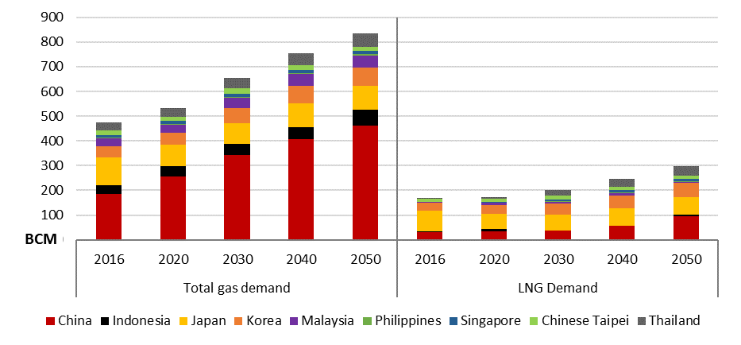
Source: APERC Analysis

By having the projection of gas and LNG demand, this study will also look at the price changes in Europe and Asia whenever the issues of destination clause or territorial restriction were solved by competition commission in the respective area. The creation of LNG hub will depend on so many factors and not just by removing destination clause. Therefore, this study will examine further Asia's gas hub creation and its correlation to destination clause. The results will provide insights from interviews that have been conducted.

Conclusions
Given that the US is projected to add at least 70 Mtpa of LNG export capacity by 2020, and at the same time other economies such as Australia, Qatar, and Russia are racing to built more capacity, there is a need for exporting economies to look into the possibility to diversify the buyers. On top of that, the oversupply situation for LNG might be prolonged until at least mid-2020's.

The conclusion will depend on the final results of the study. However, based on preliminary findings, the study found that some LNG importers are not so keen to remove the destination clause from their contracts due to supply security reason. On the other hand, most producers are ready to make contract changes as requested by the consumer, provided that their initial investment in building LNG terminal are covered.

References
APERC (Asia Pacific Energy Research Centre) (2016), LNG in Asia-Pacific-Favoring trade and rational market development,
--------(2017), Natural Gas Utilization in APEC: Is the Golden Age of Gas Still Probable?
CEDIGAZ (2017), Natural Gas Statistical Database
IEA (International Energy Agency) (2017), World Energy Statistics and Balances.
JFTC (Japan Fair Trade Commission) (2017), Survey on LNG Trades,

