Improving Projections of Global Oil and Gas Supply
Terry Yen, U.S. Energy Information Administration, 202-586-6185, terry.yen@eia.gov
Troy Cook, U.S. Energy Information Administration, 720-724-7559, troy.cook@eia.gov
Dana Van Wagener, U.S. Energy Information Administration, 919-402-0426, dana.vanwagener@eia.gov
Ken Walsh, Leidos, 919-836-7579, kenneth.j.walsh@leidos.com
Tuncay Alparslan, U.S. Energy Information Administration, 202-586-3138, Tuncay.alparslan@eia.gov
Ari Kahan, U.S. Energy Information Administration, 202-586-4058, ari.kahan@eia.gov

Overview
As the interconnections between domestic and international energy markets become more complex and the role of the U.S. in international energy trade has grown in significance with the rise of shale gas and tight oil production, international energy analysis at the U.S. Energy Information Administration (EIA) has taken on a renewed emphasis. While there are many models of global energy production, no existing model adequately estimates worldwide oil and gas production, conversion, and transportation logistics in a single integrated framework that also reflects coproduction of oil and gas resources. To more robustly capture the interplay between energy commodities for shared resources and markets, EIA is developing the Global Hydrocarbon Supply Module (GHySMo). GHySMo provides flexible geographic resolution, endogenous modeling of hydrocarbons and prices, and internal resource trade-offs. It is composed of three modules representing the upstream, logistics, and conversion processes of hydrocarbon production that are dynamically integrated. The model structure and preliminary results of the GHySMo Upstream module are discussed in this abstract.

Methods
The GHySMo Upstream module outputs regional commodity specific supply quantities over time for a set of regional price paths to the GHySMo Logistics module, which balances these supply quantities with demand quantities at the regional level to produce regional equilibrium price paths for each hydrocarbon commodity of interest. The GHySMo Upstream module operates at the level of a “nation-basin-field-costblock-engine” (NBFCE), with each NBFCE representing a “project”.
The module consists of two functional sub-modules: a data preparation sub-module and a capacity expansion and dispatch sub-module. In the data preparation sub-module, time-invariant resource cost curves and resource field size distributions for four resource data “engines” are first generated (via the “Resource Handler”). The four engines, grouped together based on the similarity of input information, are: 1) expected future volumes from known fields or groups of fields, most of which are already in production and subject to natural field level decline behavior, 2) additional volumes from known fields or groups of fields possible with investment, 3) fields or groups of fields that are not yet discovered, and 4) light/tight oil and shale gas, sometimes referred to as continuous resources, or resource plays.
The cost curves and distributions from the Resource Handler undergo some additional preprocessing, that include calculations of the number of rig-years needed to develop resources, and calculations of parameters that allow the GHySMo Upstream module to endogenously “make discoveries” of fields. They are then merged with scenario specifications and regional price paths in the “Supply Handler”, where production profiles are applied, additional costs for development not included in the Resource Handler are calculated, and the resulting cost curves for fields smaller than a user-specified size are blended (fields above the size cutoff are left unblended).
These blended and unblended resource cost curves and their production profiles are fed into the capacity expansion and dispatch sub-module, where the net present value (NPV) of each NBFCE project is calculated. The NPV’s are used, along with the number of available rigs, to schedule the development of each NBFCE project. Production of each NBFCE project selected for development is summed to generate annual regional commodity specific supply.

Results and Conclusions

Preliminary annual supply quantities (for a specific set of price paths based on EIA’s International Energy Outlook 2017 (IEO2017)) will be presented for 24 regions and 6 commodities (natural gas, liquefied petroleum gases, light crude, medium crude, heavy crude, and condensate). Sample preliminary results for one commodity is shown below. As expected, we found that the production volumes depend greatly on the commodity price paths. However, due to the GHySMo upstream module being based on discrete projects that must meet constraints such as the number of available rigs, the response is not continuous.

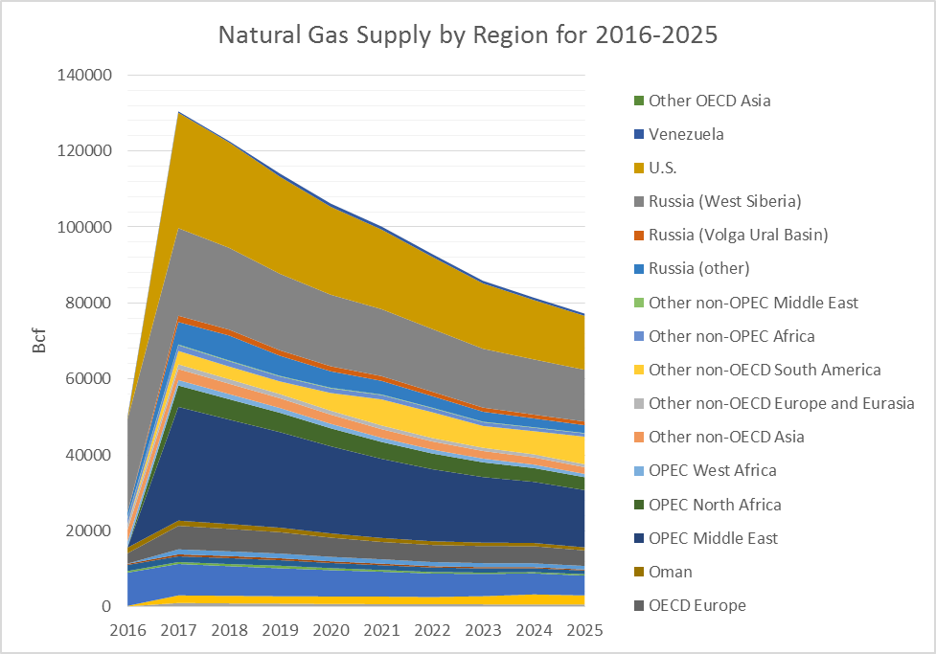

References
None.

