Electricity Market Impacts of Variable Renewable Energy and Carbon Emission Policies
Todd Levin, Argonne National Laboratory, 630-252-6878, tlevin@anl.gov
Audun Botterud, Argonne National Laboratory, 630-234-8854, abotterud@anl.gov

Overview

Over the past decade the penetration of variable renewable energy (VRE) resources, such as wind and solar, has increased rapidly in power systems throughout the world. Such system evolution has been driven by decreasing VRE technology costs, but has also been supported and accelerated through various mechanisms that have been implemented to achieve policy objectives. Some of these mechanisms focus specifically on carbon emissions, for example a carbon tax or a ‘cap-and-trade’ framework that limits emissions and creates a market for emissions credits. Other mechanisms directly target specific technologies, for example a production tax credit (PTC) for each kWh of electricity produced by a VRE resource, an investment tax credit (ITC) to offset the capital costs of new VRE resources, or a renewable portfolio standard (RPS), which mandates that a certain fraction of system electricity generation comes from renewable sources.

All else equal, increased VRE penetrations tend to reduce wholesale electricity prices in competitive power markets and there is a wide body of literature that examines this effect and associated operational impacts [1]. However, many past studies only consider scenarios with exogenously defined VRE penetrations levels. While such studies address the system and market impacts caused by increased VRE generation, they do not address the market impacts that are caused by the policies (or lack thereof) implemented to support the increased VRE penetration levels or related objectives. Furthermore, many of these studies introduce new VRE capacity into an existing generation portfolio without considering the corresponding thermal unit investments and retirements that may result under long-run equilibrium conditions.

To address this gap in the literature we present a comparative analysis of five policies that may be implemented to support the development of VRE resources. We determine the least-cost generation portfolios that will result under a range of policy parameters and analyze the corresponding impacts to wholesale energy prices.

Methods

We utilize a mixed-integer programming model from previous work [2] that minimizes the total cost of serving demand for energy and ancillary services, while considering unit investments and retirements, hourly commitment and dispatch, and various operational constraints. In contrast to previous applications, wind and solar investments are also optimized based on system and policy parameters, rather than being exogenously defined. We assume that the results obtained from this least-cost approach reflect the competitive market outcome under economic equilibrium. The model also utilizes a unit clustering approach to represent investment and commitment decisions for similar units with integer variables. This approach has been shown to dramatically reduce computation time without significantly impacting the numerical results [3].
The model is executed for a one-year period in two distinct stages. In the first stage, unit investments, retirements, commitment and dispatch are optimized over a twelve week subset of the year – considering one week per month. This limits computational complexity and ensures that the investment problem is tractable. In the second stage the identified investment decisions are fixed, and unit commitment and dispatch decisions are optimized for a full year (8760 hours). Hourly prices for energy and ancillary services are determined from the dual variables of their respective balancing constraints.
The model is applied to analyze a simplified representation of the ERCOT system in Texas considering planned capacity additions through 2022, extrapolating current demand projections to 2030, and requiring a 15% planning reserve margin. The load curve is defined based on historical 2017 data but is shifted upwards to reflect the projected 2030 peak load value of 89,177 MW, which represents a 28% increase from 2017. Four thermal unit types are considered as investment options - nuclear, coal, natural gas combined cycle (NGCC) and natural gas combustion turbine (NGCT) – as well as wind, solar, and battery storage. Cost assumptions are based on the assumptions to the 2018 U.S. Energy Information Administration Annual Energy Outlook. In addition to a baseline scenario (without policy interventions), five different policies are analysed. Sensitivity analysis is conducted with three different parameter values for each policy (Table 1).

Table 1: The policy scenarios considered by this analysis
Policy | Abbreviation | Description | Metric | Scenario Range
Carbon Tax | CTAX | A cost is applied to each ton of emitted carbon. | $/ton | $30-$90
Emissions Constraint | EMS | Annual maximum constraint on carbon emissions. | tons/year | 100-150
Investment Tax Credit | ITC | Credit for each MW of installed wind and solar capacity. | % of capital cost | 20%-60%
Production Tax Credit | PTC | Credit for each MWh of wind and solar generation | $/MWh | $10-$30
Renewable Portfolio Standard | RPS | Annual minimum constraint on VRE generation potential. | % of generation | 30%-50%

Results
In the baseline scenario 25,800 MW of new NGCC capacity is developed, with no other additions. The average market clearing energy price is $29.00/MWh and 179 million metric tons of carbon are emitted (390 kg/MWh). VRE provides roughly 22% of system generation, with most coming from wind.
Figure 1 illustrates the relationship between VRE penetration and the average energy price for each policy and scenario. VRE penetrations generally increase as the policies become increasingly stringent. One exception is found under the carbon tax policy. A $30/ton tax does not significantly impact the VRE penetration, instead natural gas largely displaces coal generation. A $60/ton tax does lead to new wind capacity, increasing the VRE penetration to 43%. However, when the tax is increased to $90/ton, new nuclear capacity is introduced instead and the VRE penetration level decreases to 31%. With the exception of the RPS, the least stringent scenario for each policy does not increase the VRE penetration above baseline.
Figure 1 also highlights how different policies may lead to comparable VRE penetration levels but different market outcomes. Most notably, the three policies that target renewable generation directly (ITC, PTC, RPS) typically decrease average energy prices. This is because wind and solar resources with zero or negative (with the PTC) marginal costs increasingly set the energy price. Alternatively, the two policies that target carbon emissions generally increase the energy price. The carbon tax increases the marginal cost of natural gas and coal generation, while the emissions constraint shifts generation from coal to NGCT units with higher marginal cost.

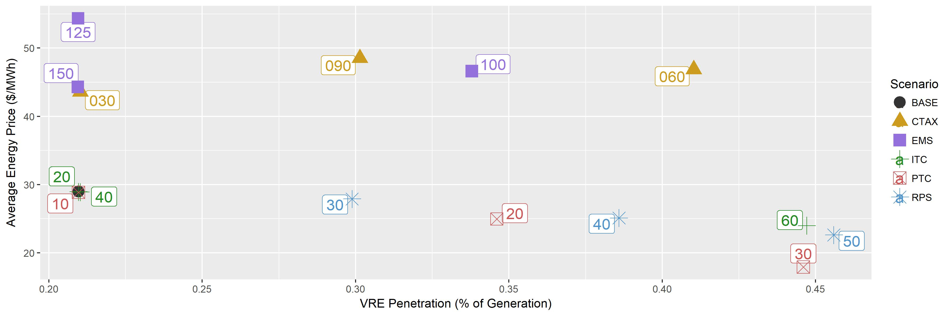

Figure 1: The relationship between VRE penetration and the system average energy price for each considered scenario. The numerical labels provide the value of the associated policy metrics. These are detailed in Table 1.

Conclusions

Our analysis indicates that different policies can result in comparable VRE penetration levels but very different electricity market outcomes. The differences in energy prices that are observed between these policy scenarios will also impact unit revenues. This suggests that under some policies additional revenue sufficiency measures – e.g. capacity markets - may be required to maintain resource adequacy. Future work will focus on understanding how these VRE policies impact plant revenues when implemented in conjunction with, or in the absence of, capacity markets and other revenue sufficiency mechanisms.

References
[1] R. Wiser, A. Mills, J. Seel, T. Levin, and A. Botterud, “Impacts of Variable Renewable Energy on Bulk Power System Assets, Pricing, and Costs,” Lawrence Berkeley National Lab, Berkeley, CA, LBNL-2001082, 2017.
[2] T. Levin and A. Botterud, “Capacity Adequacy and Revenue Sufficiency in Electricity Markets With Wind Power,” IEEE Transactions on Power Systems, vol. 30, no. 3, pp. 1644–1653, 2015.
[3] B. S. Palmintier and M. D. Webster, “Heterogeneous Unit Clustering for Efficient Operational Flexibility Modeling,” IEEE Transactions on Power Systems, vol. 29, no. 3, pp. 1089–1098, May 2014.

