MUTE CARBON PRICE? HOW TO RESTORE ECONOMIC INCENTIVES IN EMISSION TRADING

Vera Zipperer, DIW Berlin, +49 30 897 89-667, vzipperer@diw.de
Misato Sato, Grantham Research Institute on Climate Change and the Environment LSE, +44 20 7107 5027, m.sato1@lse.ac.uk
Karsten Neuhoff, DIW Berlin, +49 30 897 89-470, kneuhoff@diw.de

Overview
Our core research question is: With the increasing use of benchmark based free allocation in emission trading schemes, what is the optimal design of emissions benchmarks, that provide consistent incentives to enable industries to move forward with low carbon investments in the long term?
Reducing carbon dioxide emissions (CO2) into the atmosphere is an essential tool in mitigating climate change. In this respect, one important quantity-based policy tool are a Emission Trading Systems (ETS) with a cap on emissions and tradable emission allowance certificates, through which carbon is priced. Putting a price tag on this negative externality, carbon emissions, should incentivize firms to reduce these.
A key aspect in designing an ETS is to avoid adverse effects of the trading system. Firms might consider relocating to regions or countries outside of the geographical scope of the system to avoid paying for their emissions within the ETS. Such relocations can create adverse effects in form of price distortions, profit reductions, unemployment increases in the ETS-region, and increased emissions in the rest of the world. This so-called carbon leakage is most likely to occur in sectors which are carbon intensive and thus have to bear larger costs under an ETS. As a leakage protection mechanism, firms in carbon intensive sectors are often granted emission allowances for free. However, this effectively mutes the carbon price of the ETS for the firms (Sterner and Muller, 2008).
In many ETSs around the world, emission benchmarks were introduced to allocate free emission allowances. Even though the introduction of benchmarks signifies a big step in the free allocation discussion, the design of benchmarks remains open for improvements. Currently, the benchmarks are driven from a technical and engineering perspective (Ecofys et al., 2009), without taking economic incentives or medium term firm behaviour into account. In order to restore and implement proper economic incentives through the carbon price, even with free allocation, going beyond technical benchmarks is needed.
There are three main challenges ahead when moving from technical benchmarks to an allocation which ensures economic incentives. First, the allocation through benchmarks has to be linked to firm specific activity levels. In recent years, this activity measure developed from historical output numbers to so-called ‘dynamic’ allocation which relates the emission benchmark to regularly uptdated output figures. This helps avoiding perverse incentives stemming from historic output levels paired with a different economic situation (Zetterberg, 2014; Fischer and Fox, 2007; Fischer, 2001). Second, carbon costs from an emission trading scheme are often not fully internalised by the final consumers because of limited carbon price pass through (Neuhoff et al., 2014). Thus, the consumer has limited incentives to choose less carbon intensive products or even substitutes. In turn, producers face less pressure to develop new breakthrough technologies to reduce their carbon emissions. Third, additional inefficiencies remain considering longer-term investments. A muted carbon price paired with low demand side response holds back investments because firms are uncertain of how to cover any incremential costs created through further carbon reductions. One way to overcome this investment barrier is to provide additional emission certificates which cover incremental cost increases at the benchmark level.
We propose an adjustment of benchmarks in terms of their input and by-product scope to provide consistent economic incentives for firms to invest and to reduce their carbon emissions. With the help of an analytical model we show that inputs, which to not have carbon costs internalised already, should be reduced from the benchmark level. The production of desirable by-products, which might reduce carbon emissions in other material production processes, should be incentivised by adding allowances for these by-products at the benchmark level. We test our proposed benchmark design for the steel sector, both theoretically as well as empirically. The paper also discusses remaining inefficiencies not solved through adjustment of benchmarks, e.g. demand side response.

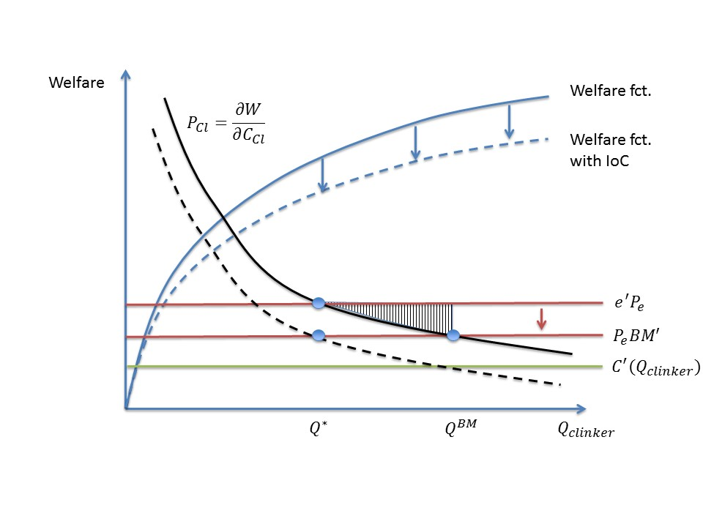
Methods
Figure 1
This paper provides an analytical framework for the design of emission benchmarks. With the help of a theoretical model, we analyze how emission benchmark values affect firms’ incentives in industrial production processes. We use the example of the steel sector to model the firms profit maximization problem. We test different cases of benchmark adjustment, varying in the scope of inputs and by-products covered, and compare the proposed benchmark design to the socially optimal production quantities with the help of a welfare function analysis. In the second part of the paper, we quantify the effect of the benchmark adjustments with industry plant level data.

Results
The analysis of this paper shows that the system boundaries of benchmarks have to be drawn in such a way, that inputs without internalised carbon costs as well as desirable by-products are considered in the benchmark and thus their socially optimal use is incentivised. Three principles for benchmark design emerge: First, additional allocation for on-site input production should be granted if the combined production process is less carbon intensive compared to a separate production process of two stand-alone plants. Second, additional allocation for production of by-products should be granted if they are desirable goods and the producers of competing products also receives free allocation. Third, the benchmark allocation should not be adjusted for inputs or by-products which do not receive free allocation. Even if these principles of benchmark design were followed, there would still be inefficiencies in the emission trading scheme because of a lack of demand side response. We show that a consumption charge might be useful to restore socially optimal supply quantities of materials withouth deterring overall welfare (Figure 1).

Conclusions
The paper shows the importance of well designed free allocation mechanisms in the context of investment and emission reduction incentives. A benchmark adjustment for inputs and by-products without internalised carbon costs is necessary while an adjustment for inputs and by-products with internalised costs would lead to unfair competition across firms. An adjustment of the benchmark design is however not sufficient to reinstall socially optimal supply levels nor to lead to radical innovations. Demand side responses have to be triggered in order to create a longterm investment environment for firms. Policy makers should thus not only focus on the upstream but also on the downstream incentives in emission trading schemes.

References
- ECOFYS, Fraunhofer ISI, and Oeko-Institut. 2009. Methodology for the free allocation of emission allowances in the EU ETS post 2012.(November 2009): 1–128.
- Fischer, Carolyn. 2001. “Rebating Environmental Policy Revenues: Output-Based Allocations and Tradable Performance Standards.” Resources for the Future Discussion Paper(July 2001): 1–22.
- Fischer, Carolyn, and Alan K. Fox. 2007. “Output based allocation of emissions permits for mitigation tax and trade interactions.” Land Economics, 83 575–599.
- Neuhoff, Karsten, Vanderborght Bruno, Ancygier Andrzej Atasoy Ayse T., Haussner Manuel, Ismer Roland, Mack Bendict, Sabio Nagore, Ponssard Jean P., Quirion Philippe, van Rooij Arjan, Sartor Oliver, Sato Misato, and Shopp Anne. 2014. Carbon control and competitiveness post 2020: The cement report, Climate Strategies, 2014, London. February 2014.
- Sterner, Thomas, and Adrian Muller. 2008. “Output and abatement effects of allocation readjustment in permit trade.” Climatic Change, 86(1): 33–49, DOI: http://dx.doi.org/10.1007/s10584-007-9281-0.
- Zetterberg, Lars. 2014. “Benchmarking in the European Union Emissions Trading System: Abatement incentives.” Energy Economics, 43 218–224, DOI: http://dx.doi.org/10.1016/j.eneco.2014.03.002.

