Overview
PERFORMANCE OF THE U.S. PETROLEUM INFRASTRUCTURE UNDER FUTURE OIL MARKET SCENARIOS
Gbadebo Oladosu, Oak Ridge National Laboratory, 865-576-2485,oladosuga@ornl.gov

Global and regional oil markets have experienced significant changes since 2000 due to a combination of economic/financial, geopolitical and other developments. In line with a trend dating back to the mid-1980s, crude oil imports by the United States (U.S.) peaked at more than 10 million bbl/d in 2006, with domestic production declining to about 5 million bbl/d. Driven by persistent increases in oil prices between 2003 and 2007, new technologies were developed in the U.S. to extract crude oil from non-conventional shale formations. By 2008 horizontal drilling and fracking technologies had led to a break-through in the efficient extraction of oil from these formations. The production of oil in the U.S. climbed to about 9.4 million bbl/d in 2015, leading to a significant decline in imports. However, accommodating the new oil proved to be challenging to the domestic petroleum supply chain. These challenges arose from mismatches between the location and quality of the new light oil, and the location and configuration of U.S. refineries. The severity of the resulting dislocations to the U.S. petroleum infrastructure is well-illustrated by the spread between the prices of West Texas Intermediate –WTI (the long-standing U.S. light-sweet marker crude) and Brent (the global light-sweet marker crude). The spread between the prices of these two crudes from 2006 to 2010 was generally below $5/bbl but remained persistently above $15/bbl, peaking at more than $30/bbl, between 2011 and 2013. The large discount of the WTI price relative to Brent during the latter period shows that the domestic petroleum infrastructure necessary to support the new domestic oil flow was not fully prepared. No doubt, this negated some of the potential benefits to the U.S. economy from the increase in domestic oil production, and delayed its ability to affect the global oil market. Thus, there is a crucial need for greater understanding of the responses of individual petroleum supply chain components, as well as their interdependencies, under potential future resource and market developments. There are a number of existing studies on the consequences of rejuvenated oil production in the U.S. (EIA, 2015a, EIA, 2015b; Brown et al, 2014; Bordoff and Houser, 2015). The effort discussed in this paper contributes to this literature, particularly by explicitly accounting for interdependencies in the oil flow infrastructure.

Methods

This study employs a recently developed linear programming (LP) model of the U.S. petroleum market. The LP model, designated TRIM (Transportation, Refining and Infrastructure Model), provides a compact but integrated representation of the U.S. petroleum supply system (see Figure 1). It models the network structure of the crude oil transportation system to connect oil production/imports with refiners, capturing crucial interdependencies among the system components. There are 19 domestic oil producing regions in TRIM, which are connected through a network of pipelines and other transportation links to 33 refinery locations. These refineries produce petroleum products, which are each aggregated at the Petroleum Administration for Defense Districts (PADDs) region level for distribution. TRIM is currently an annual static model, and includes a limited representation of global oil market components that interact closely with the U.S. petroleum market.

Results

Simulations are performed with TRIM under two sets of cases. The first set consists of the AEO2015 Reference, Low Oil Price and High Resource cases (EIA, 2015), with the ban on oil exports from the U.S. remaining in place. The second set includes the same AEO2015 cases, but lifts the ban on U.S. oil exports in line with recent congressional action under the 2016 Appropriation Act (U.S. Congress, 2015). From an infrastructure perspective, the results imply that oil production forecasts under the AEO2015 Reference and Low Oil Price cases can be produced between now and 2030 with the oil export ban in lace, but not under the High Resource case. Lifting of the oil export ban did not change the U.S. oil supply-demand balance significantly under the Reference and Low Oil Price cases, but leads to exports of 1 million bbl/d to 2 million bbl/d under the High Resource case. These results incorporate a number of assumptions, which are further explored with side cases.

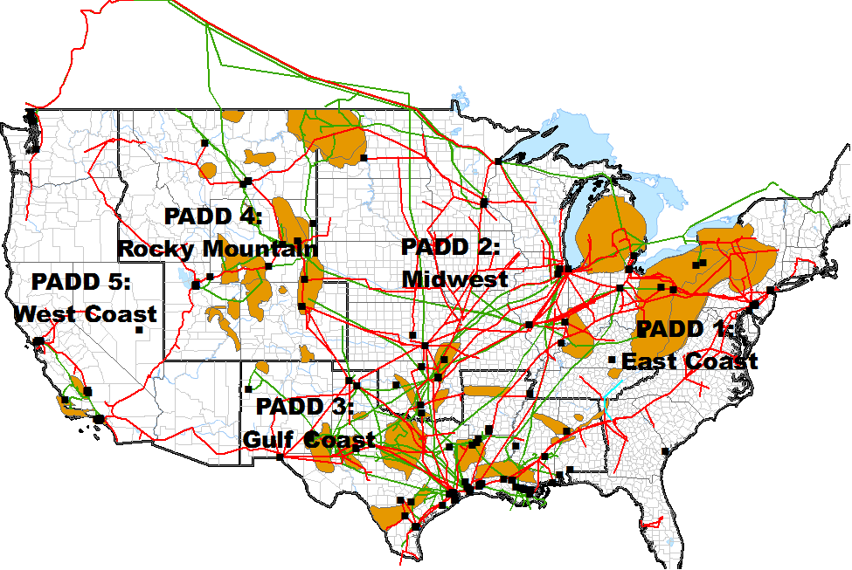
Figure 1: U.S. Petroleum Administration for Deference Districts (PADD): Tight oil plays (brown areas), refineries (black squares), major crude oil (green) and product (red) pipelines. Source: Map produced by the authors based on GIS energy data files from the EIA (http://www.eia.gov/maps/layer_info-m.cfm)

Conclusions

Simulation results suggest that U.S. oil production of slightly below 10 million bbl/d between now and 2030 can be accommodated by the petroleum supply infrastructure under the Reference and Low Oil Price cases of the AEO2015, with the lifting of the oil export ban having limited impacts. However, this conclusions rests on the buildout of oil transportation capacities as assumed under the TRIM simulations, which are based on available data on planned projects. Shadow prices on capacity constraints for many oil transportation links decline under the Reference case as new capacities are added after 2018. Even so, the High Resource case increases the stress on the domestic petroleum supply infrastructure, and there is a sizable amount of oil export under this scenario following the end of the U.S. ban. Further developments of TRIM is ongoing to better capture interactions between various components of the U.S. petroleum supply system, and the global oil market, under future market scenarios.

References
- United States Energy Information Administration – EIA (2015) Annual Energy Outlook 2015. http://www.eia.gov/forecasts/aeo/
- U.S. Congress (2015) H.R.2029 - Consolidated Appropriations Act, 2016 https://www.congress.gov/bill/114th-congress/house-bill/2029/
- United States Energy Information Administration – EIA (2015a) Effects of Removing Restrictions on U.S. Crude Oil Exports http://www.eia.gov/analysis/requests/crude-exports/pdf/fullreport.pdf
- Brown, P., Pirog, R., Vann, A., Fergusson, I. F., Ratner, M., & Ramseur, J. L. (2014). US Crude Oil Export Policy: Background and Considerations. Congressional Research Service, 43442, 2014.
- Brown, S. P., Mason, C., Krupnick, A., & Mares, J. (2014). Crude Behavior: How Lifting the Export Ban Reduces Gasoline Prices in the United States. Resources for the Future (RFF), February.
- Bordoff, J., & Houser, T. (2015). Navigating the US Oil Export Debate. Columbia University: Center on Global Energy Policy, 1, 5.
- United States Energy Information Administration – EIA (2015b) Technical Options for Processing Additional Light Tight Oil Volumes within the United States https://www.eia.gov/analysis/studies/petroleum/lto/pdf/lightightoil.pdf

