leveraging HoME-purchase behavior FOR buildings energy savings: The case of Apartment buildings in Seoul

Pureum Hong, KAIST College of Business, Republic of Korea, prhong@business.kaist.ac.kr
Jaeyoung Jang, KAIST College of Business, Republic of Korea, thinthink@business.kaist.ac.kr
Jaewoong Lee, KAIST College of Business, Republic of Korea, jwlee86@business.kaist.ac.kr
Jiyong Eom, KAIST College of Business, Republic of Korea, eomjiyong@business.kaist.ac.kr

Overview
As of 2013, the buildings sector accounted for 56.7% of total final energy consumption in Korea with about 44% of its residential energy demand used for thermal services—space heating and cooling—suggesting major opportunities for buildings energy efficiency in the nation. In terms of residence type, apartments accounted for 63.4% of the population in Korea in 2013 and 44.8% in Seoul in 2014 (KSIS 2015) with the shares continuing to rise, requiring increasing energy policy attention. To promote buildings energy efficiency in general, the government has introduced several energy efficiency measures to both new and existing buildings, such as the green building certification system (GBCS), the building energy efficiency certificate (BEEC), and the building energy efficiency disclosure (BEED). However, it is not clear whether or not such policy measures have indeed influenced home buyers’ purchase decisions in a positive way. Previous stated or revealed preference studies on European housing markets concluded that energy efficiency certificate or labelling is not a major attribute in home-purchase decisions (Amecke, 2012; Lainé, 2011), although its potential benefits appear to be reflected in the market price as a premium (Brounen & Kok, 2011). More importantly, little has been known about the potential influence of the operational energy efficiency of buildings in general, as opposed to that of certified or labeled buildings, on housing-purchase decisions. In addition, no previous study modeled home-purchase decision in association with energy demand and attendant carbon emissions, failing to provide concrete implications for buildings energy efficiency policy. Our research fills the research gap.
We develop a nested logit choice model based on the apartment-unit level transaction data in Seoul, addressing the questions of (i) what the determinants of apartment purchase decisions are from the perspective of energy savings; (ii) whether or not improved buildings energy efficiency leads to overall energy savings; and (iii) how buildings energy efficiency programs can be improved accordingly? After identifying the consumers’ home-purchase behavior, we simulate the potential impacts on energy savings and carbon emissions of various energy efficiency measures that can be considered for apartment buildings.

Methods and Data
Model : We employ the nested logit framework suggested by Verboven (1996) and Adamou et al. (2013), which deal with revealed preference data at the market level, not at the individual consumer level. Our model is characterized by a three-level nested logit representing home buyers’ decision as a series of logits (Figure 1). The top model describes for the choice of heating type (district, central, or individual), the middle model is for the choice of housing floor area (one from 5 space ranges); and the bottom model is for buildings operational energy efficiency (one from 11 energy-use intensity grades). These decision criteria are assumed to correlate tightly with household configuration, income, and monthly heating and cooling expenditures, all of which are not observed in our study (Greening et al., 2000).
Figure 1. The three-level nested logit model for apartment purchase decision
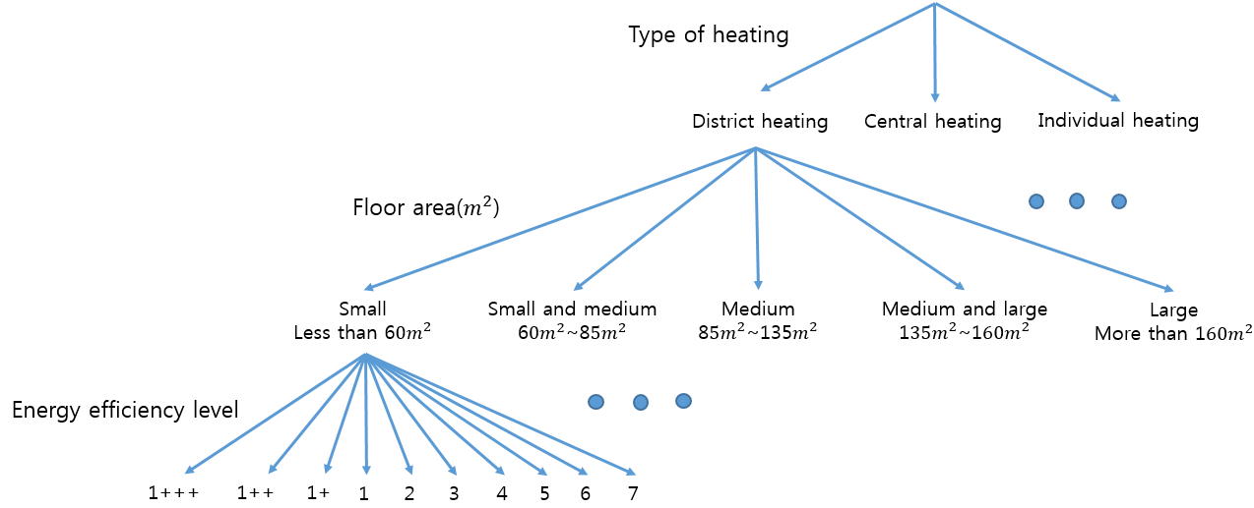
Data : Year-2014 transaction data at the apartment-unit level were obtained from the Ministry of Land, Infrastructure and Transport and divided into 12 markets according to the month of the transaction. The individual transaction data (18,070 in total) were matched with their detailed real estate and utility service information accessed from Korea’s dominant portal sites, Naver and Daum. The portal sites provide the general information of individual apartment buildings, such as floor plan, construction year, and negiborhood characteristics, as well as energy related information, such as average maintenance fee and heating costs of the buildings.
Estimation : The choice model has been estimated by the aggregate-share formulation suggested by Adamou et al. (2013):
$$ln\left(S_{jt}\right)−ln\left(S_{0t}\right)=c+x_{jt}β+σ_{1}ln\left(S_{j/h,t}\right)+σ_{2}ln\left(S_{h/g,t}\right)$$
where $S_{jt}$ is the market share of choice j (energy efficiency level) in month t; $S_{0t}$ is the share of the outside good; $S_{j/h,t}$ is the share of choice j in subgroup h (choice of floor area); $S_{h/g,t}$ is the share of all subgroup-h choices in group g (choice of heating type); $x_{jt}$ is a vector of attributes of choice j. Parameters $σ_{1}$ and $σ_{2}$ capture the degrees of substitutability among choices in the same group and subgroup, respectively.

Results
 | SUBSIDY | PENALTY |  | SUBSIDY | PENALTY
1+++ | 1.41% | 1.39% | Small | 0.06% | 0.06%
1++ | -0.13% | -0.13% | S&M | -0.06% | -0.06%
1+ | -0.20% | -0.19% | Medium | 0.14% | 0.14%
1 | -0.70% | -0.70% | M&L | 0.47% | 0.46%
2 | -2.40% | -2.37% | Large | -0.48% | -0.47%
3 | -0.05% | -0.05%
4 | -0.01% | -0.01%
5 | -0.36% | -0.36%
6 | -24.60% | -24.39%
7 | -8.04% | -7.96%
8 | -24.90% | -24.68%
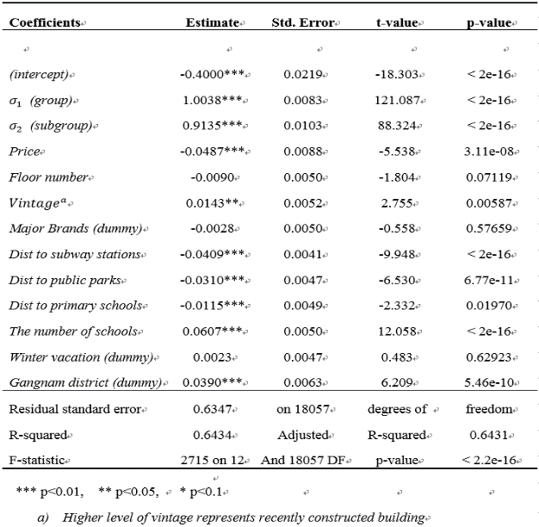
Table 1. Estimation Results Table 2. Simulation Results (assumed $σ_{1}=0.999$)

In Table 1, we report the results of the econometric estimation. Our model is broadly consistent with random utility maximization, which requires $0≤σ_{2}≤σ_{1}≤1$ (McFadden, 1978). As $σ_{1}$ is close to unity, choices in the same subgroup (choice of floor area) seem to be perfect substitutes. In addition, the model has expected signs for the attributes that are known to be critical in home-purchase decisions in Korea. The households prefer to buy apartments that are recently built, close to subway stations, public parks, and primary schools. They also think highly of some affluent districts, particularly of the Gangnam district. The results suggest that buildings energy efficiency can well be taken into account in articulating households’ apartment-purchase decisions in Seoul. This finding constrasts with that of the previous empirical studies for European cities (Amecke, 2012; Lainé, 2011).
Having identified the apartment-purchase behaviour in Seoul, we ran two policy scenarios for the all Seoul districts through simulation: (i) A 1% home-purchase subsidy for energy efficient buildings with the top 4 grades (from 1+++ through 1); and (ii) A 1% home-purchase penalty for energy efficient buildings with the bottom 7 grades (from 2 through 8). Table 2 shows the preliminary results for the scenario exercise. No significant difference between subsidy and penalty schemes in the table suggests little loss aversion in the apartment-purchase behavior in Seoul. The clear increase in the share of the highest grade and decrease in the share of the bottom 3 grades was indicated as introducing policies, on the other hand, the home buyers’ purchase change mostly moved to Medium & Large floor area apartments from Large floor area apartments. The impact of the policies on the share of middle grades is vague, which deserves further examination.

Conclusions
Our preliminary results confirm that the apartment buyers in Seoul do consider operational energy efficiency of the buildings, as well as other attributes. Although a variety of residential energy efficiency programs may be contemplated, they would have very different influences on the choice of energy efficiency grades, the choice of buildings floor area, and the choice of heating fuel, resulting in positive or negative implications for energy savings and carbon emissions for the entire sector. Further investigation is underway in three directions: (i) various policy simulations for the entire city to see if any unanticipated rebound effect might occur in terms of energy demand and carbon emissions; (ii) welfare analysis in general associated with various policy instruments; and (iii) addressing the potential issue of price endogeneity by using instrumental variables or specifying the supply-side market dynamics.

