CASE Studies in alternate uses of Biomethane from Wastewater Treatment Plants and Landfill Gas Facilities in california

Lori Smith Schell, Ph.D., ERP Brendan P. Shaffer, M.S. Professor Scott Samuelsen
Empowered Energy University of California-Irvine University of California-Irvine
+1 (970) 247-8181 +1 (949) 444-3761 +1 (949) 824-5468
LSchell@EmpoweredEnergy.com bps@apep.uci.edu gss@apep.uci.edu

Overview
This analysis includes 303 wastewater treatment plants (“WWTPs”) and 314 landfill gas (“LFG”) facilities located in the State of California, which collectively generate significant quantities of biomethane. Methane emissions are estimated to have a global warming potential (“GWP”) anywhere from 21-26 times as strong as the GWP of carbon dioxide emissions. Consequently, there is strong motivation by California regulators to determine how to capture and put to productive use the biomethane generated by California’s WWTPs and LFG facilities. This paper examines a number of utilization scenarios for each of the included California WWTP and LFG facilities to determine which utilization scenario would result in the most beneficial use of that facility’s biomethane, based on economics, volume of useful product generated, and/or air quality impact.

Methods

An economic biorefinery cost module was developed as part of a larger integrated Geospatial Bioenergy System Model (“GBSM”) and it is the economic results that will be presented in this paper. The interaction of the economic biorefinery cost module with the other components of the GBSM is illustrated in Figure 1.

Figure 1: Schematic of Geospatial Bioenergy System Model

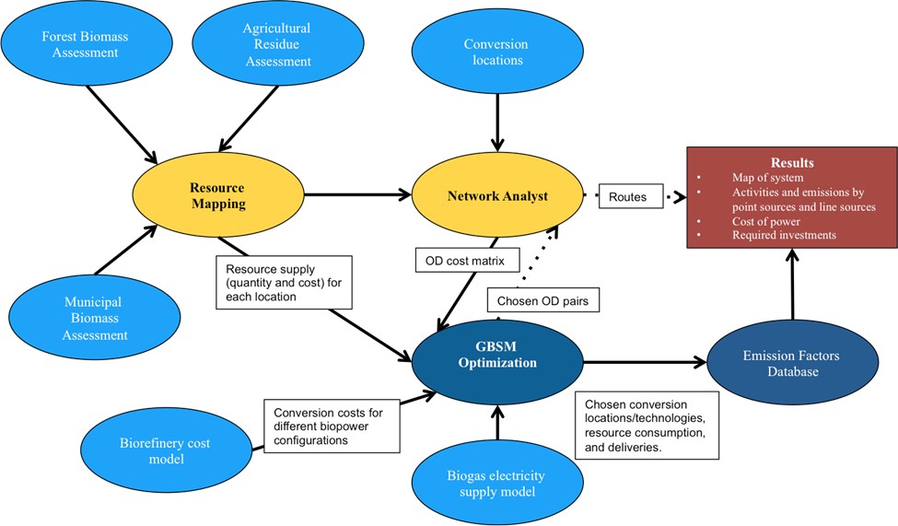

The economic biorefinery cost module calculates the levelized cost of energy (“LCOE”) for sixteen different utilization scenarios for each included California WWTP and LFG facility. The emission factors database calculates each plant’s air pollutant emissions based on conversion technology, facility location, and time of year. The sixteen utilization scenarios included eight electric power generation scenarios, three alternative fuel production scenarios, and three pipeline injection scenarios (for natural gas replacement, power generation, and alternative fuel production, respectively). The economic biorefinery cost module flowchart is shown in Figure 2.
Figure 2: Economic Biorefinery Cost Model Flowchart

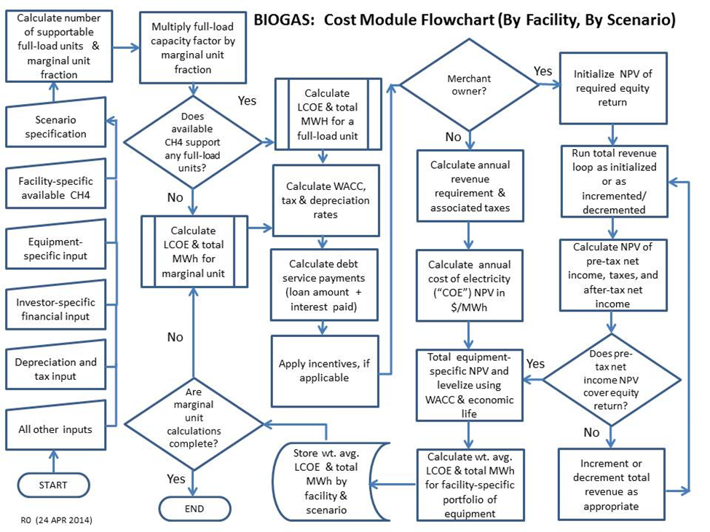

Results

The lowest LCOE for electric power generation from biogas was approximately $53/MWh. The LCOE for alternative fuel production from landfill gas was $11.85/MMBtu, $14.82/MMBtu, and $20.15/MMBtu for onsite production of CNG, LNG, and hydrogen fuel, respectively. For WWTP, the LCOE of alternative fuel production was $11.50/MMBtu, $14.48/MMBtu, and $18.96/MMBtu for onsite production of CNG, LNG, and hydrogen fuel, respectively.

Conclusions

The conclusions of the analysis depended on whether the goal was to minimize air quality impacts, to maximize total product output, or to minimize the LCOE. From an air quality perspective, the use of biogas for electric power generation increased ozone and PM2.5 concentrations, albeit by small amounts. The scenarios using biogas to power a combined cycle generator produced the maximum power production. However, this scenario also produced the highest emissions and air quality impact. If fuel cells with nameplate power below 1.4 MW were deployed at WWTPs and LFG facilities with capacities less than 1.4 MW, the maximum power production increased and air quality improved. From an economics perspective, the lowest LCOE was for the production of transportation fuel, at $11.50/MMBtu (the equivalent of $39.25/MWh). This compared to the lowest LCOE for electric power generation of $53.00/MWh. As a result, the conclusion from the analysis was that the economics of biomethane utilization favor the production of renewable alternative transportation fuel over the generation of electric power.

References

Black & Veach, 31 October 2013, Final Consultant Report, Small-Scale Bioenergy: Resource Potential, Costs, and Feed-In Tariff Implementation Assessment, Prepared for the California Public Utilities Commission, Docket No. R.11-05-005.

New York State Energy Research and Development Authority, February 2006, Biogas Processing, Final Report, NYSERDA 7250.

