Overview

HEADING TOWARDS complete and competitive ELECTRICITY MARKETS

Reinhard HAAS, Hans AUER, Georg ERDMANN*)
Energy Economics Group, Vienna University of Technology, E-mail: haas@eeg.tuwien.ac.at
*) Technical University fo Berlin, Institut für Energiesysteme
In recent years, the idea of politically motivated capacity payments for power generators in addition to revenues from the energy-only market, has gained attention in the energy economic discussion in different countries, e.g in Germany. The reason for this is that a number of market payers claim that the long-term reliability of the electricity system is at risk as long as there is no politically organized mechanism for capacity payments in place, see e.g. Crampton (2012). Indeed, in many countries such CPs have already been introduced.
The core intention of this paper is to serve as a primer for introducing truly competitive electricity markets in every country world-wide. It is triggered by the current discussion on how to integrate large shares of variable RES but the basic intention goes beyond that. It is to show how to head towards real competition in electricity systems, including all dimensions such as generation storage, but especially the customer side, see Koch (2013).
The major objective of this paper is to analyze and provide insights on the conditions that will bring about a sustainable and competitive electricity system with higher shares of RES without escalating political interventions. How can the original idea of competition be reestablished so that “Markets should do their work”?
The objectives in detail are: (i) to explain how in the future a really competitive market-based electricity system without continuing governmental interferences can be brought about; (ii) to argue why CP will not contribute to such a system but rather retain the conventional system; (iii) to show that generators will no longer be the heart of the system but rather balancing groups / supply companies.

Method

Our method of approach is based on the following principles: (i) Crucial is coverage of residual load (= difference between final electricity demand and generation provided by non-flexible electricity generation) ; this is modeled on an hourly base over a calendar year based on assumed RES-E generation (ii) Deduction of available conventional and backup capacities including must-run (iii) flexibility on the demand side based on consumer behavior incl. flexibility instrument such as batteries etc.; (iv) hourly electricity prices equal to short-term marginal costs and scarcity rents.

Results
The major results are:
- A key role in this new concept will play balancing groups (BG). These are the entities which finally have to balance generation, flexibilities and demand options. The major logical market actor of a fully complete competitive market is the balancing group (supplier) NOT the generators as assumed in the past. The BG strives for a balance between supply and demand by means of entering into Long-term contracts (LTC), participating in spot markets as well as making contracts with customers for energy, power and load management balances, see Fig. 1.
- Of core relevance for a complete markets and to enhance competition is a pricing system in an energy-only market (EOM) where the price signals provide information about scarcity or excess capacities at every point-of-time;
- Most important to balance variations in residual load is an optimal portfolio of flexibility options which already exists today but is not fully harvested due to low economic incentives. Some of this flexibility options are:
- Short-term and long-term storages – batteries, hydro storages;
- Technical demand-side management measures conducted by utilities like cycling, load management)
- Demand response due to price signals mainly from large customers to price changes, time-of-use pricing
- Transmission grid extention leads in principle to flatter load and flatter generation profiles;
- Smart grids: They allow switch of voltage levels and contribute in this context to load balancing;
- A specific question is how to cope with risk for investors due to cycling prices. In this context the element of long-term contracts (LTC) as e.g. forwards (OTC contracts) or futures is of core relevance. LTCs traded at different power exchanges provide the information for the current expected value of future costs of electricity. Every supplier (as a member of a balancing group) can make an appraisal of future capacity needs and can purchase LTC already today up to at least 6 years in advance. If necessary the markets will make available such contracts even for longer time periods if the market works. Construction fo flexible power plants as CCGT takes at the maximum 3 to 5 years and current future price should provide the opportunity to serve as a hedging position.
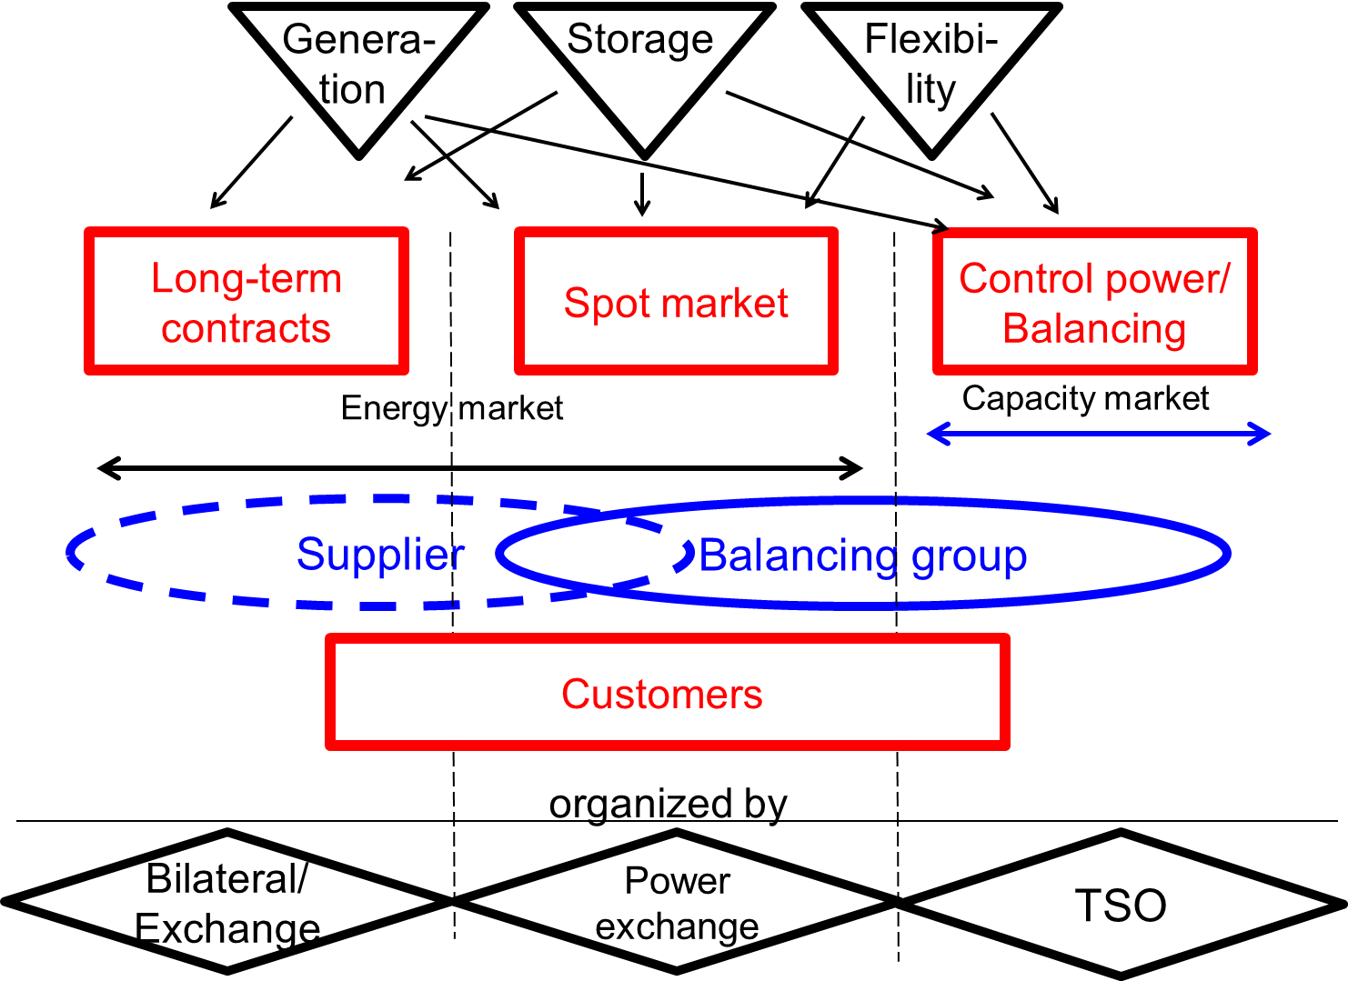

Figure 1. Design of a fully competitive electricity market

Conclusions
Our major conclusions are:
- All arguments in favour of capacity payments (CP) including aspects of market failure could be managed by a complete, wholly integrated market which would include supply-side as well as demand-side options, without government intervention in electricity generation. This approach would provide the basis for a truly competitive electricity system. Complete markets should be introduced thereby ensuring full competition between all market participants, generation, storage and flexibility options on the demand-side in all market segments, in the long-term contracts, spot markets and the control power markets;
- A revised EOM has to be introduced which allows temporarily shortage prices higher than short-term marginal costs;
- In a complete market there is a new core player in the chain, the balancing group (the “supplier”). This player is the logical market coordinator of the electricity supply chain and the organizer of competition between the different options;
- The policy targets regarding GHG reduction and the shares of electricity from RES are set by governments. These targets must be communicated to market participants in advance allowing a suitable planning time s for medium-term (about 6 years);
- A very important element of such a market will be flexibility options. But these will only be harvested when sufficiently high price signals from the electricity markets trigger these options, when “the exploration principle in the markets work” (Erdmann 2012). Yet this will only be done if the market is not distorted by centralized capacity payments.
- The only reasons for the introduction of CP are the lobbying activities of the (incumbent) generators seeking to regain (at least part of) their former power and their attempts to benefit from rent seeking. In our view they would be death of competition, and head back to a strictly planned economy and freeze the old fossil/nuclear system.
- If CP are considered necessary the market should organize them. E.g suppliers/ balancing groups could make bilateral contracts with generators. In a first phase until the market is fully established, strategic reserves could be kept as a back-up system.
- The market can also cope with the above mentioned problem of investment risk by means of hedging with LTC.
The major final conclusion of this analysis is, that it will be necessary to accept a paradigm shift in our understanding of the whole electricity system, from generators to suppliers governing the markets.

References:
Cramton P., Ockenfels A.: Economics and Design of Capacity markets for the power Sector, Zeitschrift für Energiewirtschaft, 36, 2/2012, 113-134.
Erdmann, G.: Das Entdeckungsverfahren des Marktes nutzen. In: Energie & Management, 15.8.2012, S. 6.
Koch Oliver, Electricity market design, Presentation at IAEE-conference, 18-21 July 2013 Düsseldorf.

