FORECASTING THE EVOLUTION OF ELECTRICITY DEMAND AND DISTRIBUTED GENERATION TOWARDS 2035: AN INNOVATIVe BOTTOM-UP APPROACH

[Florent Chiappini, ERDF]
[Thomas Heggarty, ERDF]

Overview
In France, the power industry is vertically disintegrated, the Distribution System Operator role (20kV and under) is fulfilled by Electricité Réseau Distribution France (ERDF) for 95% of customers. The distribution network is facing major challenges, what with the increased penetration of renewables and further electrification of transport and heat. Furthermore, the French energy policy is going through some significant changes: decision power is partly being transferred to the regions and a new law regarding the energy transition was released in 2015, setting ambitious targets for 2030 and 2050 in terms of CO2 emissions, energy efficiency, renewable and electric vehicles. These challenges give rise to a dire need for forecasting ability with regards to the evolution of electricity demand and distributed generation at a local scale, both in terms of power and energy.
Various existing approaches produce nation-wide results which lack the small scale precision a DSO requires to accurately plan investments in network assets and to communicate with the various stakeholders. These past two years, ERDF has therefore built its own tool, based on publicly available data provided by the French national statistics bureau (INSEE) and other relevant public and private organisations (ADEME, CEREN, CERTU, Commissariat Général au Développement Durable, Météo France…). Various experts in engineering, economics, geography, sociology, urban planning and architecture were also consulted.
Following a bottom-up approach allowing a local relevance, economic, technical and social factors are varied across four different scenarios to obtain four different visions of electricity demand evolution on a local scale, between 2015 and 2035, using an annual time step.

Methodology
Over 500 variables affecting electricity demand are taken into account, defined at various geographical levels (municipality, department, region and nation) depending on the most accurate data available. For example, the number of people per household and its evolution are defined for a single municipality, the value added of the cardboard industry for a department, and the energy efficiency of a boiler at a national scale. Unlike other studies, a bottom-up approach was adopted: the consumption of each department is calculated, the national value is then aggregated.
These 500 variables take different values in the four different scenarios. They each correspond to coherent visions based on assumptions that could be summarised by the following six key factors.
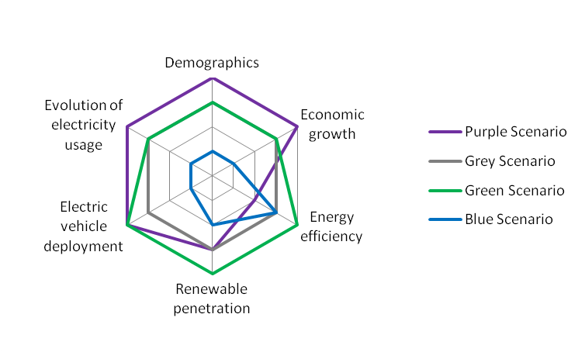

Results
The tool is currently being finalised, preliminary results for energy will be made available in the first semester of 2016 and presented abroad for the first time in Bergen. As 35 million Linky smart meters are gradually installed (the roll-out started in December 2015 and the target is to be met in 2021), the data collected will progressively replace the publicly available statistics, producing accurate, up-to-date, fine-tuned results at a local scale.
These results are to be used internally for various purposes such as providing key assumptions for studies that aim to optimise investments in network assets, to perform a cost-benefit analysis on a smart grid solution, to plan for the purchase of energy required to compensate for losses... The tool is also used as a basis to communicate with external stakeholders. This will allow councils, departments and regions to be involved in the forecasting study, making it a two-way process, thus expressing a shared vision of the future of the distribution network. The tool also has an educational purpose, enabling the general public to grasp the challenges facing the power sector in its task to facilitate the French energy transition.

Conclusions
Energy transitions in various countries generate uncertainties. Historically, the electric distribution sector is barely assessed by energy economists while it is the key driver of energy transition (renewable, electric vehicles, other distributed energy resources...). This article is an answer to these lacks. It points out the innovative features of the bottom-up approach implemented to forecast the evolution of electricity demand and generation at the distribution level in France. The methodology implemented will be described, from the definition of the 500 variables taken into account in the four scenarios to the calculation of the consumption for each department and the aggregation of the results at the national scale. Additionnaly, the paper highlights the different uses of this tool: improvement of internal investment decision-making by the DSOs, establishment between local public authorities and the DSOs of a shared vision of the future of the distribution network. Finally, the paper presents results and analysis for the first time.

References
References will be detailed in the final version of the article.

