POLICY DESIGN AND ENvironMENTAL BENEFITS OF electric vehicles

Amela AJANOVIC, Reinhard HAAS,
Energy Economics Group, Vienna University of Technology, 1040 Wien, E-mail: Ajanovic@eeg.tuwien.ac.at

Overview
Due to increasing GHG emissions as well as significantly improved electric vehicle technology (including batteries), the interest in electric vehicles (EVs) has increased over the last decade. The use of EVs is mainly driven by various EU-targets such as emission reduction targets for new cars, as well as the target of a 10% share of renewable energy in the transport sector by 2020. Moreover, at national and local levels broad portfolios of supporting measures are currently being implemented. These can be divided into two groups: monetary measures (e.g. tax exemptions and reductions, subsidies, etc.) and non-monetary measures (e.g. use of bus lanes, free parking spaces, etc.). All this measures have contributed to the growing number of EVs in recent years.

The core objective of this paper is to provide a more nuanced picture of prospects and impediments of different types of EVs (battery electric vehicles (BEV), hybrid electric vehicles (HEV), plug-in hybrid electric vehicles (PHEV), range extenders (REX) as well as fuel cell vehicles (FCV)) focusing on policies implemented and environmental benefits of electric vehicles.

Method
Our paper links a comprehensive environmental investigation with an economic analysis, and provides recommendations for electric vehicles promotion policies. The fact is that policy measures currently used to promote EVs can increase their number but the core question is whether these strategies really lead to the reduction of GHG emissions. The reason is that electric vehicles are more or less environmental friendly technology depending on the carbon-intensity of energy used. We analyze the whole well-to-wheel (WTW) emissions related to the provision of the energy service mobility including also the embedded life-cycle emissions of the car. Figure 1 shows the basic method of approach used in this paper.
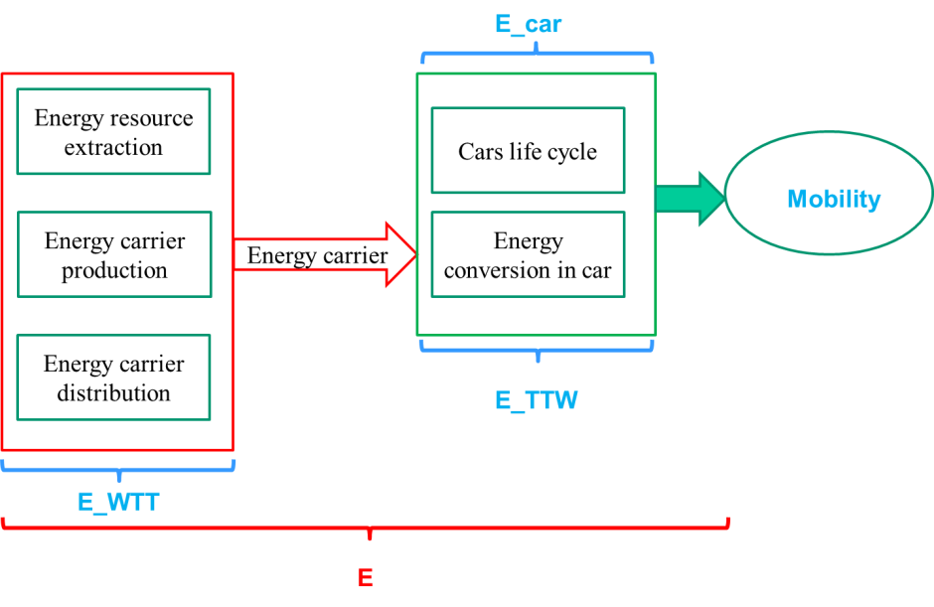
Figure 1. Method of approach for the environmental assessment of GHG emissions
Total emissions of passenger car mobility (E) can be very different depending on the energy and material flows in the WTT part of the energy supply chain, the efficiency of the energy use in cars (in TTW part) as well as emissions associated with the car production and scrappage. They are calculated in g CO₂ per km driven as:
$E_{i}=\sum_{k=1}^{m}{E_{{\text{WTT}}_{k}}}+\sum_{k=1}^{m}{E_{{\text{TTW}}_{k}}+E_{{\text{car}}_{i}}}$ (g CO₂/km) (1)
where
i…type of car (e.g. battery electric vehicles, plug-in hybrid electric vehicles, etc.)
k…type of energy carrier (e.g. electricity, gasoline)
Results
Figure 2 shows current CO₂ emissions per 100 km driven for the whole energy supply chain (as well as for well-to-tank (WTT) and tank-to-wheel (TTW) part) and for various types of EVs in comparison to conventional gasoline and diesel cars. Power of all analyzed cars is 80 kW. It is obvious that all kinds of EVs contribute to the CO₂ emission reduction in the TTW part of the energy supply chain. However, the lowest CO₂ emissions are in the case of BEV powered by electricity from renewable energy sources (RES) – wind or hydropower – and FCV powered with hydrogen produced from RES. For these EVs TTW-fuel emissions are zero.

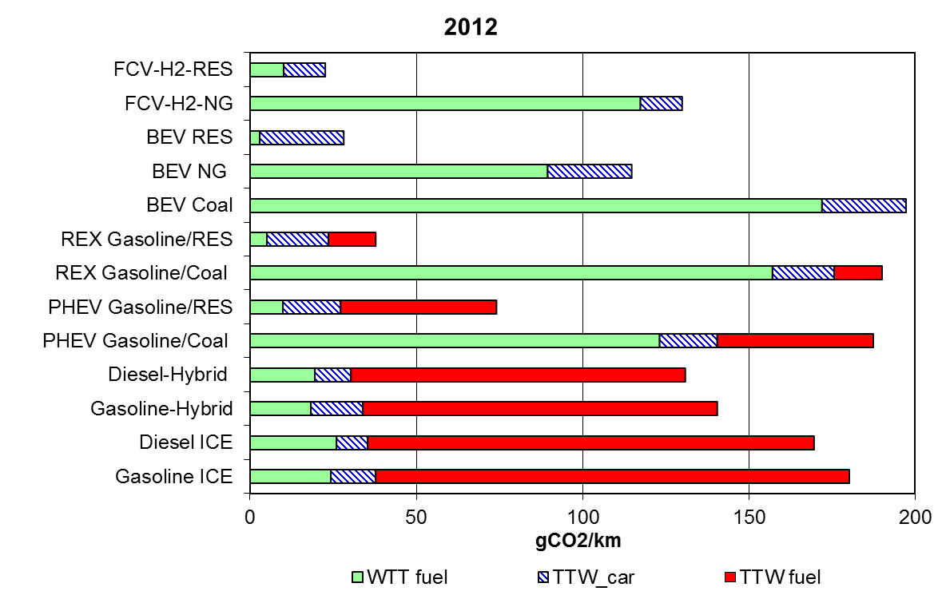
Figure 2. CO₂ emissions per km driven in 2012 for various types of EV in comparison to conventional cars (power of car: 80kW)

A major finding is of our work is that, when looking at the current electricity generation mix in Europe and the resulting average CO₂ emissions, the use of EVs can reduce GHG emissions significantly only in Norway, Sweden and France.

With the exception of electricity generated purely from old coal power plants, EVs can contribute to the reduction of CO₂ emissions compared to those produced by conventional gasoline or diesel cars. However, to harvest the full environmental benefits of rechargeable EVs and to contribute effectively to heading toward sustainability in transport, it is most important to ensure that EVs use electricity from renewable energy sources.

Unfortunately, this is currently not specified in policies for the promotion of EVs. Consequently, in most European countries the full potential of GHG emission reduction due to EVs cannot be reaped. Significant positive effects on the environment can only be expected in countries with a high and increasing share of RES in the electricity mix.

Due to the fact that most of the measures currently implemented for the promotion of EVs (e.g. measures such as tax exemptions, free parking spaces and the use of bus lanes) are not sustainable in the long run, new policies will be needed. Most important is that future promotion strategies should depend on the carbon content of the electricity used and its dynamic development. Moreover, CO₂-based fuel- and registration taxes will be important complementary policy tools. Furthermore, indirectly, all measures supporting an increase in the use of RES lead to the reduction of electricity-specific CO₂ emission factors, and consequently, to a better environmental performance of EVs.

Conclusions

The major conclusions are:
- To harvest the full benefits of rechargeable EVs for reducing GHG emissions and to indeed contribute to heading towards sustainability in transport it is most important to ensure that these EVs are using electricity from renewable energy sources;
- The implementation of mixed monetary and non-monetary policies could increase the number of EVs used. However, these measures lead not always directly to significant reduction of GHG emissions. Promotion policies currently implemented in almost all countries do not properly address the aspect of the source of electricity generation, and hence do not gain the full GHG emission reduction potential of electric vehicles.
- In the future all promotion strategies should depend on the carbon content of the electricity used.
- Only in countries with a high share of RES in the electricity mix significant positive effects of EVs on the environment can be expected.

