Overview

CARBON PRICING STRATEGIES UNDER BINDING POLITICAL ECONOMY CONSTRAINTS
Jesse D. Jenkins, Massachusetts Institute of Technology, +1.503.333.1737, jessedj@mit.edu
Valerie J. Karplus, Massachusetts Institute of Technology, +1.617.800.7982, vkarplus@mit.edu
When it comes to climate change mitigation, reducing CO₂ emissions using a price that internalizes associated damages—the preferred economic prescription—has proven untenable in many countries. Where CO₂ pricing policies exist (e.g. carbon taxes or emissions cap and trading schemes), established prices have typically fallen far short of levels required to fully internalize climate damages in economic decisions (i.e. estimates of the full social cost of carbon). Instead, piecemeal policies that mandate changes at the level of sectors, technologies, and behaviors have proliferated, overlapping with or substituting for a CO₂ price. Globally, scholars would be hard pressed to find a single nation with a CO₂ price approaching lower-bound estimates of the social cost of carbon applied broadly to all emitting activities.
The causes of the failure to price CO₂ are widely recognized. Immediate effects on powerful established industries and households today combined with uncertain and diffuse benefits of climate change mitigation in the future motivate effective political opposition to pricing schemes by affected parties and skeptics. Less recognized are what paths, if any, exist to a world where CO₂ pricing is economically viable.
Here we demonstrate a general approach to designing climate policy in the face of binding political constraints. Specifically, we study the welfare implications of CO₂ pricing schemes with strategic application of resulting revenues to compensate for and/or relieve several common forms of political constraints in a stylized partial equilibrium model of the energy sector. We demonstrate that the strategic application of carbon pricing revenues to subsidize clean energy suppliers and/or compensate for the private surplus lost by fossil energy producers or energy consumers can significantly improve the economic efficiency and environmental efficacy of carbon pricing policies when political economy constraints bind.

Methods

We develop a stylized, static partial equilibrium model of the energy sector and identify the welfare-maximizing combination of carbon pricing and revenue allocations under four common forms of binding political economy constraints: 1) a direct constraint on the CO₂ price itself; 2) a constraint on the energy price increase that results from CO₂ pricing; 3) a constraint on the decline in the private surplus of energy consumers (net of lump-sum transfers); and 4) a constraint on the decline in fossil energy producer surplus (again net of transfers).
We formulate and solve this model numerically under each political constraint, identifying the welfare-maximizing combination of CO₂ price, subsidy for clean energy production, and compensatory lump-sum transfers to energy consumers or fossil energy producers. In each case, we compare the change in net benefits associated with relieving the political economy constraint through strategic application of revenues to a case in which revenues are instead used to offset other government expenditures. In addition, we analytically derive solutions to the carbon price and energy price increase constraint cases and discuss insights based on comparative statics.

Results

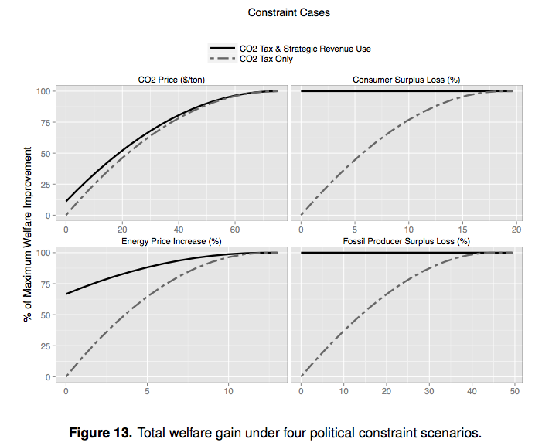
Simulation results show the CO₂ emissions and welfare impacts of several strategies for softening the blow of a CO₂ price to affected parties, by comparing to CO₂ pricing scenarios where these strategies are not employed. Specifically, we consider the four types of political constraints listed above, and elaborate how CO₂ price revenues could be strategically allocated to relieve or compensate for these constraints. Of the four constraints considered, a direct constraint on the absolute level of the CO₂ price offers the least room for welfare improvement, as the absolute level of the CO₂ price must remain fixed and cannot be relieved by strategic use of revenues. Using revenues to subsidize clean energy production can partially compensate for the constraint by driving reductions in deadweight loss associated with remaining un-internalized climate damages, but these benefits must be traded off against the economic distortion associated with subsidies, limiting the effectiveness of this strategy. By contrast, significant welfare gains are possible under a constraint on energy price increases, as carbon pricing revenues can be used to subsidize clean energy, which not only compensates for the constraint (as in the carbon pricing constraint case), but also helps reduce energy prices, all else equal, relieving the contraint and allowing for a higher carbon price than would otherwise be politically feasible. Indeed, we find that a substantial CO₂ price is possible even if no increase in final energy prices is tolerated at all. This comparison suggests that instead of limiting CO₂ prices with no clean energy support—essentially the status quo—if the true objection is energy price increases, it may indeed be sensible to allow a relatively robust CO₂ price while ensuring final energy prices remain low via subsidies for clean energy production and easing the welfare impacts on energy consumers..

We also find that under constraints on the private surplus losses experienced by energy consumers or fossil energy producers, using revenues to offset private losses due to imposition of a carbon price supports a return to optimal CO₂ price levels and a first-best solution—provided compensatory transfers are frictionless and consumers and producers do not exhibit loss aversion. In practice, neither assumption is likely to hold, and our framework allows exploration of the implications of loss aversion and tradeoffs among alternative uses of government revenues.
In addition to these results, we present the distributional results under each constraint case and carbon pricing strategy and explore sensitivities to different assumptions about energy supply and demand elasticities.

Conclusions
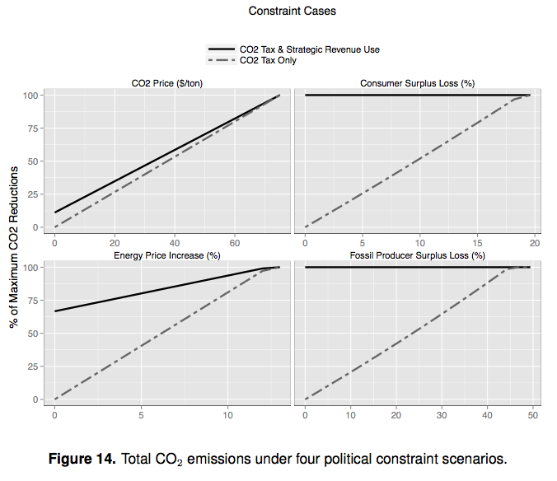
As this work demonstrates, careful attention to political economy constraints can yield strategies for the application of carbon pricing revenues that improve both the economic efficiency and environmental efficacy of CO₂ pricing schemes.
While we should not lose sight of the first-best policy prescription, researchers and policy-makers can usefully begin from the presently feasible set of alternative policies, taking political constraints as binding in the near-term, and evaluate options for improving welfare and expanding this feasible set over time. This work contributes to that challenge by identifying strategies to accommodate and compensate for several commonly encountered forms of political constraints on carbon pricing policies.
Our static framework could be extended to consider dynamic implications and the role of uncertainty. By expanding the size of the clean energy industry, driving potential learning-by-doing or induced innovation, and building experience with substantial carbon pricing levels, these policy strategies can further improve long-term policy outcomes.

