LONG-TERM URANIUM MARKET DYNAMICS

Antoine Monnet, French Alternative Energies and Atomic Energy Commission, Université Paris Saclay, antoine.monnet@cea.fr

Overview
The availability of natural uranium has a direct impact on the global capability to feed new nuclear reactors in the coming decades as it is forecasted that Light Water Reactors will remain the main nuclear technology for most of the 21st century. Therefore, the expansion scenarios of this low-carbon source of electricity should be considered in conjunction with long-term dynamics on the uranium market. This paper presents a market model that accounts for both regional economic specificities and resource depletion. It highlights their impact on long-term availability as well as the role of some key parameters of the market structure: dynamic constraints and the level of competition.

Methods
The general design for the market model puts the stress on supply and price-setting mechanism. Demand is exogenous: world nuclear fuel demand scenarios are used as inputs. They are derived from IIASA A3 and C2 scenarios (respectively 5 400 GW and 2100 GW of installed nuclear power in 2100) [1], [2]. The supply side is designed to cope with regional specificities: the market players are spread into 6 regions (as shown in Fig. 1: the top 5 regions for reserves and production – Africa, Australia, Canada, Kazakhstan, United States – plus the rest of the World) and every region has its own resource endowment (ultimate resources and production costs). The results and methodology of previous work were used to set the initial endowment of each region [3].

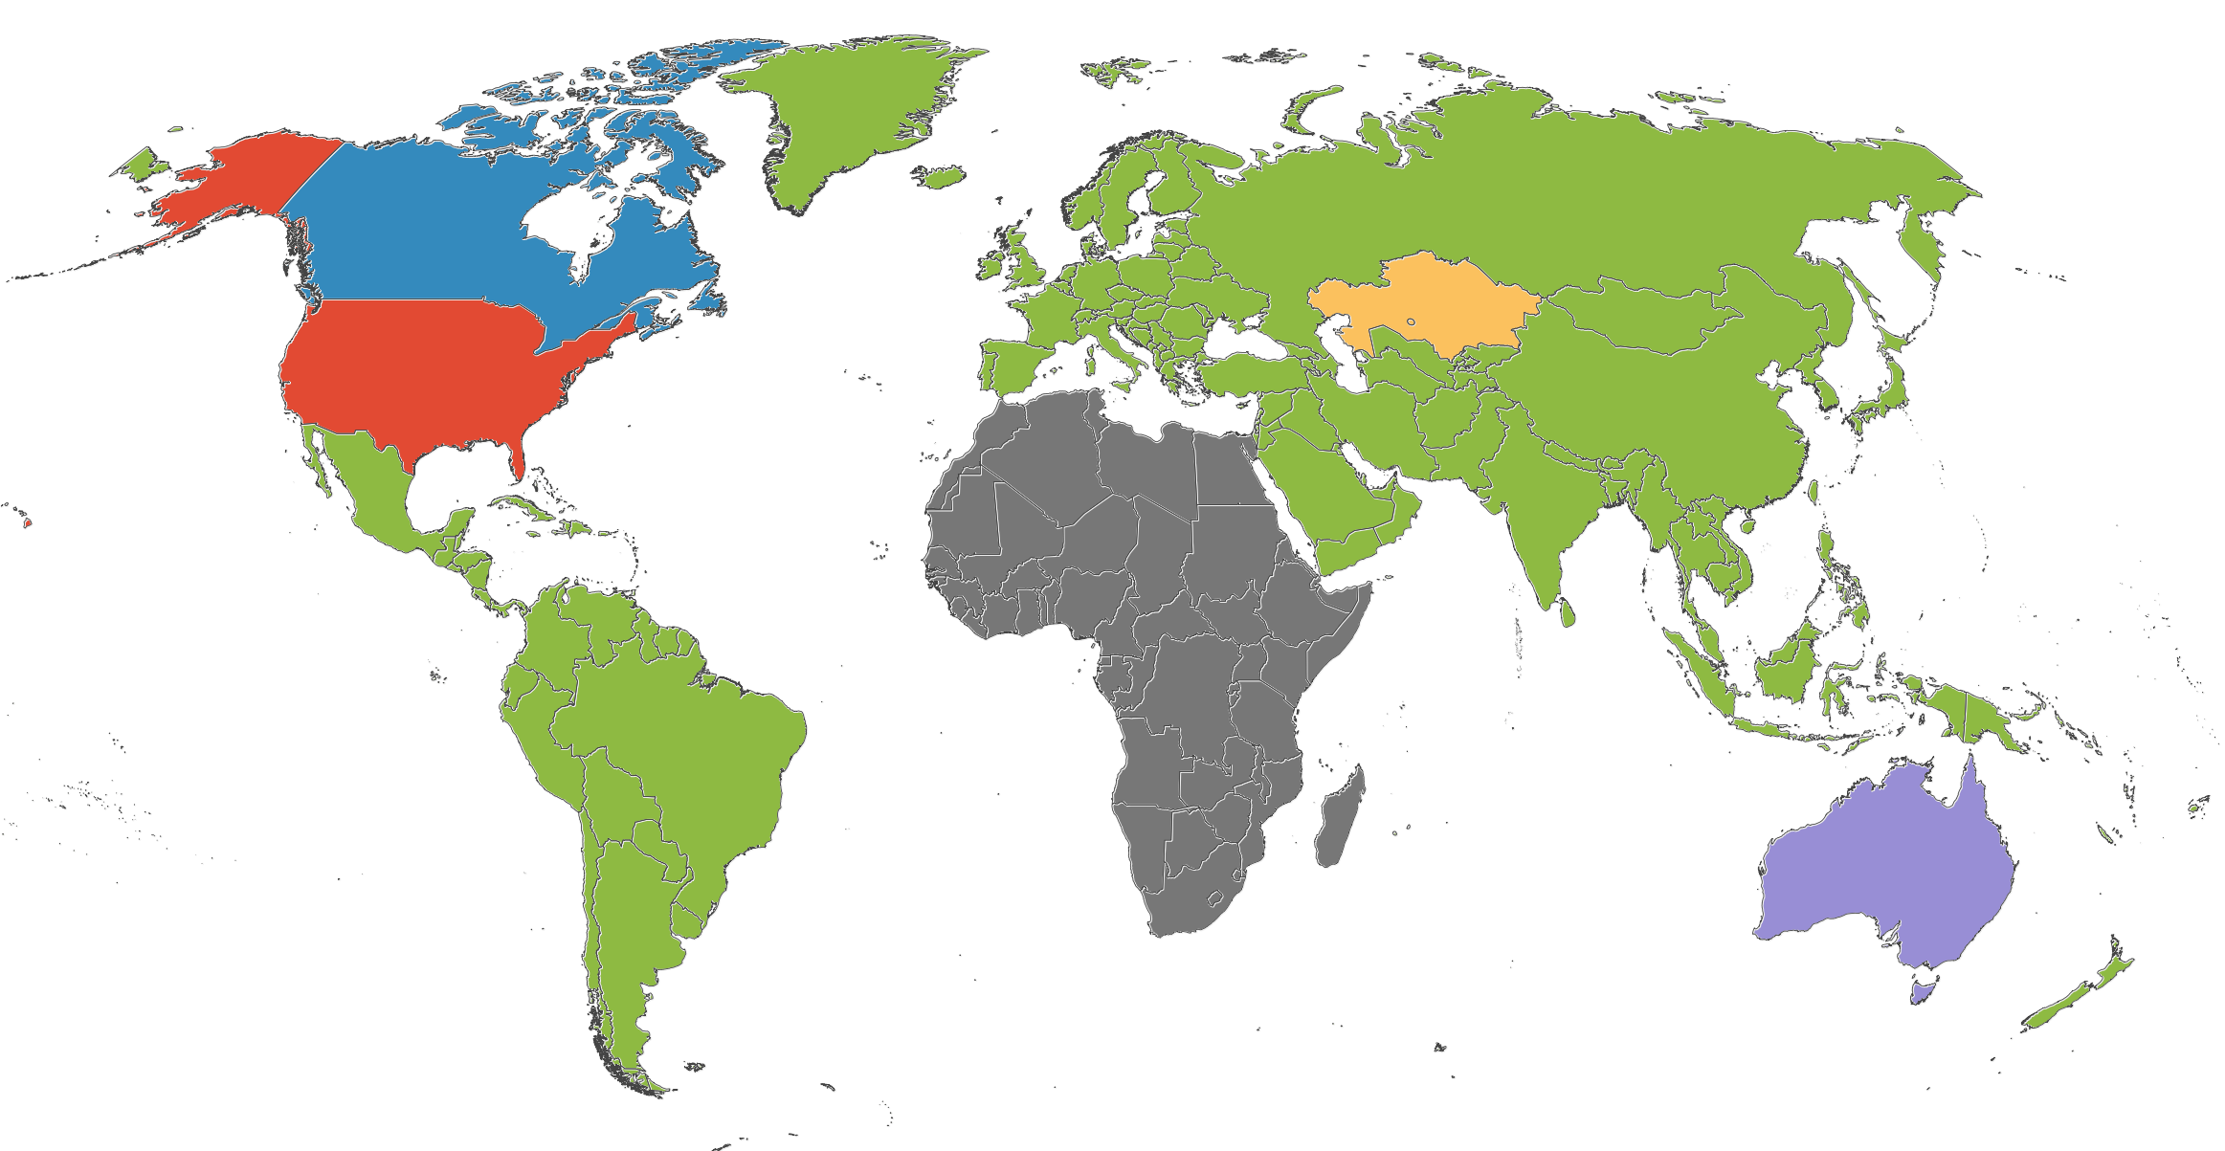
Fig. 1 – Regional breakdown used in the market model

On the side of the price-setting mechanism, the framework is also divided into two subsets: a clearing market equilibrium and a series of dynamic constraints. Commissioning a new uranium mine is not always possible even if it has the lowest production cost among all available projects worldwide. Commissioning constraints introduced in the model are of different types: insufficient exploration effort, lead-time before production starts, self-funding limitations, anticipation of demand. The model treats these constraints as endogenous. For instance, the annual exploration expenditures are derived from the price history through time series analysis. This relationship as well as the correlation between discovery costs and cumulative exploration expenditures are two important dynamic constraints. They serve to introduce differencial rents on the market. Another important dynamic constraint is applied to the R/P ratio (ratio between identified resources and annual production). A feedback on price is applied when the R/P ratio decreases to a threshold value in order to account for the anticipation of demand, incompressible lead-times and a supply risks. All together, these constraints introduce the scarcity rent on the market, with a greater role played by the R/P constraint.
With respect to the clearing equilibrium, the paper compares two mechanisms: one represents a perfectly competitive market and the other corresponds to an oligopoly in which the 6 regions are the market players. In both cases, the clearing price is set to the production cost of the marginal mine (i.e. the highest-cost mine put into production to meet the exogenous demand) plus applicable scarcity rent (may the threshold R/P ratio be reached).

Results
Introducing the dynamic constraints allows for a certain deviation from the long-term perfectly competitive equilibrium since it forces differential rents. More realistic market dynamics can be observed. An interesting finding is the influence of a long-term increase in discovery costs: it plays a significant role in shaping the price trends. Simulations also show different long-term dynamics when the players are spread into regions (to simulate an oligopolistic mechanism) compared with the World considered as a single region (undefined number of players to simulate a perfectly competitive mechanism). Finally, the scarcity rent will play a great role in the 21st century: depending on the demand scenario, ignoring this rent leads to a global shortage or critical supply risks (R/P < 10 years) (Fig. 2) which is unlikely to happen without being anticipated.

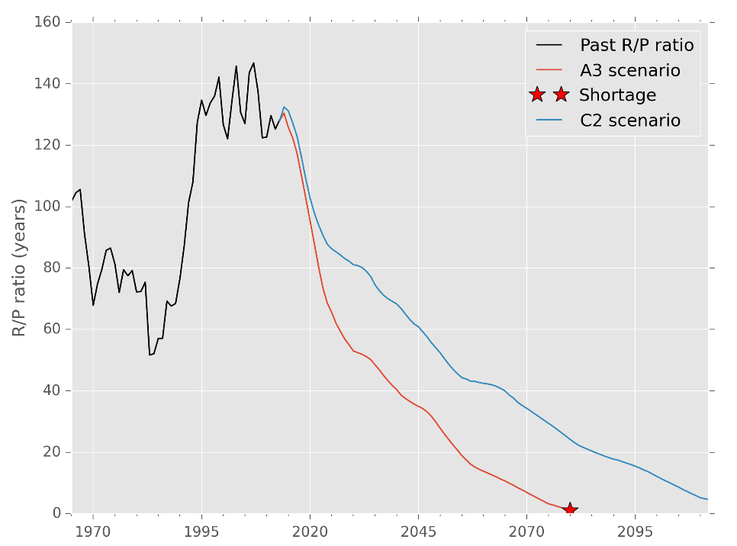
Fig. 2 – R/P ratio dynamics in a competitive market with no scarcity rent

Conclusions
Analysing uranium market dynamics is important to anticipate the capability to feed new reactors in the coming decades. This study identifies and integrates most important drivers of the market into a regional 6-player model. The results show different trends compared with a perfectly competitive version of the model. This framework is useful to analyse and sort the sensitivity of the various parameters. Among them, the trend in discovery costs and the scarcity rent have a significant role. As the model remains flexible enough, future works could introduce exogenous constraints on supply. This would be useful to study:
- the impact of some unconventional or by-product resources being pushed on the market when a threshold price is reached;
- the impact of a major player stopping its production.

References
[1] A. Baschwitz, C. Loaec, J. Fournier, M. Delpech, and F. Legée, ‘Long term prospective on the electronuclear fleet: from GEN II to GEN IV’, in Proceedings of the Global 2009 congress - The Nuclear Fuel Cycle: Sustainable Options & Industrial Perspectives, Paris, France, 2009.
[2] International Institute for Applied Systems Analysis and World Energy Council, Global Energy Perspectives. Cambridge University Press, 1998.
[3] A. Monnet, S. Gabriel, and J. Percebois, ‘Statistical model of global uranium resources and long-term availability’, EPJ-N, vol. 2, 2016.

