Economic Impacts of Renewable Support Schemes

Prof. Dr. Georg Erdmann, TU Berlin, Georg.erdmann@tu-berlin.de
Fernando Oster, TU Berlin, Fernando.oster@tu-berlin.de

Overview
In some countries the financial support of renewable electricity generation has reached significant volumes that are expected to have a measurable macroeconomic impact. It does not only depend on the total aggregated amount of payments to the renewable electricity generators but also on the way of financing the support payments. Depending on the time profile of the claims on those who have to refinance the payments - typically the final electricity consumers - the renewable energy support may lead to the crowding out of other private or public investments, it may reduce private consumption or it may temporarily increase aggregated macroeconomic demand as was the case in Germany until 2011. Here, the investments in renewables have certainly been more pronounced than in other European countries in the last 15 years. Thus final electricity consumers have cumulated claims of about 250 billion Euros which finance the system of feed-in premia. Depending on the state of the economy, unemployment rates, trade deficits, state debts etc. may result as a consequence.

Methods
It is somehow astonishing that up to the present there had been little academic discussion about this topic, with the exception of [1]. The other publications on investments, labour markets and foreign trade effects of the development of renewables (RES) produce misleading results as they neglect the macroeconomic feedbacks, for example reduced investments and employment in other sectors than renewable electricity equipment manufacturing and generation. Our paper will use a macroeconomic input-output-model in the tradition of Keynesian multipliers to explain the relevant mechanisms and relations in a comprehensive way. Taking into account the German Renewable Energy Sources Act (EEG) of 2000 and its consecutive amendments, the paper will also produce a time series of annual growth impacts induced by the design of the renewable energy support scheme (exclusively in the electricity sector, see figure 1). To this end the macroeconomic impacts of RES deployment triggered by the EEG from 2000 onwards is analysed and compared to a counterfactual scenario with no RES deployment.

Results
It turns out that the crucial effect is not the overall renewable electricity support as such but the time lag between the investment year of a certain renewable capacity and the year in which these investments have to be sponsored in form of the regulated feed-in premium. In Germany the feed-in premium for renewable generation facilities is paid by electricity consumers over 20 years from the investment year on. Therefore the time lag is up to 20 years, or, simplified, ten years on average. Accordingly the economics of the renewable support scheme is similar to a deficit spending programme of the government with the exception that the support payments to the generators don’t increase the official state budget but some shadow household. For the deficit spending nature of the renewable support scheme it is irrelevant whether the deficits are accumulated in the formal state budget or in form of claims to future electricity consumers. The result is that the German GDP was increased by up to 0.9 percent in the years of 2010 and 2011, and this only due to renewable investments financed through a virtual state deficit. Overall the comparison of the factual and counterfactual scenarios leads to the results summarized in the figure below. One may observe a phase of growth until 2014 and a consecutive phase of recession as a consequence of the support scheme design and the assumption that the renewable support scheme in Germany ceases to exist after 2014.

Conclusions
The conclusions are relevant, if one assumes that renewable electricity becomes more and more competitive so that new renewable investments will need less or, ideally, zero financial support. In that case the originally positive GDP effect of renewable investments turns out to become negative. The electricity consumers still have to pay the renewable electricity levy for some remaining years, but the incremental demand impulse through high investments into renewable capacities vanishes. The situation is equivalent to governments that apply an austerity policy in order to reduce the cumulated state debt by raising taxes above the level of state expenditures. 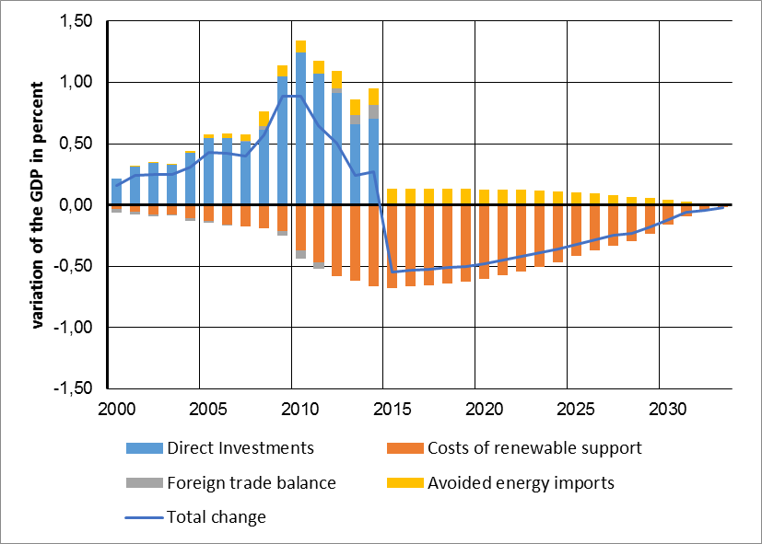
Figure 1: Macroeconomic impacts of investments in renewables between 2000 and 2014 measured by the change of the gross domestic product [2, 3, 4]

References
[1] gws, Prognos, ewi (2014): Gesamtwirtschaftliche Effekte der Energiewende. Projekt Nr. 31/13 des Bundesministeriums für Wirtschaft und Energie, Berlin. Available under www.bmwi.de/BMWi/Redaktion/PDF/Publikationen/gesamtwirtschaftliche-effekte-der-energiewende.pdf [04/2016]
[2] Prognos (2009): Endbericht - Ökonomische Wirkungseffekte der „Konjunkturoffensive Hamburg“. Im Auftrag von Behörde für Wirtschaft und Arbeit der Freien und Hansestadt Hamburg. Hamburg, Bremen, Berlin, 2009. Available under: www.prognos.com/fileadmin/pdf/publikationsdatenbank/Prognos_Konjunkturoffensive_HH_Endbericht.pdf [04/2016]
[3] BMWi (2014): Federal Ministry for Economic Affairs and Energy: EEG in Zahlen: Vergütungen, Differenzkosten und EEG-Umlage 2000 bis 2015. Berlin 2014.
[4] Expert commission on the „Energy of the future“ monitoring process (2014): Statement on the first progress report by the German government for 2013. Berlin, Münster, Stuttgart, 2014. Available under: http://www.bmwi.de/BMWi/Redaktion/PDF/M-O/monitoringbericht-energie-der-zukunft-stellungnahme-zusammenfassung-2013,property=pdf,bereich=bmwi2012,sprache=de,rwb=true.pdf [04/2016]

