CAUSES AND CONSEQUENCES OF OIL PRICE SHOCKS: A VECM-BASED DECOMPOSITION ANALYSIS

Gbadebo Oladosu, Oak Ridge National Laboratory, 865-576-2485,oladosuga@ornl.gov

Overview
Recent sharp changes in global oil prices have elicited spirited discussions about the causes and economic consequences. The potential causes highlighted in the literature include changes in the global economic outlook, changes in the supply and demand of oil, geopolitical factors, appreciation of the U.S. dollar, and policy responses by oil producers and consumers, among other factors (Baffes et al, 2014). There are a number of qualitative evaluations of the roles of these factors, but quantitative estimates of their contributions to the oil price changes and the economic consequences are just emerging (Arezki and Blanchard, 2014; Baffes et al, 2015; Hou et al., 2015; EIU, 2014; Tokic, 2015). Quantitative assessments of the individual factors are indispensable since the economic consequences of oil market changes depends on the composition of the driving factors and their net market impacts (Kilian, 2014).

Methods
This study employs a recently developed quarterly vector error correction (VEC) model of the United States (U.S.) economy to quantify the roles of several important oil market and macroeconomic drivers, and their potential economic implications (Oladosu, 2015). The ten variables in the model have been updated to span the period from 1973:1 to 2015:1. Decomposition analysis is then performed to quantitatively evaluate the contribution of different oil market and macroeconomic shocks to oil price changes and the real U.S. GDP, including the most recent period of oil market changes.

Results
A comparison of the pattern of historical shocks implied by the VEC model with historical oil price movements and the net oil price index (NOPI-1, based on four previous quarters) shows that all three measures imply a significant positive oil price-specific shock in the early 1970s. Although the VEC model suggests that the oil price collapse in 2008/2009 is not an oil price-specific shock, the collapse since the third quarter of 2014 is shown to be partly due to an oil price-specific shock. Figure 1 shows the quarterly change in the real U.S. GDP and real WTI oil price since the first quarter of 2011. The difference between the model’s baseline forecast, given the data for 2010, and the actual data for this period is shown as the “Total” variable in Figure 1, which is decomposed into contributions from structural shocks in the model. These results suggest that the most significant source of changes in recent oil price swings are the own oil price shock and the combination of shocks associated with financial variables (i.e. federal funds rate, real money supply, real exchange rate and the inflation rate). The financial shocks in the VEC model represent global economic and financial shocks which drive changes global commodity prices, including oil. The signs of contributions from the oil market quantity variables to changes in the real oil price vary over the period from 2011 to 2015, and are generally smaller in magnitude relative to those from oil price and the financial shocks. Contributions from the global oil demand shock are positive for most of the period but negative for the first quarter of 2015, and those from the OPEC production-capacity ratio in the last two quarters of 2013 are negative. The largest sources of contributions to changes in the real GDP are from its own shocks, which are interpreted as productivity changes in the U.S. economy (Oladosu, 2015). The own real U.S. GDP shocks are nearly equally distributed between negative and positive contributions during the period from 2011 to 2015. Contributions from the oil price shocks are generally negative during this period which appears to be driven by the large positive oil price shock in the last quarter of 2011. This particular shock implies a $30 positive contribution to oil prices, accounting for its negative $10 shock in the previous quarter. However, the impact of this shock on the same-quarter real GDP is small, and is counteracted by positive contributions from the real GDP shock, non-OPEC oil production shock, OECD stock shock and the real exchange rate shock. As a consequence the contribution of the oil price-specific shocks to the real GDP in the first two quarters of 2012 are positive, but turned negative from the third quarter of 2012 till the third quarter of 2014. Over this period, the contributions to the real GDP from both the OECD stock and non-OPEC oil production shocks are negative, and so unable to counteract the negative impacts of the oil price shock. After the third quarter of 2014 the total contributions of shocks to the real GDP is negative, driven largely by the negative own shocks. Interestingly contributions to the real GDP from the non-OPEC oil production, oil price, federal funds rate and the real exchange rate shocks are positive, reflecting the positive effects of increasing of U.S. oil production, significant oil price decline and the strengthening dollar.

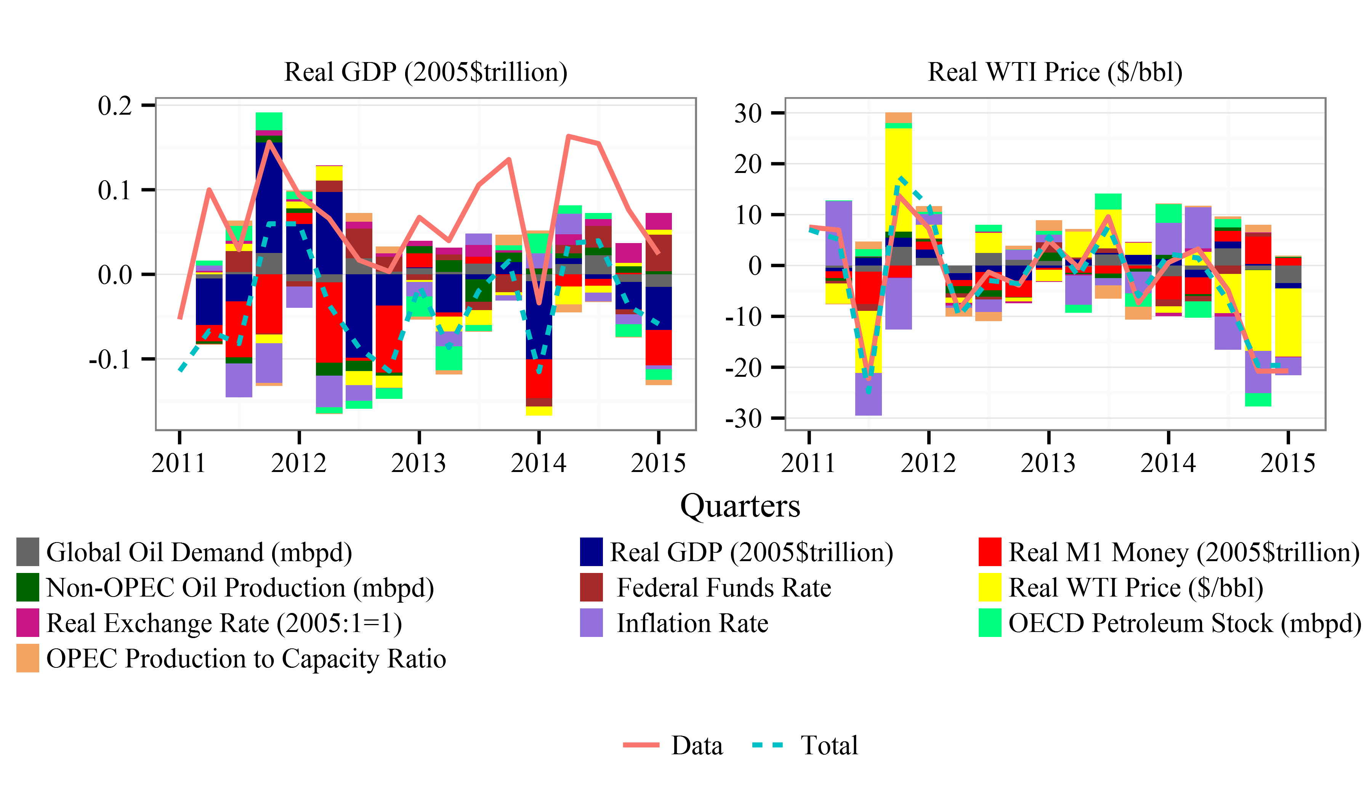
Figure 1. Contributions of structural shocks to changes in real U.S. GDP and real WTI oil price: 2011:1-2015:1

Conclusions
Results of the analysis in this study show that, unlike the 2008/2009 oil price collapse, the large change in oil prices since the third quarter of 2014 are in large part due to oil price-specific shocks. The oil price shock can be interpreted as shocks emanating from other market factors not represented in the VEC model. This would in particular capture changes in the global economic outlook and its impacts on future oil prices, geopolitical events, as well as overreactions to fundamental oil supply/demand information. In addition, the model results show that financial shocks (captured by inflation rate, real money supply, federal funds rate and the real exchange rate in the model) also contribute about one-third of the change in oil prices. This provides some quantitative support for the role of financial market variables as highlighted in Tokic (2015). However, the current study finds that the role of the exchange rate is tenuous since its contributions are small in magnitude, and negative only in two of the four quarters from 2014:2 to 2015:1. The impact of the oil price shock on the real GDP is found to be negative for the period from 2012:3 to 2014:3 but positive, though small, for 2014:4 and 2015:1, matching the significant decline in oil prices since 2014:3. Contributions from own real GDP shocks as well as OECD stock, global oil demand real money supply and inflation rate shocks, with the last two shocks reflecting weaknesses in the global economic system, are negative in the first quarter of 2015. However, positive contributions to the real GDP from non-OPEC production, federal funds rate and real exchange rate shocks reflect the positive effects of increasing of U.S. oil production, significant oil price decline and the strengthening dollar.

References
- Arezki, R., & Blanchard, O. (2014). Seven Questions About The Recent Oil Price Slump. IMFdirect December, 22, 2014.
- Baffes, J., Kose, M. A., Ohnsorge, F., & Stocker, M. (2015). The great plunge in oil prices: Causes, consequences, and policy responses. World Bank Policy Research Note, 15(01).
- Economic Intelligence Unit – EIU (2014) The Business of Cheaper Oil. The Economic Intelligence Unite Limited, London.
- Hou, Z., Keane, J., Kennan, J., & te Velde, D. W. (2015). The oil price shock of 2014. Working Paper. Overseas Development Institute, London, UK
- Kilian, L. (2014). Oil Price Shocks: Causes and Consequences. Annual Review of Resource Economics, 6(1), 133-154.
- Oladosu, G. (2015). Oil market shocks and the economy in a quarterly structural vector error correction model of the United States economy. USAEE Working Paper No. 15-202, February 2015.
- Tokic, D. (2015). The 2014 oil bust: Causes and consequences. Energy Policy, 85, 162-169.

