IS SECTOR COUPLING A WELL-DEFINED STRATEGY?
Jasmine RAMSEBNER*, Reinhard HAAS
Energy Economics Group, TU Wien, *E-mail: ramsebner@eeg.tuwien.ac.at

Overview
The increasing amount of electricity generation from the variable renewable energy (VRE) sources sun and wind throughout the course of the energy transition to reach EU climate goals, is expected to result in frequent times of excess electricity production. Apart from commonly discussed measures, such as a European super grid or new electric storage options, the power surplus may be transformed to e.g. gas or heat and used in other end-sectors through Power-to-X (P2X) technologies, leading to an interconnection of sectors called Sector Coupling (SC) or Sector Integration (SI) [1]. The basic idea of SC is, to use electricity produced from VRE sources in other end-sectors, such as transport, industry and residential, whereas prices in times of excess electricity are economically favourable. The definition of this strategy, however, still lacks precision and the term is often used misleadingly. The core objective of this paper, thus, is to identify the scope of SC, identify promising examples and analyse their tecno-economic aspects. Based on a 2050 scenario for Austria, the basic SC potential is outlined.

Method
Our method of approach includes a thorough literature review with a strict focus on the specific term “sector coupling” and its definition for a better understanding of its overall purpose, benefits and system boarders. It shall be distinguishable from other similar approaches or methods applied on a different level. Within this setting, the most promising examples of SC strategies are briefly explained in respect to their energy economic aspects, potential and further research need. The next steps in this study are a analysis of the correlation of wind and heat demand and its potential to decarbonise the heat sector. Another case study is the implementation of a P2G plant and seasonal storage of excess power from summer until winter as H2. In winter the higher electricity demand can be supplied through gas plants operated with this green gas. This is a promising opportunitiy for Austria to reach the 100% renewable electricity goal in the long term.

Results
Our thorough literature review shows, that definitions of SC are scarce and vary in the scope that is associated to the strategy. Authors seem to agree that SC is about linking the power sector to the transport, industry and residential (heating/cooling) sector and to fulfil this demand with renewable energy. Usually this is seen as a one way path from power to X. Whereas some papers put a strong focus on the use of free surplus energy from VRE to reduce e.g. curtailment needs, other definitions emphasize the decarbonisation potential through renewable power for industry, heat and transport. The concept and term of SC has become popular in the course of the German energy transition [2].
It can be seen, however, that the examples for SC differ depending on a country’s VRE potential, infrastructure and goals. Authors from Denmark, e.g. frequently mention the approach of merging the electricity, heating and transport sector in the context of Smart Energy Systems for the specific purpose of using surplus generation from wind power and integrating larger shares of VRE into the power market [3]. Denmark is a pioneer and shows successful examples of coupling the power to the heat sector to increase the integration of high wind power potentials. In 2004, a change in regulations for small CHP plants paved the way to use excess wind power in times of low demand for the economic production of heat. If Denmark supplements some of its CHP units with heat pumps and additional heat storage capacity, the integration of wind power can be raised from the present 20% to around 40%. A ban on installing electric heating in new buildings, however, still limits the implementation of electric district heating (DH) from wind power via electric boilers and heat pumps. Figure 1 describes the economic use of power in the heat sector in times of low electricity prices that could be realised once the regulations are adapted further to allow electric boilers (El-boiler) in the country. One promising case for SC in transport is the operation of public transport with H2 directly from a wind park (P2G). H2 allows the storage of energy as a different carrier which may be used when needed to further decouple production and demand. Another option would be the direct coupling of power to transport by charging EVs from solar PV. Discrepancies between demand (usually in the evenings or mornings) and supply (mainly at noon) require an electrical storage facility. The PV generation profile, however, may fit well for company PV systems which could offer EV charging at work during noon hours.
First results for the Austrian infrastructure shall be outlined at the conference. Figure 2 shows the variability of power generation in Austria in an example of hydro, wind and solar power only. Due to the limited amount of wind potential in the country, generation surplus mainly occurs in summer times, whereas power scarcity is an issue in winter. Consequently, long-term electrical storage (pumped hydro and compressed air) is required, but capacities are spatially limited and alternative flexibility methods, via e.g. P2G, will be inevitable. Figure 3 describes the limits of storing surplus power on a summer day. The short-term pumped hydro storage capacity is limited to 4.5 GW filled up in green, still leaving the orange area as excess power and SC potential. Figure 4 describes the general pathways of SC defined from our literature review. It shows different possibilities to couple the central or decentral renewable power generation to the end sectors, such as transport or residential (households). There are several options for a use of power as heat, gas and fuel etc., but also as direct electrification of transport or heating. Furthermore, the integration of energy carriers may function as long-term seasonal power storage option (H2). The illustration in the graph allows H2 derived from excess renewable power in summer times to be used in CHP plants for heating in the residential sector. Further research initated with this work is an analysis of promising SC options with respect to their economic feasibility and respective requirements in the upcoming decades.
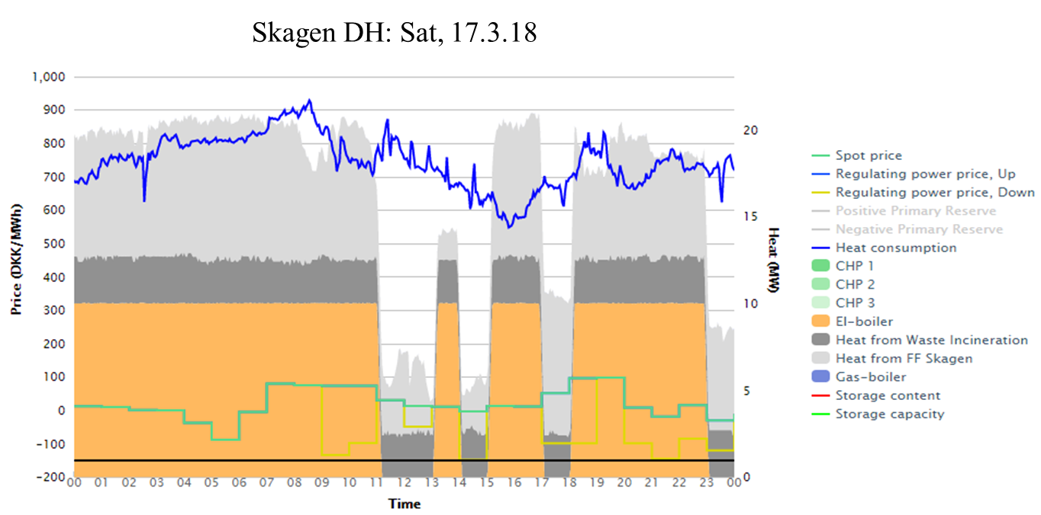 | 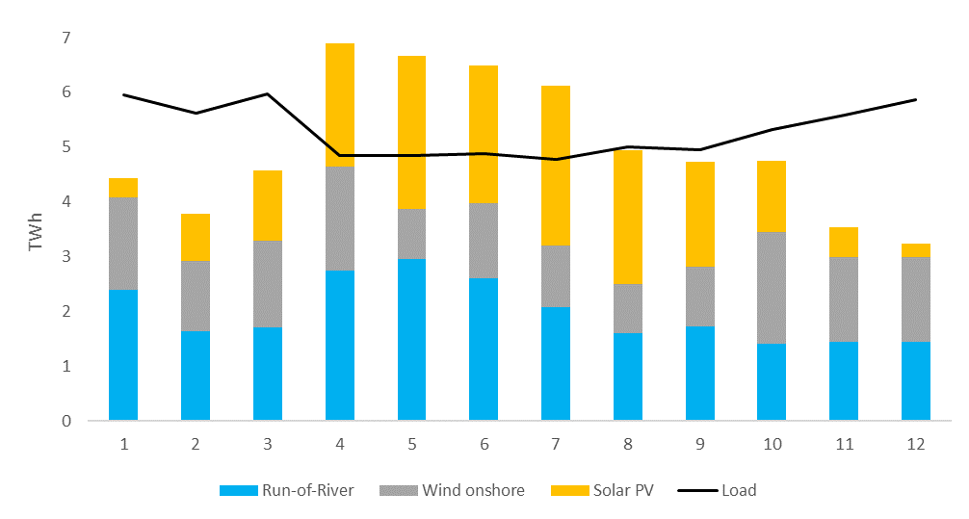
Fig. 1. Flexibility through P2Heat via el-boiler. (Source: http://www.energyweb.dk/skagen/?english&history) | Fig. 2. Monthly generation in a 100% VRE scenario for Austria (Source: EEG TU Wien)
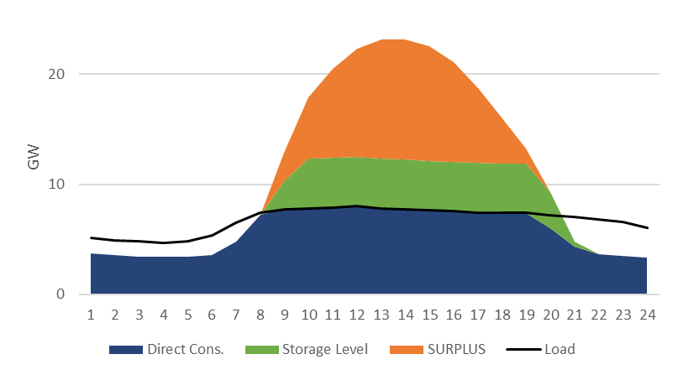 | 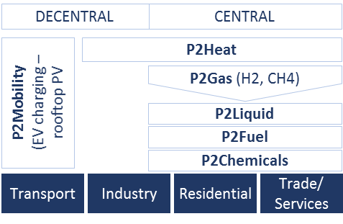
Fig. 3. Exemplary summer day: surplus generation and storage, AT 100% VRE. Short-term storage 4.5 GW (Source: EEG TU Wien) | Fig. 4. Central vs. decentral approaches of SC from a spatial perspective (proximity plant to use-location) (Source: EEG TU Wien)

Conclusions
We find that needs to be shed on the myths, goals and scope of SC. In our approach towards SC, we aim to point out that, in favour of the energy transition, SC only fulfills its aim with power from RES and is specifically promising to serve as a solution to handle its variability to achieve 100% renewable energy. Specifically, in a scenario with frequent excess power generation, due to the increasing share of VRE sources, SC represents one promising tool aiming at using this surplus in other end-sectors. The amount of excess electricity that cannot be stored within the power sector may be used directly or transformed for the use in transport, industry and heating which indirectly promotes their decarbonisation and helps to avoid RES curtailment. This research will derive a first analysis of the correlation of wind and heat demand as well as the potential of P2G for seasonal H2 storage for the future supply security in a 100% renewable electricity scenario in 2030 for Austria. In terms of economic feasibility a certain amount of operating hours for P2G plants is essential and shall also be analysed for the given scenario. This work builds the basis for further research and shows that more economic analysis of SC options, considering country specific RES potential and given infrastructure is essential to derive appropriate solutions.
References
[1] | K. Schaber, F. Steinke and T. Hamacher, “Managing Temporary Oversupply from Renewables Efficiently: Electricity Storage Versus Energy Sector Coupling in Germany,” in International Energy Workshop, Paris, 2013.
[2] | M. Robinius, A. Otto, P. Heuser, L. Welder, K. Syranidis, D. S. Ryberg, T. Grube, P. Markewitz, R. Peters and D. Stolten, “Linking the Power and Transport Sectors - Part 1: The Principle of Sector Coupling,” Energies, vol. 10, no. 7, p. 956ff, 2017.
[3] | B. Mathiesen, H. Lund, D. Connolly, H. Wenzel, P. A. Østergaard, B. Möller, S. Nielsen, I. Ridjan, P. Karnøe, K. Sperling and F. Hvelplund, “Smart Energy Systems for coherent 100% renewable energy and transport solutions,” Applied Energy, vol. 145, pp. 139-154, 2015.

