Transition in world oil market and its effect on Saudi Arabia.
Nourah AlYousef
Associate professor of Economics
King Saud University
E-mail. Alyousefn@yahoo.com or Nayousef@ksu.edu.sa
Phone +966565166788
Key word: Oil Market, Saudi Arabia, Unconventional gas and oil.
- Introduction:
Although the transition to a low oil economy was announced in the 1970´s, oil remains at the core of the world energy system. In 2011, the world oil consumption reached 88 million b/d, representing 33.1% of the world energy consumption (Table 1). The OECD reduced by 1.2% its oil consumption (600,000 b/d) but the non-OECD countries increased their oil consumption by 2.8% (1.2 million b/d), largely due to China.
Table 1 Energy Consumption (%)
Source | 2011
Oil | 33.1
Natural Gas | 23.7
Coal | 30.3
Nuclear | 4.9
Hydropower | 6.4
Renewables | 1.6
Total (MToe) | 12,274,6
Source: BP Statistical Review 2012
The Middle East dominates the supply side of the world oil trade (51.8%). Saudi Arabia has the leading role at the supply side, using its spare capacity to smooth any unexpected large disruptions in the oil supply. In recent years, reserves of unconventional oil and gas resources have been discovered that may allow countries like the United States and China to meet larger portion of their energy demands. This might have an effect on the oil market.
The world’s natural gas reserves stand at around 6621,2 trillion cubic feet(tcf), with about 2/3 in the Middle East and Russia. With technology improvements in exploration and production, producible gas reserves have grown by as much as 50% since 1989. Conventional gas represents the majority, but unconventional sources play a large part. In fact, unconventional sources are forecast to meet a third of global gas production by 2035. Shale gas is one of these unconventional sources. How much these unconventional sources will change the world oil market? Saudi Arabia as the largest producer and exporter of oil (2012) and a leading sources of imports to the USA, China, Japan, India and South Korea. How much this will be affected by Shale gas and oil revelation in the USA.
Moreover, National Bureau transportation has emphasize that unconventional gas resources (shale gas) could offer the means to immensely increase the supply of fossil fuels for transportation, which will cut into the rising demand for oil. The IEA outlook 2012, stressed that natural gas will displace oil as the largest single fuel in the U.S. energy mix by 2030
This paper is concern about what is the potential contribution of unconventional oil and gas resources to the future global oil supply? How these development will affect the demand of Saudi Arabia oil. Will Saudi Arabia remain a major source of oil supply?
This paper will start with review on recent transition in world oil and gas market. Followed by summary of the world outlook for energy market by BP, EIA, and OPEC. The study then examines the influence on Saudi Arabia as a major oil producer, followed by conclusions.

Figure 1:
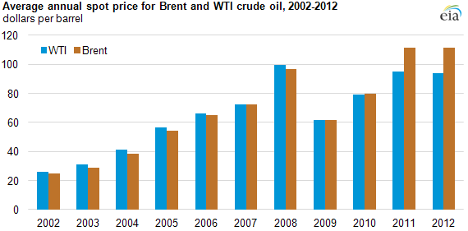
2. Unconventional gas and oil in the United States
The beginning of the new decade has witnessed an extraordinary rise in production of unconventional gas and oil in the United States. Oil and gas production, after decades in decline, are being driven upward by new technologies and high prices, prompting supporters to predict an economic revival and approaching energy independence. On the other side- rise of gas usage as a major source of energy has been witnessed in major consuming countries (In China, Natural gas usage increased by 22.2% in 2011). Also, with more efficient cars and trucks and fallen costs for renewable energy, indicating that rate of growth of demand might decline.
Oil- consuming countries have been facing high oil prices since 2003. Increase of demand by China and India and other Developing Economics facing limited growth in oil supply between 2003-2007, oil prices surge to over $100 / B . This decline in the rate of increase in supply supports the peak oil hypothesis, which indicates that production of oil has reached its maximum and future will show continuously declining production quantities (Schindler and Zittel, 2008). This has had its own implications in developing new technology to shift away from the dependence on conventional crude oil .

Table 2: Growth in oil supply and oil demand between (2002-2012)
 | Supply |  | Demand
2002 | 76,994 | -0.89% | 78,160 | 0.84%
2003 | 79,598 | 3.38% | 79,722 | 2.00%
2004 | 83,105 | 4.41% | 82,511 | 3.50%
2005 | 84,595 | 1.79% | 84,105 | 1.93%
2006 | 84,661 | 0.08% | 85,255 | 1.37%
2007 | 84,543 | -0.14% | 86,288 | 1.21%
2008 | 85,507 | 1.14% | 85,776 | -0.59%
2009 | 84,389 | -1.31% | 84,337 | -1.68%
2010 | 86,006 | 1.92% | 86427 | 2.48%
2011 | 87,109 | 1.28% | 87,421 | 1.15%
2012 | 89,090.1 | 2.22%
Source: www.eia.doe.gov
Technological innovation has revealed huge unconventional resources in the USA, reversing the movement of decreasing supply and changing global energy balance. The reason for this is that U.S. production of oil and natural gas is surging, due to the use of fracking technology to extract oil and gas in such places as North Dakota and Texas. According to BP, there are estimated technically recoverable resources of 240 billion barrels (Bbbls) for tight oil and 200 trillion (Tcm) for shall gas. Asia has an estimated 57 Tcm of shall gas and 50 Bbbls of tight oil, versus 47 Tcm and 70 Bbbls respectively for North America. In total North America accounts for 24% of global tight oil and shale gas resources.(BP outlook)
The recent revolution in unconventional oil and natural gas discoveries has established the commercial viability of numerous gas and oil-bearing shale, mainly in North America. This has caused a worldwide interest in searching and developing such resources in other parts of the world.

EIA 2013 shows in the USA, how growing consumer preferences, developed technology, and economic changes leading to additional domestic energy production, enhanced vehicle efficiency, better use of clean energy, all led to reduction in energy imports.
According to the IEA report “There is hardly any aspect of the global oil supply chain that will not undergo some measure of transformation over the next five years, with significant consequences for the global economy and oil security.”.
Figure 3:
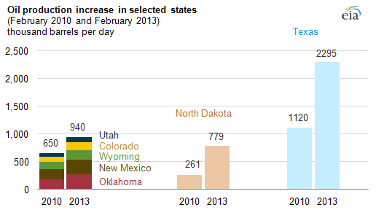

In the USA, onshore oil production, including crude oil and lease condensate, rose more than 2 million barrels per day (bbl/d), or 64%, in the Lower 48 states from February 2010 to February 2013.
The production growth that began in 2010 has continued mainly from Texas, North Dakota and other states—Oklahoma, New Mexico, Wyoming, Colorado, and Utah— In 2012 U.S. oil production increased by more than 800,000 barrels a day, huge increase that the International Energy Agency projected the U.S. will surpass Saudi Arabia as the world's largest oil producer by 2017, and will become a net exporter by 2030. This increase comes mainly from shale gas and tight oil. In 2012, 2.1 Mb/d (24%) of US oil production was from tight oil and 24 Bcf/d (37%) of natural gas from shale. These resources have boosted gas output by nearly 20% and oil by 30% between 2008-2012(BP, 2012 report)
Other aspect of the US oil market is the changes in transportation fuel use, which a major contribution to reduction of imports. In 2007 the United States consumed about 28 percent of total U.S. energy use for transportation. Moreover, 70 percent of the petroleum consumed in the United States goes to transportation sector. However, the use of Primary energy has decline in the last five years from 27,748 Trillion Btu in 2008 to 26,262 Trillion Btu in 2012 in spite of increase of USA GDP and population which is an indication of increase in transportation energy consumption efficiency . This decline comes from Petroleum consumption which constitute 92.77% in 2012 decrease from 95.53% in 2008 while at the same time Natural gas share rise from 2.49% to 2.87% and renewable share increased from 2.98 to 4.36%
Table 4: USA Transportation sector Primary Energy consumption (Trillion Btu)
 | Petroleum | Natural gas | Renewable Energy | Total Primary | Ratio Of Petroleum | Ratio of Natural Gas | Ratio Of Renewable
2008 | 26230 | 692 | 826 | 27748 | 94.53% | 2.49% | 2.98%
2009 | 25375 | 715 | 715 | 27025 | 93.89% | 2.65% | 3.46%
2010 | 25686 | 719 | 719 | 27479 | 93.48% | 2.62% | 3.91%
2011 | 25247 | 732 | 732 | 27137 | 93.04% | 2.70% | 4.27%
2012 | 24702 | 763 | 763 | 26626 | 92.77% | 2.87% | 4.36%
Source: www.eia.doe.gov

Source: www.eia.doe.gov

The reduced demand for energy is motivated by significant reductions in light-duty vehicle travel that reflect both changes in consumer preferences and a general shift in mobility needs together with a more fast development of transportation technology that reduces cost and improves efficiency. It also includes an expansion of alternative fuel markets across all transportation types.

.
The improvement in efficiency has led to a decline in total Consumption of petroleum products , a decline from 20,247 thousand Barrels per Day in Jan. 2008 to 18,130 thousand Barrels per Day in Dec. 2012 (Figure 6)a decrease by 1.11 % in spite of increasing USA population and GDP. The increase in USA production and decrease in consumption, coming from the largest consumer of petroleum in the world (21.6% in 2011) will affect the world oil market.

Source: www.eia.doe.gov

USA Reliance in import:
Between 1985 and 2005, net imports of liquid fuels as a share of consumption rose, from previous level of 47% to 60 percent in 2005. Since that time, however, the tendency toward rising U.S. dependence on liquid fuels imports has again overturned, with the net import share dropping to an estimated 41 percent in 2012, (eia data) and with EIA projecting additional major declines in 2013 and 2014. According to BP growing production and flat consumption will see the US become nearly self-sufficient in Energy by 2030. The US will remain a small net importer of oil, US energy production will reach 99% of domestic consumption.(BP outlook) Production will exceed import by the end of 2013 (eia.doe.gov) (figure 7)
Figure 7:
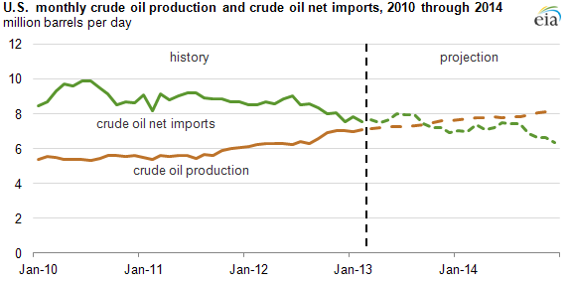
Saudi Arabia is the second-largest supplier of U.S. crude oil imports after Canada. U.S. net crude oil imports from the Saudi Arabia averaged almost 1.502 million barrels per day (bbl/d) between 1994-2008, With total U.S. crude oil imports fell to their lowest level since 1997. Crude oil from Saudi Arabia averaged 1,215 between 2010-2012 omitting imports in 2009, when the economic recession resulted in declining U.S. crude oil demand.

Source: www.eia.doe.gov

- China the second oil importer in the world:
China's real GDP growth rate was about 10 percent per year between 2001-2011, China is a main engine of the increase in energy consumption, and an important factor in the oil prices increase. Economic growth in China is still strong—China's gross domestic product grew at an estimated 7.8% in the first half of 2012—where China growth has been slowing in recent years, as is its growth in energy consumption. (EIA's China Country Analysis Brief )

Source: www.eia.doe.gov

China is the world's second largest oil consumer after the United States, and the largest global energy consumer, according to the EIA data, China is the world's second largest net importer of oil in 2011. China's oil consumption growth has been increasing by average of 6.3% between 2001-2011, where oil constitute 19% of total China energy consumption. Natural gas (4% of total Energy Consumption) demand in China has also increased rapidly in recent years average of 17.01% between 2001-2011, and China has considered to raise natural gas imports via pipeline and liquefied natural gas (LNG) where Qatar is a main exporter. China accounted for about half of the global coal consumption, and 70% of local Energy consumption, and though China try to replace Coal by natural gas it’s consumption still growing by average of 9.72% in the last ten years.

Source: www.eia.doe.gov

China crude oil Import:
Saudi Arabia is the largest source of China's crude oil imports1 1,005 million bbl/d (19 percent)., followed by Angola, ,623 million bbl/d (11 percet) . In an attempt from China’s government to diversify its supply sources, Its NOCs invested in long contracts in various regions of the world.
China and Shall gas:
The U.S. Energy Information Administration has estimated that China’s technically recoverable shale gas resources could be 50 percent bigger than those in the United States That has created optimisms that deloping those resources could help meet China’s insistently growing energy demand and affluence its dependence on coal-fired power plants. The Chinese National Energy Administration is aiming to produce 6.5 billion cu. meters of shale gas a year by 2015 and almost 1 trillion cu. meters a year by 2020 . However, according to the eia, China’s shale gas, may be large, but they are inaccessible, and in most places there is not enough water to provide for hydraulic fracturing, or fracking. Also, in China, state companies dominate the sources ownership, and mineral rights and this is effected by state bureaucracy. Natural gas provides just 4 percent of China’s total energy. China’s 12th five-year plan aims to increase natural gas to 8 percent of national energy use by 2015. According to Bp outlook, ther is no suggestion that it will develop vastly by 2030 (Figure 11)
Figure 11: BP outlook 2030
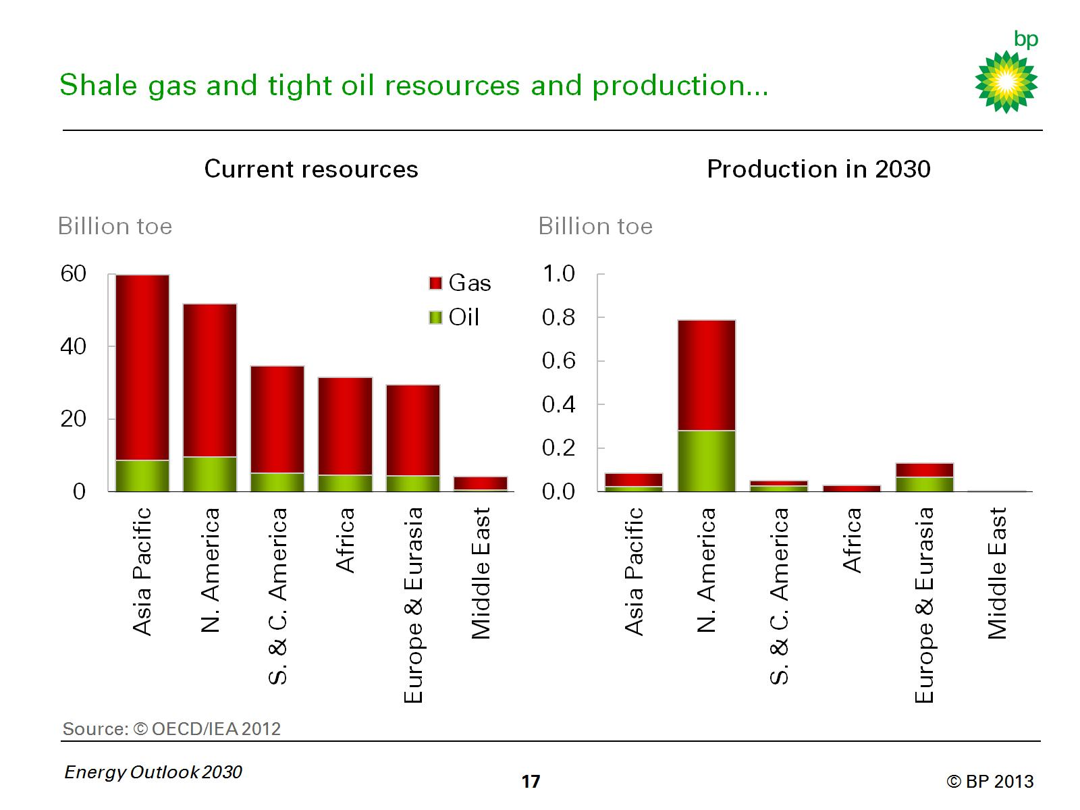

1. Shale gas world resources
Preliminary assessments of 48 shale gas basins in 32 countries propose that shale gas resources, which have recently provided a major increase to U.S. natural gas production, are also available in other world regions. An EIA-Study reported initial assessments of 5,760 trillion cubic feet (Tcf) of technically recoverable shale gas resources in 32 foreign countries, compared with 862 Tcf in the United States. EIA Of the countries studied, two groups may find shale gas development important. One those who depend heavily on natural gas imports but that also have significant shale gas resources(France, Poland, Turkey, Ukraine, South Africa, Morocco, and Chile). The second group is those countries that already produce large amounts of natural gas and also have large shale resources. United States, Canada, Mexico, China, Australia, Libya, Algeria, Argentina, and Brazil.

Figure 12: Shall gas sources in different region covered by the study
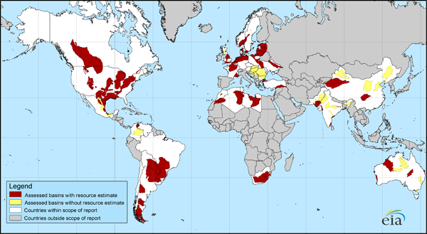
Source: U.S. Energy Information Administration based on Advanced Resources International, Inc. data

Estimates of shale gas resources in other parts of the world are highly unclear. Only in the past 3 years the use of shale gas became obvious and many countries are just now beginning to study how much shale gas they may have. Even so, the study did not cover all regions where shale gas might be found especially Middle East and Russia

- Saudi Arabia:
Saudi Arabia was the world's largest (11,545.70 Mb/d in 2012)t producer and exporter of petroleum and other liquids in 2012, It is exports 8.6 million bbl/d (net). Saudi Arabia has an estimated 268 billion barrels of proved oil reserves—over 16% of the global total— Saudi Arabia has a spare oil production capacity, that has been used to moderate oil prices and used to relieve market disruptions. In 2012, 16% of Saudi liquids exports were directed to the United States, accounting for 13% of total U.S. liquids imports. 15% to Europe, 54% to Far East, accounting to 33% of total Japan imports,19% of total China Import, 19 of total India import.. Which are equal Japan (1.1 million bbl/d), China (1.1 million bbl/d), South Korea (0.8 million bbl/d), and India (0.7 million bbl/d).Saudi Arabia is the largest source of imports to all five countries.

Source: www.eia.doe.gov

Conclusion:
According to some of the finding of OPEC, EIA , BP and IEA outlook 2012.2013

- Shale gas resources are large according to the EIA and Bp But how much will be developed is a great challenge. Shale gas production is coming mostly from North America (mainly the US). USA production increased from 15 billion cubic feet a day (bcf/d) in 2010 to 25 bcf/d in 2012. Repeating the success of US shale gas development internationally involves many challenges such as water shortages, a lack of infrastructure, being found in a remote land, the need to replicate USA technology might go through difficulty coming from domestic government regulations (Figure
- Crude oil production, especially from tight oil plays, rises sharply over the next decade.. USA oil production will rise to 7.5 million barrels per day (bpd) in 2019, up from less than 6 million bpd in 2011. The US oil shale production increase by over 1 mb/d, initial forecasts now see oil shale supply rising rapidly. Tight oil will account for 9% of global supplies while shale gas will reach 16% of the world total by 2030. North America will dominate output accounting for 72% of tight oil/shale gas supplies in 2030 (BP outlook)
- Natural gas will be the fastest growing fossil fuel at 2% p.a., reaching 456 Bcf/d (+144) by 2030. Compare to Oil growth (0.8% ) reaching 104 Mb/d in 2030 (BP outlook)
- Growth in non-OPEC liquids supply over 2013–2016. It rises by over 4 mb/d, mainly from shale oil in the US, Canadian oil sands, and crude oil from the Caspian and Brazil. These compensate for expected declines elsewhere (OPEC outlook 2012)
- Total OPEC liquids supply rises.
- OPEC crude oil spare capacity is expected to exceed 5 mb/d as early as 2014. OPEC Member Countries move on to invest greatly in exploration, development, refining and transport in order to sustain and expand supply capacities.(OPEC outlook) and Since Saudi Arabia account for 32% of OPEC total oil supply in 2012 and its spare capacity is the largest in OPEC around 1 Mb/d in 2012. According to BP outlook 2013, the US, Russia, and Saudi Arabia will supply over a third of global liquids for the remainder of the outlook. The 2011 level of Call on OPEC isn’t reached again until 2021
- Total non-OPEC liquids supply increases strongly in crude and NGLs from the Caspian, Russia, Brazil and US shale oil, as well as stable increases in biofuels and oil sands, are far stronger than declines elsewhere (OPEC outlook)
- Global energy intensity in 2030 is nearly half (46%) of what it was in 1990 and 31% lower than 2011. EU energy consumption is more or less back to where it was in 1995 (BP outlook)
- This means that call on OPEC crude (Including Saudi Arabia) in global liquids supply will decline between 2012-2016 .as its illustrated by the following (figure:14)

Figure 14 : Call on OPEC spare Capacity

Call on OPEC (RHS)

9

Mb/d
36
Spare capacity
6
33

3
30

27
0
2000
2010
2030
2020
Source Bp outlook January 2013 Christof Rühl group chief economist

- by 2020. Lower growth in Shale gas production after 2020 is acceptable by the fact that the best shale oil plays will be tapped first. Their contribution in the medium-term will continue to come only from North America. In the longer term, however, unassertive contributions might also come from other parts of the world.( BP outlook)

- Lower Economic Growth (LEG), largely as a result of the on-going Euro-zone debt crisis and the Chinese growth slowdown. This might have an effect on Saudi oil demand. In the downstream, where transport fuels drive future demand structure Gasoil/diesel is expected to witness the largest volume gain, due to the growing transport sector, especially in developing Asian countries mainly (China and India).

- According to the IEA,” Growth in oil consumption in emerging economies, mostly for transport in China, India and the Middle East, more than compensates reduced demand in the OECD, pushing global oil use steadily higher. Other region increases slowly. China alone accounts for 50% of the net increase worldwide. A steady decline in OECD regions is brought about by efficiency gains, inter‐fuel substitution and saturation effects”
- IEA report 2012 stated that “The United States is projected to become the largest global oil producer before 2020, exceeding Saudi Arabia until the mid‐2020s. At the same time, new fuel‐efficiency measures in transport begin to curb US oil demand. The result is a continued fall in US oil imports”

REFERENCE:
WWW.EIA.DOE.GOV Eia 2013 outlook
IEA 2012 outlook
BP 2013 outlook
OPEC 2012 outlook

International energy Agency, November 2012 Bureau of Transportation Statistics, National Transportation Statistics, Transportation Energy Data Book, available at http://www.bts.gov/publications/national_transportation_statistics
International energy Agency
EIA's Petroleum Supply Monthly
Transportation fuel use is a key factor in the outlook for U.S. oil imports Eia.doe.gov May 3 2013.
Nations outside the 32 countries studied. These include Russia and the Middle East, which have very large resources of conventional gas

