On THe future role of hydrogen: storage for electricity and fuel for mobility

Amela AJANOVIC, Reinhard HAAS,
Energy Economics Group, Vienna University of Technology, 1040 Wien, E-mail: Ajanovic@eeg.tuwien.ac.at

Overview
Since many decades hydrogen has been considered as a universal environmentally benign energy carrier. So far high production costs stated a major barrier for a broader market penetration, see e.g. Ajanovic (2008). With the current ambitious targets for increasing the share of renewable energy sources (RES) to 27% by 2030 set by the European Commission new prospects for hydrogen emerge. The reason is that an increasing share of these new RES comes from variable sources like wind and solar. This leads to the need for increased balancing activities between supply and demand, see Fig. 1, including the demand for long-term electricity storages.

The core objective of this paper is to investigate the future market prospects of hydrogen as a storage for excess electricity and its possible more competitive use in the transport sector as a renewable fuel.
Method
Our method of approach is on the supply side based on technological learning for the future development of investment costs of long-term storage options based on expected future quantities for technologies described in IEA (2011). On the electricity market side we use a fundamental approach where the intersection of supply and demand at every point-of-time gives the corresponding electricity market price. It is important to note that the quantity of storage has a feedback on the market price for charging storages as well as discharging.

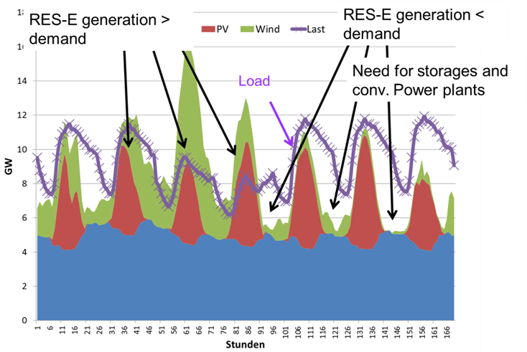 | 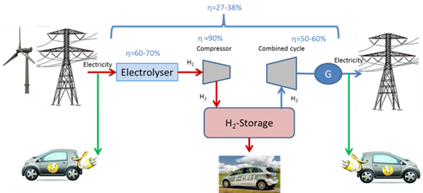
Figure 1. Development of intermittent RES-E over a week in comparison to demand | Figure 2. Energy supply chains with hydrogen as a storage for electricity and as a fuel from RES for mobility

Results
The major results of our investigations are: As shown in Fig. 2 hydrogen can be used as storage for electricity from volatile RES, however the efficiency of the whole energy supply chain including re-electrification of hydrogen is very low. However, over the period up to 2050 decreases in the costs of hydrogen production will take place mainly due to learning effects. In a dynamic market framework the costs of large centralized and smaller decentralized long-term hydrogen storage will finally be too high to become competitive in the electricity sector alone. By 2030 under most favorable learning conditions the costs of hydrogen for 2000 full-load-hours per year will be between 0.16 EUR/kWh and 0.18 EUR/kWh, see Fig. 3. For the same full-load-hours the price spread will be at the utmost about 0.08 EUR/kWh. For hydro pump storages (over a year) further prices will rather increase mainly due to a lack of sites with reasonable costs and lack of acceptance. An additional reason for the unfavorable economic conditions of long-term storage options is the self-cannibalism of storages in electricity markets. This means that every additional storage reduces the price spread and, hence, its own economic performance, Ehlers (2011). Other reasons are competition with demand response options, demand –side management, power-to-heat and decentralized storages. The costs of the latter will not decline significantly faster but they will compete on end-user price level which is (and will remain) remarkably higher.

Next we discuss whether the use of hydrogen in transport could be a solution. An alternative could be hydrogen use directly in the transport sector. Since in this sector GHG emissions are continuously increasing, one of the major challenges for the EU is to find polices and measures with which this trend can be stopped. One important target is to increase use of RES and zero-emission vehicles (ZEV) (such as battery electric vehicles (BEV) and fuel cell vehicles (FCV)) in car passenger transport.
Although these technologies have already environmental advantages, they are still not economically competitive (especially FCV). Also some technical characteristics of ZEV (such as driving range of BEV) have to be improved.

To reduce the relatively high costs of hydrogen cheap surplus electricity from variable RES can be used for electrolysis. The major problem of the economics of all storage options are their low FLH. Currently, a figure of about 2000 hours per year is considered to be the minimum. Costs are e.g. about four times higher if the FLH are reduced to 500 h/yr. Moreover, at current price spreads of about 3 to 5 cents/kWh in the Western European market no type of storage is economically attractive at FLH below 4000 h/yr. Hence, the number of full-load hours, which are dependent on availability of surplus electricity from wind and PV, have a crucial impact on the total hydrogen costs. The impact of the number of full-load hours (two different cases have been calculated: 1,800 and 3,000 hours) on hydrogen costs are shown in Fig. 4.

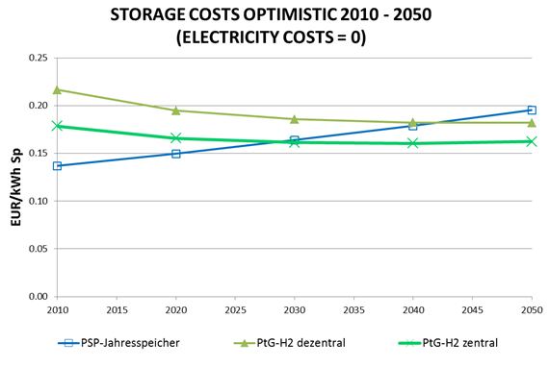 | 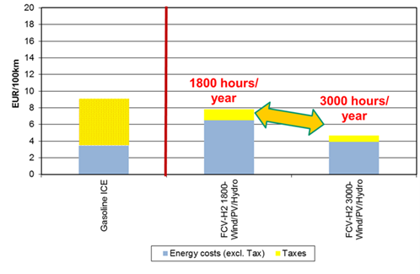
Figure 3. Development of costs of hydrogen and pumped storage depending on Technological Learning over time up to 2050 | Figure 4. . Energy costs of mobility per 100 km based on average of EU-15 countries in depending on full-load hours of the electrolysis for hydrogen production

Conclusions
The major conclusions are: (i) with respect to all centralized long-term storage technologies the future perspectives will be much less promising than currently indicated in several papers and discussions; (ii) for PtG-technologies it will also become very hard to compete in the electricity markets despite a high technological learning potential. Yet, for hydrogen there are prospects for use in the transport sector. Fuel prices in transport in recent years have rather increased compared to stagnation or decreases in electricity spot markets. Consequently, and given in addition the lack of environmentally benign fuels for mobility hydrogen and methane from renewable electricity might become an economically alternative for fueling passenger cars.

References
Ajanovic A., On the economics of hydrogen from renewable energy sources as an alternative fuel in transport sector in Austria, International Journal of Hydrogen Energy, Volume 33, Issue 16, August 2008, Pages 4223–4234
IEA: Energy Technology Perspectives, OECD/IEA, Paris 2011
Ehlers, N: Strommarktdesign angesichts des Ausbaus fluktuierender Stromerzeugung, Dissertation, Technische Universität Berlin 2011.

