COMBINING TARIFFS, INVESTMENT SUBSIDIES AND SOFT LOANS IN A RENEWABLE ELECTRICITY DEPLOYMENT POLICY
Pere Mir-Artigues, Chair of Energy and Environmental Sustainability, +0034973703212. peremir@econap.udl.cat
Pablo del Río, National Research Council of Spain (CSIC), +0034916022560, Pablo.delrio@csic.es

Overview

Policy combinations and interactions have received a considerable attention in the climate and energy policy realm. However, virtually no attention has been paid to the analysis of the combination of different deployment instruments for the same renewable energy technology. This neglect is all the more striking given the existence in current policy practice of combinations of deployment instruments either across technologies or for the same technology, both in the EU and elsewhere. The aim of our paper is to provide insight on the cost-effectiveness of combinations of deployment instruments for the same technology. A financial model is developed for this purpose, whereby feed-in tariffs (FITs) and premiums (FIPs) are combined with investment subsidies and soft loans. The results show that the policy costs of combinations are the same as for the FITs or FIPs-only option. Therefore, combining deployment instruments is not a cost-containment strategy. However, combinations may lead to different inter-temporal distributions of the same amount of policy costs which can affect the social acceptability and political feasibility of renewable energy support.

The abundant literature comparing the primary instruments with each other contrasts with the scarce research on their interactions. Indeed, virtually no attention has been paid to the combination of deployment instruments for the same technology, not even in recent, highly influential policy documents such as the policy chapter in the Intergovernmental Panel on Climate Change (IPPC) Report on Climate Change and Renewables (Mitchell et al 2011) and the International Energy Agency (IEA) Report on Policies for Renewables (Müller et al 2011).

Methodology
The model developed combines FIT and FIP remuneration levels and subsidies (or soft loans) for the same profitability level, given a specific technology and type of plant. It is based on the net present value (V) financial calculation method. This model allows policy makers to set remuneration levels and combine them with subsidies (or soft loans), for a given investor profitability level.

For example, if the term γI represents the amount of the investment subsidy and (1−γ)I refers to the portion of the initial outlays which are financed by the promoters' own funds, the expression of the V of a RES-E installation can be written as:
$$V=pq\sum_{t=1}^{t=T}{{\left(\frac{1+ε}{1+i}\right)}^{t}+γI-\left[γI+\left(1-γ\right)I+τI\sum_{t=1}^{t=T}{{\left(\frac{1+ε}{1+i}\right)}^{t}}\right]}$$
where q is the annual production plant, I the upfront investment, p the initial FIT level, i the interest rate, ε the annual rate of tariff revision and μ the annual rate of O&M cost increase. Some assumptions for the sake of simplicity are established. To obtain the relationship between p and γ (i.e., the p=f(γ) function), we set the level of the profit investment ratio, r=r*. Then,
$$p=\frac{I\left(r^{*}+1+τK\right)}{qK}-\frac{I}{qK}γ$$
The term K denotes a given finite series sum. This is a decreasing straight line.

In case of FIPs, the relationship between the premium (σ) and γ (i.e., the σ=f(γ) function) is given by the equation,
$$σ=\frac{I\left(r^{*}+1+τK\right)}{qZ}-e-\frac{I}{qZ}γ$$
which is also a decreasing straight line. The term Z denotes another finite series sum and e the electricity wholesale market price.

The combination amongst FITs, or FIPs, and soft loans requires a more complicated model. Thus, the expression of the V of a RES-E installation combining tariffs and soft loan is,
$$V=\sum_{t=1}^{t=T}{\frac{p{\left(1+ε\right)}^{t}q_{{AC}_{t}}}{{\left(1+i\right)}^{t}}-\left[\left(1-λ\right)I+\sum_{t=1}^{t=T}{\frac{m{\left(1+μ\right)}^{t}}{{\left(1+i\right)}^{t}}+}\sum_{t=1}^{t=T}{\frac{λI}{T{\left(1+i\right)}^{t}}+\sum_{t=1}^{t=T}{\frac{λI\left(1-\frac{t-1}{T}\right)i^{*}}{{\left(1+i\right)}^{t}}}}\right]}$$
There is also a similar expression referred to FIPs and soft loans. In both cases, the term (1−λ)I represents the part paid in cash by the investors and λI represents the amount of the soft loan (i*=ϕi, 0≤ϕ<1). If amortisation consists of constant payoffs and some assumptions for the sake of simplicity are established, it is finally obtained the general relationship between the three variables, which is shown in the following figure.

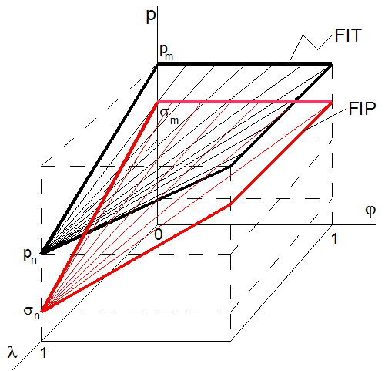
Next we analyse the impact of the changes in the level of profitability and in the level of discount rate. Finally, we compare the financial cost of combining FITs and FIPs and investment subsidies, or soft loans, with respect to a remuneration without such advantages. For example, the overall cost of the support policy per installation (C_{S}) is defined as the net present value of the tariffs received during the lifetime of this installation plus the initial investment subsidy, i.e.,
$$C_{s}\left(γ\right)=p\left(γ\right)q\frac{1+ε}{i-ε}\left[1-{\left(\frac{1+ε}{1+i}\right)}^{T}\right]+γI=p\left(γ\right)qK+γI$$

where γ is the proportion of the subsidised investment (0<γ ≤1) and p(γ) represents its associated tariff. Because it changes according to the restriction r=r*, the value of C_{S} is constant.

Results
Our main result is that the policy costs of instrument combinations per plant are the same as for the FITs or FIPs-only option, provided that the rate of net profitability and the discount rate do not change. The different levels of investment subsidies or soft-loans involve inter-temporal distributions of the same amount of policy costs. Therefore, combining deployment measures is not a cost-containment strategy.

Conclusions
We have assessed the relationship between the support costs of combinations of deployment instruments for a given technology, compared to a situation in which only one instrument (FITs or FIPs) is used. When a technology is eligible for two or more instruments, coordination between support instruments is crucial in order to reduce the total costs of RES-E support, i.e., to reduce the burden on consumers or taxpayers and avoid overcompensation for RES-E producers. In other words, remuneration levels under FITs, or FIPs, should be set taking into account support provided by other instruments. Despite that different levels of investment subsidies or soft-loans involve inter-temporal distributions of the same amount of policy costs, this fact has important policy implications. In particular, combining investment subsidies with FITs, or FIPs, involve greater policy costs in the short term compared with the FITs or FIPs-only option. Combining FITs and FIPs with subsidies, or soft loans, could be regarded by policy-makers as less attractive (and, thus, less politically feasible) than the FITs or FIPs-only option, which leads to a more uniform distribution of the costs of the policy over time.

References
Mitchell, C., et al., 2011. Policy, Financing and Implementation. In IPCC Special Report on Renewable Energy Sources and Climate Change Mitigation [O. Edenhofer, O. et al. (eds)], Cambridge, Cambridge University Press. Available at <http://srren.ipcc-wg3.de/report/IPCC_SRREN_Ch11.pdf>.
Müller, S. et al. 2011. Policy considerations for deploying renewables. International Energy Agency.

