Low oil investments and emergence of climate risk: the end is now or just business cycle as usual?

Sindre Lorentzen, University of Stavanger, Section of Industrial Economics, NO-4036, Stavanger, Norway, +47 51832247, sindre.lorentzen@uis.no
Petter Osmundsen, University of Stavanger, Section of Industrial Economics, NO-4036, Stavanger, Norway, +47 51831568,
petter.osmundsens@uis.no

Overview
The oil and gas industry experienced an unprecedently long, booming business cycle lasting for roughly a decade. This came to an end when oil prices fell markedly from 2014. While the oil price has begun its recovery, investment in development projects on the Norwegian Continental Shelf (NCS) was slow to follow suit. Two competing hypotheses emerged. On one hand, it was argued that petroleum investment will never recover, and what we are observing is the beginning of the end due to the emergence of climate risk. On the other hand, it is possible that a prolonged upturn is followed by a longer downturn where the build-up of cost level and debt are holding investments back. This leads us to the following question: have Norwegian petroleum investments experienced a permanent negative shock from the emergence of climate risk, or is the market just going through a longer than usual business cycle?

In this paper we explore these two hypotheses. In the face of the empirical observations, conjectures of the oil adventure reaching its end has become common. It has been postulated in the recent literature that the emergency of climate risk has irreparably caused a decrease in investment activity. In the context of the petroleum industry, risk caused by CO₂-driven climate change is often referred to as climate risk. In a qualitative study on companies operating on the NCS, Oslo Economics (2017) finds that climate risk affects their risk assessment through six channels: market risk, regulatory risk, technological uncertainty, physical risk and reputational risk. Fattouh, Poudineh and West (2019) argue that climate risk, especially through the channel of regulatory risk causing an energy transition, has caused a significant increase in oil companies’ discount rates. Consequently, aggregate investment will decrease. Decrease in investments, are further argued to reduce the value of oil and gas companies to plummet which might again trigger wide-spread economic downturn through contagion and the collapse of the petroleum service industry. A self-reinforcing cycle is argued, i.e. fossil fuel prices are believed to increase due to underinvestment, increased prices would in a further instance increase the speed of energy transition, which would result in even higher discount rates and lower investments. This hypothesis has proven itself to be challenging to test through empirical modelling. Henriques and Sadorsky (2010) come close by relating stock returns on energy companies to environmental sustainability through extending CAPM to include energy price. The beta coefficient of the latter is decomposed into energy price volatility, environmental sustainability (ES) and company size. Two issues prevent us from concluding that climate risk would have a similar significant effect without further investigation. First, as ES is a broader concept than climate risk, it would be incorrect to assume that what is true for the whole must be true for all of its parts. Second, the approach of Henriques and Sadorsky (2010) would at best only address the effect of climate risk through the market risk channel.

Looking at the second hypothesis. The relationship between petroleum companies’ decision-making and level of debt has become a popular topic (Domanski et al.,2015; Gilje et al.,2017; Lehn and Zhu, 2016; Lips, 2018). Lehn and Zhu, for instance, investigate the effect of debt on the level of investments in the U.S. oil industry. They find that investment is inversely related to debt. In the ten-year booming cycle cost levels were increasing steeply. When combined with a steep reduction in the oil price, many companies experienced a negative cash flow. They were reluctant to cut dividends, so debt levels were increasing fast. The first priority after the cash flow again picked up has been to service stockholders and to reduce debt that had moved above critical levels. Balance sheets were to be improved before embarking on substantial investments. Oil companies got scared from experiencing a negative cash flow. As a result, global reserve replace rate has been record low. We now finally see signs that investments are picking up globally and that major oil companies enter into large long-term projects in deep water and LNG. An increase in the investment level will, if it does take place, undermine the hypothesis that the downturn in investments was due to climate risk.

Methods
While discussions regarding the first hypothesis has become prevalent in the literature, limited empirical research has been produced on the matter due to a lack of available data. On the other hand, little to none investigation has been dedicated to exploring the second hypothesis. Hence, in this paper, we thus investigate the plausibility of the latter hypothesis. The project will also give interesting descriptions and analysis of the business cycles on the NCS, to our knowledge not studied previously. We begin by investigating the development of debt in the oil and gas industry on the NCS, and then through empirical modelling explore the relationship between development investments and debt. Our econometric approach consists of applying a panel vector autoregressive a model:
 | $$y_{it}=μ+\sum_{i=1}^{p}{A_{i}y_{t-i}}+Bx_{it}+ε_{t}$$ | (1)
Where $y_{it}$ denotes the investment for company $i$ at time $t$, and $x$ is a matrix of explanatory variables which includes company debt and various control such as oil price, rig rates and proxies for industry cost level.

Results

Our data set consists of observations of field level development investments covering the entirety of petroleum investment activity on the NCS until 2017. Field level investments are related to the oil and gas companies through ownership records obtained from the Norwegian Petroleum Directorate. Figure 1 (a) shows the aggregate development investments on the NCS, while (b) shows the business cycle extracted from log investments through three different approaches.
Figure 1: Oil and gas investments in development projects on the NCS (1970-2017)
a) Petroleum investments on the NCS | b) Investment business cycle on the NCS
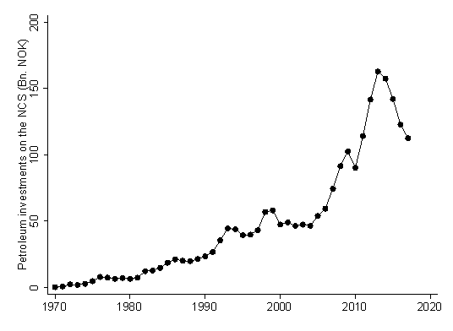 | 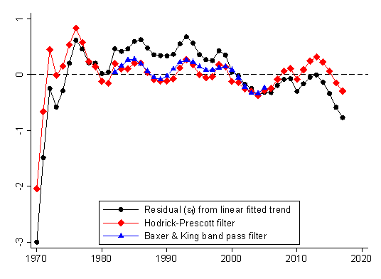

Conclusions
If it is shown that investments are negatively related to debt, controlling for other relevant variables, it indicates that recent investment fluctuations are related to the business cycle. The research will also generate results on business cycle on the NCS, e.g., if a longer than average upturn typically is followed by a longer than average downturn.

References
Domanski, D., J. Kearns, M. J. Lombardi, and H. S. Shin (2015). “Oil and debt.” BIS Quarterly Review.
Fattouh, B., R. Poudineh and R. West (2019). “Energy Transition, Uncertainty, and the Implications of Change in the Risk Preferences of Fossil Fuels Investors.” Oxford Energy Insight, 45.
Gilje, E., E. Loutskina, and D. P. Murphy (Apr. 2017): Drilling and Debt. SSRN Scholarly Paper ID 2939603. Rochester, NY: Social Science Research Network.
Henriques, I., & Sadorsky, P. (2010). “Can environmental sustainability be used to manage energy price risk?”. Energy economics, 32(5), 1131-1138.
Lang, L., E. Ofek, and R. M. Stulz (1996). “Leverage, investment, and firm growth.” Journal of Financial Economics 40 (1), pp. 3–29.
Lips, J. (2018): Debt and the Oil Industry-Analysis on the Firm and Production Level. Working paper.
Oslo Economics (2017). “Olje- og gasselskapenes vurdering av klimarelatert risikofaktorer.” OE-rapport nr. 2017-47.

