Energy system response to future uncertainties

Sannamari Pilpola, Aalto University School of Science, +358 50 433 1262, sannamari.pilpola@aalto.fi
Peter D. Lund, Aalto University School of Science, +358 40 515 0144, peter.lund@aalto.fi

Overview
Decarbonization and resilience are key goals of the future energy system transition, but being also subject to many uncertainties. Here we investigate the impacts of selected uncertainties on the overall performance and operation of a given energy system. We use Finland in 2050 as the reference system for the study. We aim to quantify to which extent will uncertainties in cost, consumption, and renewable resource potential affect the operation of an energy system and which uncertainties are the most significant for the overall system indicators, such as annual cost, CO₂ emissions and reliability. In particular, we assess how well the existing assets in the energy system can stretch to accommodate these future uncertainties. In addition to analysing the existing energy system, we will compare the performance of various kinds of energy system pathways.

Methods
The analysis is based on hourly energy system simulations of the national energy system. The system model used includes all sectors of the energy system: electricity, heat, and fuel. The operation of the given energy system is determined based on the merit order curves minimizing the hourly marginal costs. The main outputs of the model include but are not limited to the total annual costs, CO₂ emissions, primary energy consumption and electricity and heat production. The uncertainty analysis is based on the Monte Carlo method: the simulation model is repeatedly evaluated for different samples of the uncertainty. The uncertainties included here include level of consumption, various costs and resource potentials. The uncertainty ranges are based on data from literature. The model output variations are further examined to determine the most influential parameters via calculating the correlation coefficients between the output and input variations. The simulation model is calibrated with 2016 historical data.

Results
We evaluated the performance of the existing Finnish energy system (2016) against the uncertainty ranges of cost and consumption in 2050 in order to assess how well the existing assets in the energy system stretch to accommodate the future uncertainties. The key results of the uncertainty analysis are presented in Figure 1, illustrating the degree of output variation. The most significant parameter in regard to the annual CO₂ emissions, system costs, share of renewables and hours of power shortage was found out to be the level of consumption, with correlation factors 0.93, 0.76, -0.85, and 0.95, respectively. The second-most significant factor was the CO₂ price. The results show that the existing system cannot in any case reach a deep decarbonization target of -95% of the CO₂ emissions (2.7 MtCO₂). We also discovered that the existing system is not always able to meet the overall electricity demand, the median value for power shortage being 1.4% of the hours of the year. More results will be given in the full presentation.

Conclusions
The results highlight that the level of projected consumption is highly relevant, as it significantly affects system emissions, annual costs and reliability. In addition, it seems that the existing assets of the Finnish energy system are not able to fully cope with the 2050 level of consumption, prompting the need for possible capacity expansion and changes in the power mix.

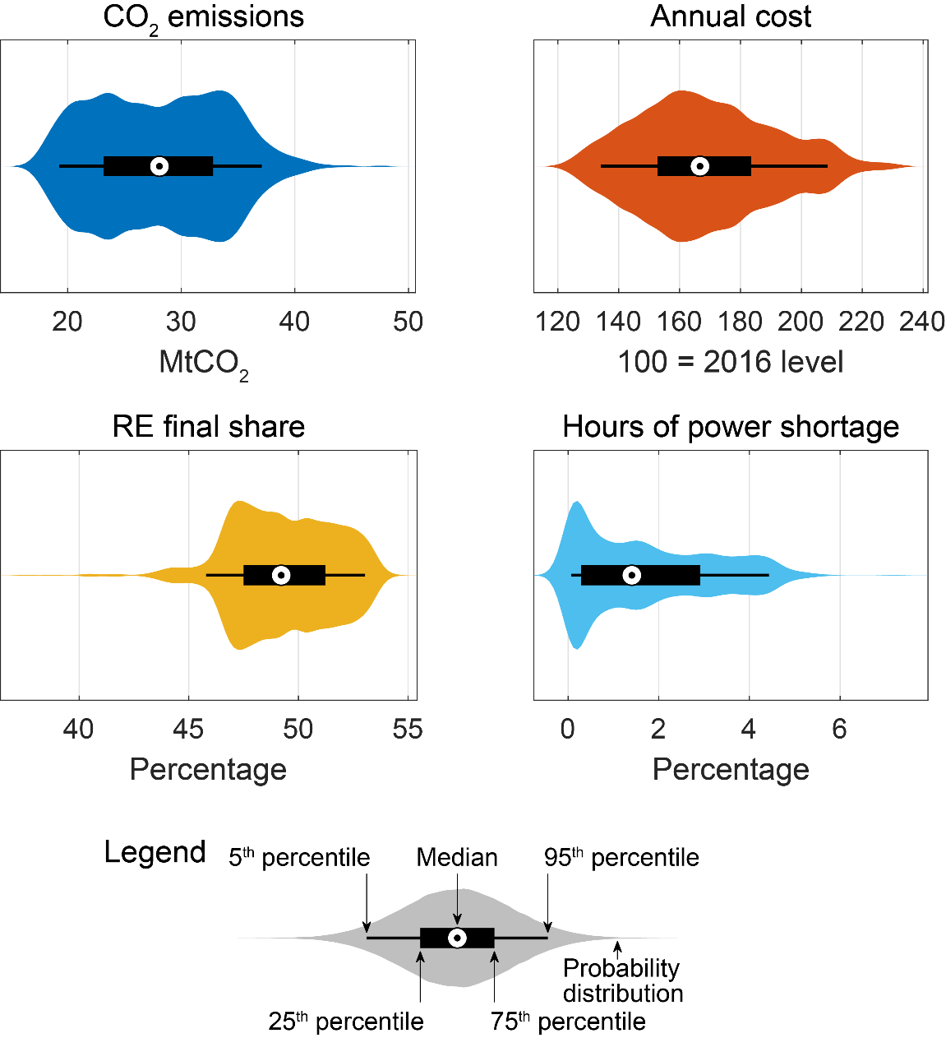
Figure 1. Key performance indicators of the Monte Carlo uncertainty analysis (N=1000) for the existing Finnish energy system (2016) against the uncertainty ranges of cost and consumption in 2050. The results are presented in so-called violin plots, accompanied by an explanatory legend.

